CSS ISLAMIC STUDIES · PR
بِسۡمِ ٱللَّهِ ٱلرَّحۡمَٰنِ ٱلرَّحِيمِ
The Prediction Papers
Three complete papers for CSS 2027 — set as FPSC prints them, 80% difficult, with keys and model answers
Three papers predicted from the record of 2015–2026, the style of the targeted 2025 and 2026 papers, and the issues of 2025–2026. Each set is printed exactly as FPSC prints the Islamic Studies paper and is followed by the MCQ key and full model answers — evidence in the order the Quran, the Hadith, then the Companions and scholars.
Edition of September 2026 · covers the papers of 2015–2026 · written for CSS 2027 and after
Contents
HOW TO BUILD THE CONTENTS
The Contents below is left empty on purpose. In Microsoft Word, right-click anywhere on the grey line below and choose Update Field → Update entire table → OK. The full table of contents with page numbers will appear.
On a Mac: right-click (or Control-click) the line → Update Field. If you edit the notes later, repeat this step to refresh the page numbers. You can also press Ctrl + A then F9 (Windows) to update every field in the document at once.

How the Prediction Papers Were Made 4
What is in this volume 4
The level of the sets — 80% difficult, 20% medium 4
The five forces behind the forecast 5
The twenty-one predicted questions at a glance 7
The three sets 7
All twenty-one questions — why each, why now 8
Prediction Set 1 — The Paper 10
Prediction Set 1 — Answer Key and Model Answers 13
Set 1 · Part I — Answer Key 13
Prediction Set 1 — Model Answers 15
Q. No. 2 · The Prophet (ﷺ) as Teacher: His Methods and the Reform of Pakistan's Education in the Age of AI 15
Q. No. 3 · Islamic Civilization and the Making of the Human Personality and Community 19
Q. No. 4 · The Distinctive Features of Islam and the Crisis of Meaning Among the Youth 23
Q. No. 5 · The Rights of Non-Muslim Citizens in an Islamic State, and the Minorities of Pakistan 27
Q. No. 6 · Riba and the Road to an Interest-Free Pakistan by 2028 31
Q. No. 7 · Takfir, the Khawarij and Militancy — and the Answer of Paigham-e-Pakistan 35
Q. No. 8 · Short Notes 39
Prediction Set 2 — The Paper 43
Prediction Set 2 — Answer Key and Model Answers 46
Set 2 · Part I — Answer Key 46
Prediction Set 2 — Model Answers 48
Q. No. 2 · Can Reason, Science and Artificial Intelligence Replace Wahi? 48
Q. No. 3 · The Diplomacy of the Holy Prophet (ﷺ) and Pakistan's Foreign Policy 51
Q. No. 4 · Islam's Rights for Women and Pakistan's Gender Gap 55
Q. No. 5 · Zuhd and Qana'ah Against Materialism and Consumerism 58
Q. No. 6 · The Impact of Islamic Civilization on the West 62
Q. No. 7 · Shura and Parliamentary Democracy: The Caliphs and the 1973 Constitution 66
Q. No. 8 · Short Notes 70
Prediction Set 3 — The Paper 74
Prediction Set 3 — Answer Key and Model Answers 77
Set 3 · Part I — Answer Key 77
Prediction Set 3 — Model Answers 79
Q. No. 2 · Khatm-e-Nubuwwat: Completeness of the Din, Unity of the Ummah and the Continuity of Guidance 79
Q. No. 3 · The Prophetic Laws of War and Modern International Humanitarian Law 82
Q. No. 4 · The Rights of the Child: Islam, the UN Convention and Pakistan 86
Q. No. 5 · The Rule of Law in Islamic Civilization and in Pakistan 90
Q. No. 6 · The Weakness of the Ummah and a Quranic Roadmap for Unity 93
Q. No. 7 · Collective Ijtihad in the Age of AI, Biotechnology and Digital Finance 97
Q. No. 8 · Short Notes 101

How the Prediction Papers Were Made

What is in this volume
1. The forecast — how the next paper was predicted from the record of 2015–2026, the style of the 2025 and 2026 papers, and the situation in the world and in Pakistan in 2026.
2. Three complete papers, printed as FPSC prints the Islamic Studies paper: Part I with 20 MCQs and Part II with seven questions (Q. No. 2 to 8, attempt four, one question of two short notes).
3. After each paper: the MCQ key with the fact to remember, then full model answers to all seven questions, each with its answer map, the decoding of the question, the model answer and why it scores.
HOW TO USE THE SETS
Sit each paper under exam conditions: Part I in 30 minutes without notes, then four questions of Part II in 2 hours 30 minutes. Only then open the key and the model answers. Mark your own work against the decoding and the why it scores lines — that is how the examiner will mark it. Sit the three sets about a week apart in the last month (Master Anatomy, Appendix A).

The level of the sets — 80% difficult, 20% medium
The 2025 paper showed that the Islamic Studies paper can be targeted: set to break memorised answers. The sets are therefore harder than an average paper, so that the real paper feels easier.
What made 2025 and 2026 hard | The evidence | How the sets copy it
No question was a straight repeat | All seven 2025 questions came at a new angle: Fard Kifayah, the classist lifestyle, post-Prophetic tolerance, the parties to the peace pacts, Muslim views of the West | Every predicted question has a new angle, even inside a familiar family
Two limbs, the second critical | 'Why…? What effects…? Identify and analyze… How are they denied…?' | Almost every question ends with a critical or applied limb (Pakistan, the present day, 'evaluate', 'why has it weakened')
Terms from the Urdu and madrasa tradition | Makarim Akhlaq, Farz Kifayah, 'the classist lifestyle' | Zuhd and Qana'ah, Tabayyun, Takfir and the Khawarij, collective Ijtihad
Comparison with a Western document | UDHR (2026), feminism (2019), social contract (2020, 2023) | Geneva Conventions, the UN Convention on the Rights of the Child, parliamentary democracy
MCQs with 'None of these' as the key | 2025: items 4, 8, 11, 17 and 20; 2026: items 3 and 4 | Every set has three or four 'None of these' traps or near-miss options
MCQs on the subcontinent | 2025: Hujwiri, Muhammad bin Qasim, Sirhindi, Aurangzeb, the Silk Letter Movement | Every set has three MCQs on Islam in the subcontinent
Concept MCQs | 2026: the basis of honour, the condition of polygamy, the status most highlighted, the equality of the Farewell Sermon | Explanations in the key teach the concept, not just the letter

- Part II: of the 24 question-units (18 full questions and 6 short notes), 19 are difficult and 5 medium (79% : 21%).
- Part I: of the 60 MCQs, 48 are difficult and 12 medium (80% : 20%). The key marks each one D or M.
- 'Difficult' here means one of: a topic never asked before, a new twist on a familiar family, a second critical limb, or a comparison with a modern document. It never means obscure: every question is inside the syllabus or the examiner's proven habits.

The five forces behind the forecast

(1) The absence signal — what 2026 left out
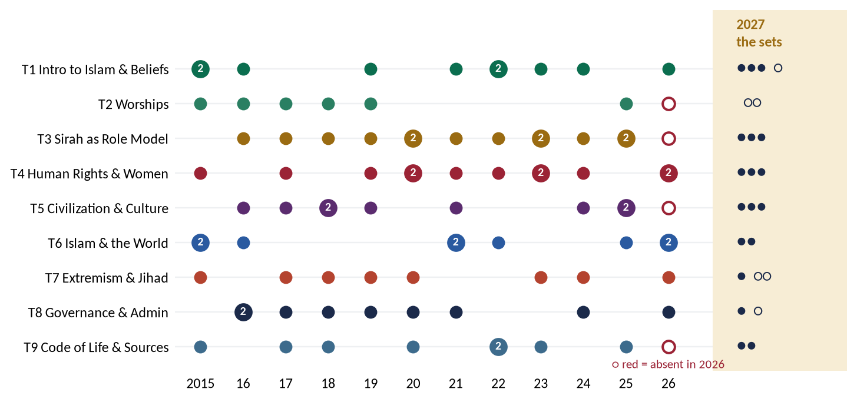
Figure 1 · The record, 2015–2026, and the 2027 forecast. Each dot is a question; the right-hand column shows how many full questions (●) and short notes (○) the three sets give each topic.
- Topic III (the Sirah) was missing in 2026 — for the first time in ten years. It had been asked every year from 2016 to 2025, twice in 2020, 2023 and 2025. It is almost certain to return in 2027, perhaps twice. Every set has a full Sirah question.
- Topic V (civilization) and Topic IX (sources and systems) were also missing in 2026. Topic IX has never been absent two years running; Topic V only once (2022–2023). Every set has a full T5 question; two sets have a full T9 question.
- Topic II (worships) returned in 2025 after a six-year silence and was absent in 2026. It is placed in the short notes of two sets — the examiner's usual place for a lighter topic.

(2) The repeat engine — the families and their rhythm
Family (topic) | Years asked | What it means for 2027
Extremism, terrorism, sectarianism (T7) | 2017, 2018, 2019, 2023, 2024, 2026 | The most-repeated family; never absent more than three years. Sets 1, 2, 3 (Khawarij; online radicalisation; mob violence)
Sources: Sunnah, Ijma, Ijtihad (T9) | 2015, 2017, 2018, 2022, 2023 | Due after a three-year gap. Set 3 (collective Ijtihad)
Economic system (T9) | 2020, 2022, 2025 | Every two or three years; the riba deadline falls in 2028. Set 1
Women's rights (T4) | 2017, 2019, 2021, 2022, 2023 | Absent since 2023 — its longest gap. Set 2 (the gender gap)
Human rights and dignity (T4) | 2020 (×2), 2023, 2024, 2026 | Continues. Set 1 (non-Muslim citizens), Set 3 (children)
Peace maker / military (T3) | 2016–2025 almost every year | Returns after the 2026 gap. Set 3 (the laws of war)
Prophethood and finality (T1) | 2015, 2022, 2024 | A two-year rhythm (2022, 2024 → 2026 missed) — due. Set 3
Self-purification (T5) | 2017, 2018, 2021, 2024 | Every three years → 2027. Set 2 (Zuhd and Qana'ah)
Ummah and challenges (T6) | 2015, 2016 | Long overdue; Gaza made it urgent. Set 3
Accountability (T8) | 2021, 2024, 2026 | Just asked; the next T8 question is likely to be a blind spot. Sets 1, 2 (letters; Shura)

(3) The blind spots — syllabus lines never asked
Topic | Never asked, 2015–2026 | Where the sets place it
T1 | Distinctive features of Islam | Set 1 · Q4
T2 | Sawm | Set 1 · Q8 (a)
T3 | The Prophet (ﷺ) as Educator and as Diplomat | Set 1 · Q2; Set 2 · Q3
T4 | Rights of non-Muslims; rights of children | Set 1 · Q5; Set 3 · Q4
T5 | Role of civilization in personality and community; rule of law | Set 1 · Q3; Set 3 · Q5
T6 | Impact of Islamic civilization on the West | Set 2 · Q6
T7 | Paigham-e-Pakistan | Set 1 · Q7
T8 | Letters of Umar and Ali; Shura and legislation | Set 1 · Q8 (b); Set 2 · Q7

(4) The contemporary layer — the world in 2026
The examiner of 2024–2026 asks how Islam solves a present problem. The sets are built on the live issues of 2025–2026, stated factually and without taking sides:
Issue | Where it is tested
Artificial Intelligence — generative AI as a source of 'knowledge', education and Ijtihad | Set 1 · Q2; Set 2 · Q2; Set 3 · Q7
The riba deadline — FSC judgment (28 April 2022); 26th Amendment (2024): riba to end by 1 January 2028 | Set 1 · Q6
The resurgence of terrorism (2023–2025) and the Paigham-e-Pakistan narrative | Set 1 · Q7
Mob violence and minorities — Sialkot (2021), Jaranwala (2023), Sargodha and Swat (2024) | Set 1 · Q5; Set 3 · Q8 (b)
Gaza (2023–2025), the ICJ case and the weakness of the OIC; Sudan, Kashmir, the Rohingya | Set 3 · Q3; Set 3 · Q6
The India–Pakistan conflict of May 2025; the Pakistan–Saudi defence agreement (September 2025) | Set 2 · Q3; Set 3 · Q6
Pakistan last of 148 countries in the Global Gender Gap Report 2025 | Set 2 · Q4
Children — about 26 million out of school; child labour; the 2025 debate on the age of marriage | Set 1 · Q2; Set 3 · Q4
Fake news and online hate — deep-fakes; the 2025 amendments to PECA | Set 2 · Q8 (b)
Consumerism, inflation and display on social media | Set 2 · Q5
Rule of law and corruption — Pakistan near the bottom of the international rule-of-law and corruption rankings | Set 3 · Q5

(5) The year-by-year style of the examiner
Phase | Style | What it predicts for 2027
2015–2019 | 'Define … describe its spiritual, moral and social impacts' | Still used for worships (the Sawm and Zakat notes)
2020–2023 | A concept in a frame: social contract, feminism, Pakistan, parliament | Frames: Geneva Conventions, the CRC, parliamentary democracy
2024–2026 | Applied and critical: 'in Pakistan', 'identify and analyze', 'comparative and critical analysis' | Every set ends most questions with a Pakistan or present-day limb

The twenty-one predicted questions at a glance
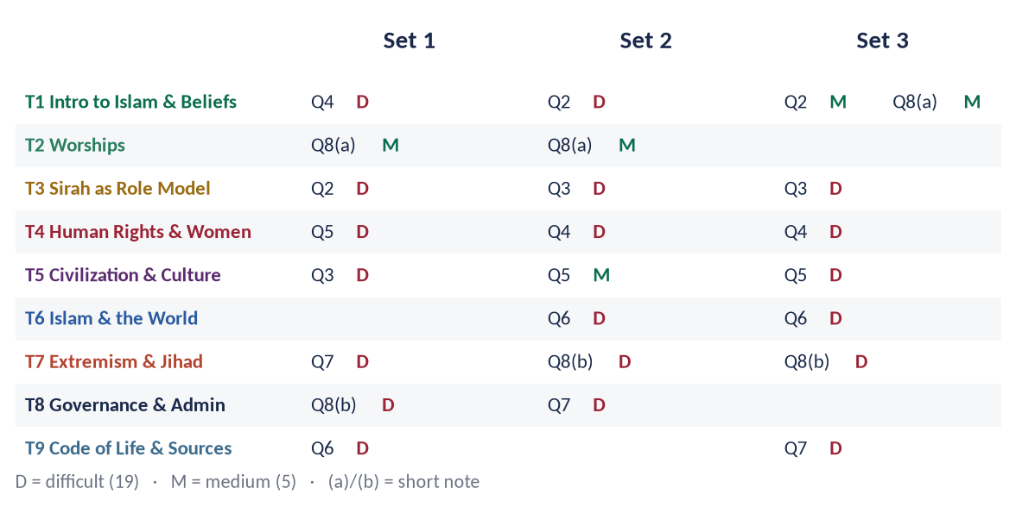
Figure 2 · The 21 predicted questions by topic and set, with their level (D = difficult, M = medium).
EXAMINER'S EYE · A PREDICTION IS A PREPARATION, NOT A PROMISE
No one can know the exact words of the next paper. What the record gives is the families, the blind spots and the style. If you can write these twenty-one answers, you can write any question that comes from the same family or blind spot — because each model answer is built from the same Knowledge Base chapters. When the real question is worded differently, keep the evidence and rebuild the headings from its words.

The three sets
Set | Character | What it tests
1 | The Most Probable Paper | The topics and families the record makes most likely for 2027: the Sirah after its first absence (2026), civilization after its absence (2026), the riba deadline, the extremism family, and the two biggest blind spots (Educator; letters of Umar and Ali).
2 | The Twist Paper | The repeat engine with the twists the 2024–2026 examiner adds: revelation against AI, diplomacy for Pakistan's foreign policy, women's rights against the gender-gap data, Islam's gift to the West (the reverse of 2026), and Shura against the 1973 Constitution.
3 | The Crisis and Blind-Spot Paper | The paper a 'targeted' examiner would set, as in 2025: every question applies Islam to a live crisis — war and Gaza, children, the rule of law, the Ummah's weakness, AI-age Ijtihad and mob violence — with finality and the Hereafter as the doctrinal anchors.

All twenty-one questions — why each, why now
Set · Q | Topic | Level | The question | Why it is predicted
1 · Q2 | T3 | D | The Holy Prophet (ﷺ) said, "I have been sent as a teacher." Discuss the methods of teaching and training adopted by the Prophet (ﷺ). How can these methods reform the education system of Pakistan in the age of Artificial Intelligence? | Educator has never been asked in twelve years; the 2026 MCQ named 'teacher' the Prophet's most highlighted status; T3 was absent in 2026 for the first time since 2015; AI and 26 million out-of-school children.
1 · Q3 | T5 | D | "Islamic civilization builds the human being before it builds cities." Discuss the role of Islamic civilization in the development of human personality and community. Why has this role weakened in contemporary Muslim societies? | A named syllabus line never asked; T5 absent in 2026; the 2025 examiner likes a second, critical limb ('why has it weakened').
1 · Q4 | T1 | D | What are the distinctive features of Islam that distinguish it from other religions and modern ideologies? How do these features answer the crisis of meaning faced by today's youth? | 'Distinctive aspects' is a syllabus line never asked; youth atheism, anxiety and the meaning crisis are the live T1 debate.
1 · Q5 | T4 | D | Discuss the rights of non-Muslim citizens in an Islamic state in the light of the Qur'an, Sunnah and the practice of the Rightly Guided Caliphs. Critically evaluate the condition of religious minorities in Pakistan against this standard. | Rights of non-Muslims never asked directly; 2025 asked tolerance in Muslim history and 2021 co-existence; Jaranwala (2023) and later incidents; 11 August 1947.
1 · Q6 | T9 | D | The Federal Shariat Court (2022) and the 26th Constitutional Amendment (2024) have fixed 1 January 2028 for the elimination of Riba from Pakistan. Explain the Islamic concept of Riba and critically analyze the challenges and the roadmap for an interest-free economy. | The deadline falls in the next paper's lifetime; the economic family was asked in 2020, 2022 and 2025; T9 absent in 2026.
1 · Q7 | T7 | D | "Takfir and the rebellion of the Khawarij are the roots of militancy in the name of Islam." Analyze this statement in the light of Islamic history, and explain how 'Paigham-e-Pakistan' counters the narrative of the militants. | The most-asked family (six times); the resurgence of terrorism in 2023–2025; Paigham-e-Pakistan is a syllabus-adjacent blind spot.
1 · Q8 | T2 · T8 | M · D | Notes: (a) Sawm as a school of Taqwa: its spiritual and social wisdom · (b) The letters of Hazrat Umar (RA) and Hazrat Ali (RA) to their governors as a charter of good governance | Sawm has never been asked; the letters of Umar and Ali are a named syllabus line never asked.
2 · Q2 | T1 | D | Can human reason, science and Artificial Intelligence replace Wahi (Divine Revelation) as the guide of human life? Argue in the light of the Qur'an and Sunnah. | Wahi was last asked in 2015; the 2026 examiner asked rational arguments; generative AI is the new rival 'source of knowledge'.
2 · Q3 | T3 | D | Analyze the diplomacy of the Holy Prophet (ﷺ) through his letters to the rulers and his dealings with delegations. What principles of foreign policy can Pakistan derive from them today? | The Prophet (ﷺ) as Diplomat is a named syllabus line never asked; 2025 asked the parties to his treaties; Pakistan's diplomacy after May 2025 and the Saudi defence pact.
2 · Q4 | T4 | D | Islam grants women the rights of education, property, work and participation, yet Pakistan stands at the bottom of the Global Gender Gap Index. Examine the causes of this gap and suggest remedies in the light of Islamic teachings. | Women's rights asked five times (last 2023); Pakistan ranked last of 148 in the Global Gender Gap Report 2025; the examiner now asks 'why the gap?' (2023: 'how denied').
2 · Q5 | T5 | M | Materialism and consumerism are the new idols of modern society. Explain the Islamic concept of Zuhd (detachment) and Qana'ah (contentment) and its role in reforming individual and collective life. | Tazkiyah asked four times and classism in 2025; consumer debt, social-media display and inflation.
2 · Q6 | T6 | D | The European Renaissance owes a debt to Baghdad, Cordoba and Sicily. Evaluate the impact of Islamic civilization on the West, and explain why this debt is seldom acknowledged. | 2026 asked the West's impact on Islam; the syllabus line is 'impact on the West and vice versa' — the other half is due.
2 · Q7 | T8 | D | Is modern parliamentary democracy compatible with the Islamic concept of Shura? Examine in the light of the practice of the Rightly Guided Caliphs and the Constitution of Pakistan, 1973. | 'Shura and legislation' is a named line never asked; 2017 asked whether the Caliphs' system was democratic; 2023 asked whether parliament's law can be Ijma.
2 · Q8 | T2 · T7 | M · D | Notes: (a) Zakat and the eradication of poverty: why has Zakat not eliminated poverty in Pakistan? · (b) Online radicalisation and fake news: the Qur'anic principle of verification (Tabayyun) | Zakat and poverty asked three times; online radicalisation, deep-fakes and the 2025 PECA amendments.
3 · Q2 | T1 | M | Belief in the Finality of Prophethood (Khatm-e-Nubuwwat) guarantees the completeness of the Din and the unity of the Ummah. Discuss in the light of the Qur'an, Sunnah and Ijma, and explain how guidance continues after the end of Prophethood. | Finality asked in 2015 and Prophethood in 2022 and 2024 (exact repeat) — the family returns every two years; the 'how guidance continues' limb is the twist.
3 · Q3 | T3 | D | "The rules of war laid down by the Holy Prophet (ﷺ) anticipated modern International Humanitarian Law by thirteen centuries." Compare them with the Geneva Conventions, and evaluate their violation in contemporary conflicts. | Military strategy asked four times, Ghazwat for peace in 2024; Gaza (2023–2025), the ICJ case and the May 2025 India–Pakistan conflict.
3 · Q4 | T4 | D | Discuss the rights of the child in Islam in comparison with the UN Convention on the Rights of the Child (1989). How far does Pakistan protect these rights against child labour, lack of education and early marriage? | Rights of children never asked; 2026 asked a comparative-critical UDHR question; 26 million out-of-school children; the 2025 child-marriage legislation debate.
3 · Q5 | T5 | D | "The nations before you were destroyed because they punished the weak and spared the powerful." In the light of this Hadith, discuss the rule of law as a characteristic of Islamic civilization, and assess the state of the rule of law in Pakistan. | Rule of law is one of the characteristics of Islamic civilization never asked; the 2026 MCQ asked the obstacle the Prophet removed (favouritism); Pakistan's low rule-of-law ranking.
3 · Q6 | T6 | D | The Muslim Ummah comprises 57 states and a quarter of mankind, yet it could not stop the tragedy of Gaza. Analyze the causes of the weakness of the Ummah and suggest a Qur'anic roadmap for its unity. | The Ummah family was last asked in 2016; Gaza, Sudan and Kashmir; the OIC's limits; the Pakistan–Saudi defence agreement (2025).
3 · Q7 | T9 | D | Explain the need and principles of collective Ijtihad in the age of Artificial Intelligence, biotechnology and digital finance. Evaluate the role of the Council of Islamic Ideology and the Federal Shariat Court in this regard. | Ijtihad asked in 2018 and 2022, Ijma with parliament in 2023; the sources family is due after a three-year gap; AI, IVF, crypto and digital banking.
3 · Q8 | T1 · T7 | M · D | Notes: (a) Belief in the Hereafter as the foundation of accountability · (b) Mob violence in the name of religion: an Islamic critique | Akhirah asked 2021 and 2023; mob violence (Sialkot 2021, Jaranwala 2023, Sargodha and Swat 2024) is the extremism family's newest face.

Prediction Set 1 — The Paper
Sit this paper under exam conditions: Part I in 30 minutes without notes, then Part II in 2 hours 30 minutes. The key and the model answers follow the paper.
FEDERAL PUBLIC SERVICE COMMISSION | Roll Number
COMPETITIVE EXAMINATION FOR RECRUITMENT TO POSTS IN BS-17
UNDER THE FEDERAL GOVERNMENT, 2027
ISLAMIC STUDIES
TIME ALLOWED: THREE HOURS | PART-I (MCQS) | MAXIMUM MARKS = 20
PART-I (MCQS): MAXIMUM 30 MINUTES | PART-II | MAXIMUM MARKS = 80
NOTE:
(i) Part-II is to be attempted on the separate Answer Book.
(ii) Attempt ONLY FOUR questions from PART-II. ALL questions carry EQUAL marks.
(iii) All the parts (if any) of each Question must be attempted at one place instead of at different places.
(iv) Write Q. No. in the Answer Book in accordance with Q. No. in the Q. Paper.
(v) No Page/Space be left blank between the answers. All the blank pages of Answer Book must be crossed.
(vi) Extra attempt of any question or any part of the question will not be considered.
PART – I (MCQS) (COMPULSORY)
Q. No. 1. (i) Select the best option/answer and fill in the appropriate box on the Answer Sheet. (20×1=20)
(ii) Answer Sheet will be taken back after 30 minutes.
(1) Who negotiated and signed the Treaty of Hudaybiyyah on behalf of the Quraysh?
(a) Abu Sufyan ibn Harb | (b) Urwah ibn Mas'ud al-Thaqafi | (c) Suhayl ibn Amr | (d) None of these
(2) After his mother, the first woman to nurse the Holy Prophet (ﷺ) was:
(a) Umm Ayman | (b) Thuwaybah | (c) Halimah Sa'diyyah | (d) None of these
(3) The Prophet's (ﷺ) envoy to the Byzantine emperor Heraclius was:
(a) Hatib ibn Abi Balta'ah | (b) Abdullah ibn Hudhafah al-Sahmi | (c) Amr ibn Umayyah al-Damri | (d) None of these
(4) The Qiblah was changed from Bayt al-Maqdis to the Ka'bah (the event of Masjid al-Qiblatayn) in:
(a) 1 AH | (b) 2 AH | (c) 3 AH | (d) 5 AH
(5) The archers posted on the hill at Uhud were commanded by:
(a) Abdullah ibn Jubayr | (b) Mus'ab ibn Umayr | (c) Zubayr ibn al-Awwam | (d) None of these
(6) The only Companion of the Prophet (ﷺ) mentioned by name in the Holy Qur'an is:
(a) Abu Bakr | (b) Zayd ibn Harithah | (c) Bilal ibn Rabah | (d) None of these
(7) Tafsir al-Jalalayn was written by Jalal al-Din al-Suyuti and:
(a) Jalal al-Din Rumi | (b) Jalal al-Din al-Mahalli | (c) Jalal al-Din Dawani | (d) None of these
(8) Which Surah contains 'Bismillah al-Rahman al-Rahim' twice?
(a) Al-Fatihah | (b) An-Naml | (c) At-Tawbah | (d) Al-Qasas
(9) The Miqat of the people of Yemen, also used by pilgrims from the subcontinent travelling by sea, is:
(a) Dhul-Hulayfah | (b) Al-Juhfah | (c) Yalamlam | (d) Qarn al-Manazil
(10) In the Hanafi school, the two Eid prayers are:
(a) Fard | (b) Wajib | (c) Sunnah mu'akkadah | (d) Nafl
(11) Darul Uloom Deoband was founded in 1866 chiefly by:
(a) Shibli Nomani | (b) Muhammad Qasim Nanautvi | (c) Sir Syed Ahmad Khan | (d) None of these
(12) The leader of the Silk Letter (Reshmi Rumal) Movement, arrested in the Hijaz and exiled to Malta, was:
(a) Ubaidullah Sindhi | (b) Mawlana Mahmud al-Hasan (Shaykh al-Hind) | (c) Mawlana Muhammad Ali Jauhar | (d) None of these
(13) Kitab al-Manazir (the Book of Optics) was written by:
(a) Ibn Sina | (b) Abu Rayhan al-Biruni | (c) Ibn al-Haytham | (d) None of these
(14) The Companion whose single testimony the Prophet (ﷺ) accepted as equal to that of two men (Dhu al-Shahadatayn) was:
(a) Khuzaymah ibn Thabit | (b) Zayd ibn Thabit | (c) Hassan ibn Thabit | (d) None of these
(15) The first great naval victory of the Muslims, Dhat al-Sawari (34 AH), took place in the caliphate of:
(a) Hazrat Umar | (b) Hazrat Uthman | (c) Hazrat Ali | (d) None of these
(16) The principle of Al-Masalih al-Mursalah (unrestricted public interest) is most closely associated with the school of:
(a) Imam Abu Hanifah | (b) Imam Malik | (c) Imam Shafi'i | (d) None of these
(17) When a man dies leaving children, the share of his widow is:
(a) 1/4 | (b) 1/6 | (c) 1/8 | (d) None of these
(18) A hadith in which a Successor (Tabi'i) narrates directly from the Prophet (ﷺ), omitting the Companion, is called:
(a) Mawquf | (b) Mursal | (c) Maqtu' | (d) Mu'allaq
(19) 'Khatib al-Anbiya' (the orator among the Prophets) is the title of:
(a) Hud | (b) Salih | (c) Shu'ayb | (d) None of these
(20) The UN General Assembly proclaimed 15 March as the International Day to Combat Islamophobia in:
(a) 2019 | (b) 2021 | (c) 2022 | (d) None of these

PART – II
Q. No. 2. The Holy Prophet (ﷺ) said, "I have been sent as a teacher." Discuss the methods of teaching and training adopted by the Prophet (ﷺ). How can these methods reform the education system of Pakistan in the age of Artificial Intelligence? (20)
Q. No. 3. "Islamic civilization builds the human being before it builds cities." Discuss the role of Islamic civilization in the development of human personality and community. Why has this role weakened in contemporary Muslim societies? (20)
Q. No. 4. What are the distinctive features of Islam that distinguish it from other religions and modern ideologies? How do these features answer the crisis of meaning faced by today's youth? (20)
Q. No. 5. Discuss the rights of non-Muslim citizens in an Islamic state in the light of the Qur'an, Sunnah and the practice of the Rightly Guided Caliphs. Critically evaluate the condition of religious minorities in Pakistan against this standard. (20)
Q. No. 6. The Federal Shariat Court (2022) and the 26th Constitutional Amendment (2024) have fixed 1 January 2028 for the elimination of Riba from Pakistan. Explain the Islamic concept of Riba and critically analyze the challenges and the roadmap for an interest-free economy. (20)
Q. No. 7. "Takfir and the rebellion of the Khawarij are the roots of militancy in the name of Islam." Analyze this statement in the light of Islamic history, and explain how 'Paigham-e-Pakistan' counters the narrative of the militants. (20)
Q. No. 8. Write notes on the following: (20)
(a) Sawm as a school of Taqwa: its spiritual and social wisdom (10)
(b) The letters of Hazrat Umar (RA) and Hazrat Ali (RA) to their governors as a charter of good governance (10)
**************

Prediction Set 1 — Answer Key and Model Answers
Set 1 — The Most Probable Paper. The topics and families the record makes most likely for 2027: the Sirah after its first absence (2026), civilization after its absence (2026), the riba deadline, the extremism family, and the two biggest blind spots (Educator; letters of Umar and Ali).

Set 1 · Part I — Answer Key
No. | Key | Answer | Level | Area | Why / the fact to remember
1 | (c) | Suhayl ibn Amr | D | Sirah | Urwah and others came first as envoys; Suhayl ibn Amr settled and signed the terms (he objected to 'Bismillah al-Rahman al-Rahim' and 'Rasul Allah').
2 | (b) | Thuwaybah | D | Sirah | Thuwaybah, the freed slave-woman of Abu Lahab, nursed him for a few days before Halimah Sa'diyyah; she also nursed Hamzah, making him his foster-brother.
3 | (d) | None of these | D | Sirah | None of these — Dihyah al-Kalbi. Hatib went to Muqawqis, Abdullah ibn Hudhafah to Khusrau, Amr ibn Umayyah to the Negus.
4 | (b) | 2 AH | M | Sirah | 2 AH, about sixteen or seventeen months after the Hijrah (Al-Baqarah 144).
5 | (a) | Abdullah ibn Jubayr | D | Sirah | Abdullah ibn Jubayr (RA) with fifty archers; Mus'ab ibn Umayr carried the standard. The archers' leaving the hill turned the battle.
6 | (b) | Zayd ibn Harithah | D | Quran | Zayd — 'when Zayd had ended his relation with her' (Al-Ahzab 37). Abu Bakr is referred to ('the second of the two', At-Tawbah 40) but not named.
7 | (b) | Jalal al-Din al-Mahalli | D | Quran | Al-Mahalli began it; his student al-Suyuti completed it — hence 'the two Jalals'.
8 | (b) | An-Naml | M | Quran | An-Naml: at its beginning and in Sulayman's letter to the Queen of Sheba (An-Naml 30). At-Tawbah has none.
9 | (c) | Yalamlam | D | Beliefs & worships | Yalamlam. Dhul-Hulayfah is for Madinah, al-Juhfah for Syria, Qarn al-Manazil for Najd.
10 | (b) | Wajib | D | Beliefs & worships | Wajib on everyone on whom Jumu'ah is obligatory (Hanafi); Sunnah mu'akkadah for the Maliki and Shafi'i schools.
11 | (b) | Muhammad Qasim Nanautvi | D | History & civilization | Muhammad Qasim Nanautvi with Rashid Ahmad Gangohi and others. Shibli is linked with Nadwat al-Ulama (1894); Sir Syed with Aligarh (1875).
12 | (b) | Mawlana Mahmud al-Hasan (Shaykh al-Hind) | D | History & civilization | Shaykh al-Hind Mahmud al-Hasan (1916–1920 in Malta). Ubaidullah Sindhi was his agent in Kabul. The movement aimed at the freedom of the subcontinent (asked in 2025).
13 | (c) | Ibn al-Haytham | M | History & civilization | Ibn al-Haytham (d. c. 1040), father of the experimental method in optics. Al-Biruni wrote Kitab al-Hind (asked 2025).
14 | (a) | Khuzaymah ibn Thabit | D | Companions | Khuzaymah ibn Thabit al-Ansari — he testified for the Prophet (ﷺ) in the case of the horse bought from a Bedouin (Abu Dawud).
15 | (b) | Hazrat Uthman | D | Companions | Hazrat Uthman (RA). Mu'awiyah built the first Muslim navy with his permission; the Byzantine fleet was defeated.
16 | (b) | Imam Malik | D | Fiqh | Imam Malik. The Hanafis are known for Istihsan (asked 2021, 2022, 2026); Imam Shafi'i restricted both.
17 | (c) | 1/8 | M | Fiqh | One-eighth (An-Nisa 12). Without children it is one-quarter — asked in 2023 and 2025, so the examiner may now reverse it.
18 | (b) | Mursal | D | Hadith | Mursal. Mawquf = the words of a Companion; Maqtu' = the words of a Successor; Mu'allaq = narrators dropped at the compiler's end.
19 | (c) | Shu'ayb | D | Prophets | Shu'ayb (AS), sent to Madyan, for his eloquent preaching against cheating in weights and measures.
20 | (c) | 2022 | D | Modern | 2022 — resolution 76/254, introduced by Pakistan on behalf of the OIC; 15 March recalls the Christchurch mosque attacks of 2019.

Level: 16 difficult, 4 medium. Score yourself: 16 or more is excellent; 12–15 good; below 12, revise the One-Liner Bank.

Prediction Set 1 — Model Answers
Each answer follows the method of the Master Anatomy (Part Five): the answer map, the decoding of the question, headings taken from the question's words, evidence inside every heading, a figure, the contemporary and Pakistan angle, and a conclusion.

Q. No. 2 · The Prophet (ﷺ) as Teacher: His Methods and the Reform of Pakistan's Education in the Age of AI
THE QUESTION · SET 1 · Q2 · 20 marks · DIFFICULT
The Holy Prophet (ﷺ) said, "I have been sent as a teacher." Discuss the methods of teaching and training adopted by the Prophet (ﷺ). How can these methods reform the education system of Pakistan in the age of Artificial Intelligence?

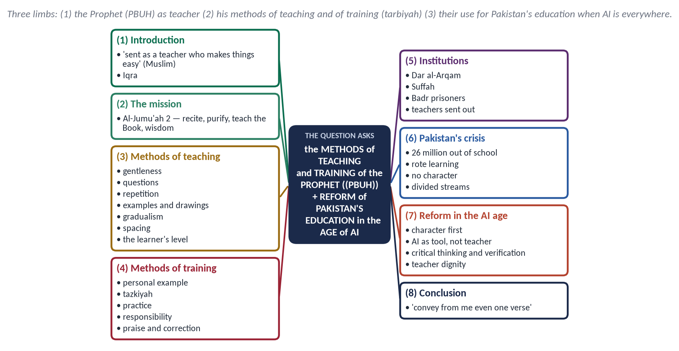
Figure 3 · The answer map: every branch is one numbered heading of the model answer below.

Decoding the question
- 'I have been sent as a teacher' — the answer must open with the Prophet's ﷺ own description of himself: 'Allah sent me as a teacher who makes things easy' (Muslim).
- 'Methods of teaching and training' — two different things: ta'lim (giving knowledge) and tarbiyah / tazkiyah (building character). Give each its own heading.
- 'Reform … in the age of Artificial Intelligence' — the difficult limb. It asks what a teacher is for when a machine can give information. The Prophetic answer: character, understanding and wisdom — the three things a machine cannot give.

The model answer

(1) Introduction
Islam began with a command to read: 'Read in the name of your Lord who created … who taught by the pen' (Al-Alaq 1–4). The Prophet ﷺ described his own mission in one word:
✦ HADITH
إِنَّ اللَّهَ لَمْ يَبْعَثْنِي مُعَنِّتًا وَلَا مُتَعَنِّتًا، وَلَكِنْ بَعَثَنِي مُعَلِّمًا مُيَسِّرًا
“Allah did not send me to be harsh or to cause hardship; He sent me as a teacher who makes things easy.” (Muslim)
➜ He named himself a mu'allim (مُعَلِّم).

In 23 years he turned an unlettered people into the teachers of the world. His methods are a complete philosophy of education.

(2) The mission of the teacher — four functions
✦ QURAN
﴿هُوَ ٱلَّذِي بَعَثَ فِي ٱلۡأُمِّيِّـۧنَ رَسُولٗا مِّنۡهُمۡ يَتۡلُواْ عَلَيۡهِمۡ ءَايَٰتِهِۦ وَيُزَكِّيهِمۡ وَيُعَلِّمُهُمُ ٱلۡكِتَٰبَ وَٱلۡحِكۡمَةَ وَإِن كَانُواْ مِن قَبۡلُ لَفِي ضَلَٰلٖ مُّبِينٖ﴾
“It is He who has sent among the unlettered a Messenger from themselves reciting to them His verses and purifying them and teaching them the Book and wisdom - although they were before in clear error.” (Al-Jumu'ah, Quran)
➜ The four functions of every true teacher: recite, purify, teach the Book, give wisdom.

- Tilawah — giving the content.
- Tazkiyah — purifying character.
- Ta'lim al-Kitab — explaining the meaning.
- Hikmah — teaching how to apply it.
Modern education does the first and third; it has dropped the second and fourth. That is the root of our crisis.

(3) His methods of teaching (ta'lim)

(i) Gentleness and ease
✦ HADITH
يَسِّرُوا وَلَا تُعَسِّرُوا، وَبَشِّرُوا وَلَا تُنَفِّرُوا
“Make things easy and do not make them difficult; give good news and do not drive people away.” (Al-Bukhari and Muslim)
➜ The first rule of teaching: no fear, no burden.

When Mu'awiyah ibn al-Hakam (RA) spoke during prayer by mistake, the Prophet ﷺ did not scold him:
✦ HADITH
فَبِأَبِي هُوَ وَأُمِّي، مَا رَأَيْتُ مُعَلِّمًا قَبْلَهُ وَلَا بَعْدَهُ أَحْسَنَ تَعْلِيمًا مِنْهُ
“May my father and mother be his ransom — I never saw a teacher before him or after him who taught better than he did.” (Muslim)

The Bedouin who urinated in the mosque was also taught gently: 'You were sent to make things easy, not hard' (Al-Bukhari).

(ii) Questions that make the learner think
He asked before he told: 'Do you know who the bankrupt is?' (Muslim); 'Which tree is like the believer?' (Al-Bukhari). A question wakes the mind — modern pedagogy calls it enquiry-based learning.

(iii) Repetition and clear speech
He repeated an important word three times so that it was understood (Al-Bukhari), and spoke so clearly that 'one could count his words' (Al-Bukhari and Muslim).

(iv) Examples, drawings and demonstration
He drew a straight line and lines beside it to show the right path and the paths of Satan (Ahmad), and taught prayer by showing it: 'Pray as you have seen me praying' (Al-Bukhari). Visual and practical learning.

(v) Gradualism and the learner's level
The Quran came over 23 years. He told Mu'adh (RA) to teach the people of Yemen step by step — first Tawhid, then prayer, then Zakat (Al-Bukhari and Muslim). He gave different answers about 'the best deed' to different people, according to their need.

(vi) Spacing — not boring the learner
Ibn Mas'ud (RA) said the Prophet ﷺ gave admonition on some days only, 'for fear of boring us' (Al-Bukhari).

(vii) Equality of learners
He fixed a separate day for women at their request (Al-Bukhari), and the poorest Companions of the Suffah became the greatest scholars.

(4) His methods of training (tarbiyah)
- Personal example: Aishah (RA): 'His character was the Quran' (Muslim). He dug the trench with his own hands.
- Tazkiyah: he trained the heart — sincerity, humility, control of anger.
- Practice and responsibility: young Companions were given real duties — Usamah commanded an army; Zayd ibn Thabit learned a foreign script in weeks; Mus'ab ibn Umayr was sent as the teacher of Madinah.
- Praise and correction: he praised Ubayy for knowing Ayat al-Kursi — 'May knowledge be pleasant for you' (Muslim) — and corrected mistakes in private.
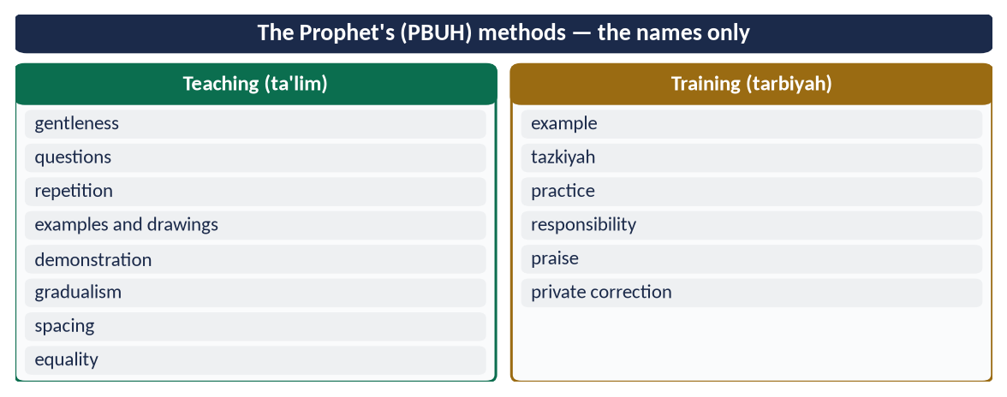
Figure 4 · At a glance — the Prophet's ﷺ methods — the names only. The detail is in the sections above.

(5) The institutions he built
Dar al-Arqam in Makkah (the first school) → Mus'ab sent to Yathrib → the Suffah in the Mosque → the prisoners of Badr freed for teaching ten children each to read → teachers sent to Yemen and the tribes. Knowledge was declared a duty: 'Seeking knowledge is an obligation upon every Muslim' (Ibn Majah).

(6) Pakistan's education crisis
- About 26 million children are out of school — one of the highest numbers in the world — despite Article 25-A (free and compulsory education, 5–16).
- Rote learning and exam cheating; little understanding.
- Three streams — elite English schools, public schools, madaris — that divide society.
- Degrees without character: corruption among the educated.
- Poor pay and status of teachers; corporal punishment still reported.

(7) Reform in the age of Artificial Intelligence
AI can give any fact in seconds. But it cannot give tazkiyah, wisdom or a living example — the very things Al-Jumu'ah 2 puts at the centre. The Prophetic model therefore becomes more relevant, not less.
Prophetic method | Reform for Pakistan in the AI age
Tazkiyah before ta'lim | A character curriculum: honesty, punctuality, service, taught by practice, not only by books
The teacher as example | Teacher training and pay; teachers chosen for character as well as knowledge
Questions, not memorisation | Replace rote exams with problem-solving; teach students to question AI output
Verification | Teach tabayyun (Al-Hujurat 6): check sources, recognise deep-fakes and AI errors
Gradualism and level | AI-assisted personalised learning at each child's pace — the machine as tool, the teacher as guide
Gentleness | End corporal punishment; schools as places of mercy
Equality of learners | One national core curriculum; girls' schooling; bring the 26 million back
Knowledge for all | Low-cost digital classrooms for villages; the mosque and school together

✦ SCHOLARLY VIEW
Allama Muhammad Iqbal · Poet-philosopher
Education without the heart produces a mind that is clever but lost; the school must build khudi (selfhood) and not only fill the memory.
➜ The same diagnosis as Al-Jumu'ah 2.

(8) Conclusion
✦ HADITH
بَلِّغُوا عَنِّي وَلَوْ آيَةً
“Convey from me, even if it is one verse.” (Al-Bukhari)
➜ He made the whole Ummah a chain of teachers.

The Prophet ﷺ taught gently, through questions, examples and practice, and trained character before he filled minds. In an age when machines supply information, Pakistan needs teachers who supply meaning, wisdom and example. That is the Prophetic school — and the only education that no algorithm can replace.

Why this answer scores
- It separates teaching from training, as the question does.
- Every method has a hadith and an event; Al-Jumu'ah 2 frames the answer.
- The AI limb is answered with a reason (what AI cannot give) and a reform table, not with slogans.

Q. No. 3 · Islamic Civilization and the Making of the Human Personality and Community
THE QUESTION · SET 1 · Q3 · 20 marks · DIFFICULT
"Islamic civilization builds the human being before it builds cities." Discuss the role of Islamic civilization in the development of human personality and community. Why has this role weakened in contemporary Muslim societies?

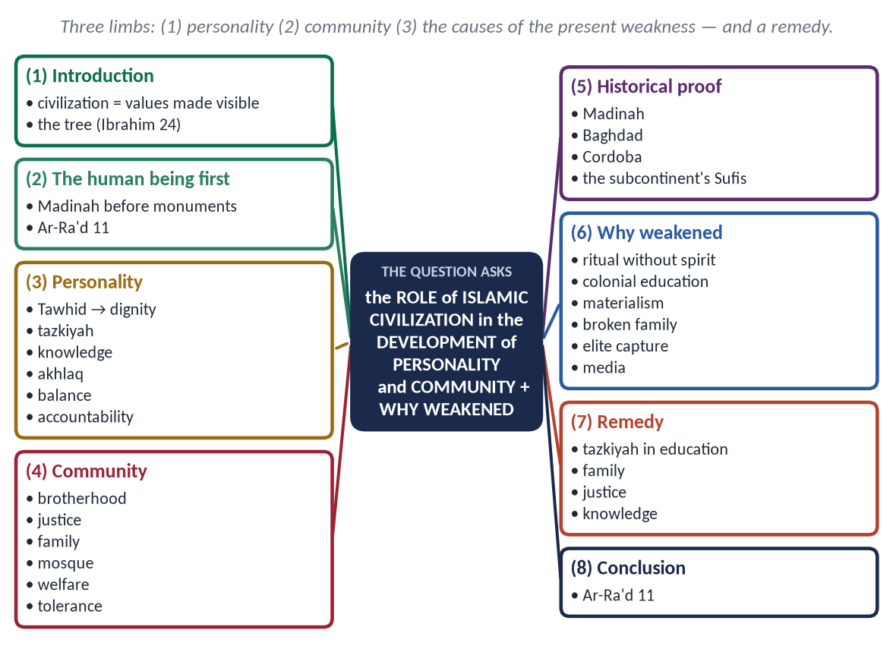
Figure 5 · The answer map: every branch is one numbered heading of the model answer below.

Decoding the question
- The statement means that Islamic civilization is first a moral and spiritual project; buildings follow people.
- 'Personality' (the individual) and 'community' (society) need separate headings.
- 'Why has this role weakened?' — a critical limb: give causes, honestly, then a short remedy.

The model answer

(1) Introduction
Civilization (tamaddun, from madinah) is the whole way a people think, live and build. Its visible part — cities, arts, sciences — grows from an invisible root: beliefs and values.
✦ QURAN
﴿أَلَمۡ تَرَ كَيۡفَ ضَرَبَ ٱللَّهُ مَثَلٗا كَلِمَةٗ طَيِّبَةٗ كَشَجَرَةٖ طَيِّبَةٍ أَصۡلُهَا ثَابِتٞ وَفَرۡعُهَا فِي ٱلسَّمَآءِ﴾
“Have you not considered how Allah presents an example, [making] a good word like a good tree, whose root is firmly fixed and its branches [high] in the sky.” (Ibrahim, Quran)
➜ Tawhid is the root; personality and community the trunk; cities and sciences the branches.

The good word (Tawhid) is the root; personality and community are the trunk; cities and sciences are the branches.

(2) The human being before the city
The Prophet ﷺ spent thirteen years in Makkah building people before he built a state. In Madinah the first building was a simple mosque of mud and palm-trunks; the first act was brotherhood (Mu'akhat). Change begins inside:
✦ QURAN
﴿… إِنَّ ٱللَّهَ لَا يُغَيِّرُ مَا بِقَوۡمٍ حَتَّىٰ يُغَيِّرُواْ مَا بِأَنفُسِهِمۡۗ …﴾
“Indeed, Allah will not change the condition of a people until they change what is in themselves.” (Ar-Ra'd, Quran)
➜ Change begins inside the human being — then it reaches society.

Why the human being first? (a) Institutions are only as honest as the people who run them — a corrupt officer defeats a good law. (b) The Quran addresses the person — 'O you who believe' — before it addresses the state. (c) The Prophet ﷺ measured greatness by character: 'The best of you are those who are best in character' (Al-Bukhari). (d) A civilization of buildings without values ends in luxury and decay, as Ibn Khaldun observed of every dynasty.

(3) The role in developing the human personality

(i) Tawhid — freedom and dignity
Bowing to One God frees man from bowing to kings, wealth and fear. 'We have honoured the children of Adam' (Al-Isra 70).

(ii) Tazkiyah — the purified self
✦ QURAN
﴿قَدۡ أَفۡلَحَ مَن زَكَّىٰهَا ۝ وَقَدۡ خَابَ مَن دَسَّىٰهَا﴾
“He has succeeded who purifies it. And he has failed who instills it [with corruption].” (Ash-Shams, Quran)
➜ Tazkiyah is the measure of success.

Prayer, fasting and remembrance train self-control; the result is a personality that is the same in private and in public.

(iii) Knowledge and reason
'Are those who know equal to those who do not know?' (Az-Zumar 9). The command to read made the Muslim a learner for life.

(iv) Character (akhlaq)
✦ HADITH
إِنَّمَا بُعِثْتُ لِأُتَمِّمَ مَكَارِمَ الْأَخْلَاقِ
“I was sent only to perfect noble character.” (Al-Bayhaqi)

Truthfulness, trust, modesty, patience and mercy are the marks of the civilized person.

(v) Balance
'Seek the Home of the Hereafter … but do not forget your share of this world' (Al-Qasas 77). No monk, no materialist — a whole human being.

(vi) Accountability
Belief in the Hereafter creates an inner auditor that works where no police can.

(4) The role in developing the community
- Brotherhood: 'The believers are but brothers' (Al-Hujurat 10); the Mu'akhat of Madinah.
- Justice and equality: 'No Arab has superiority over a non-Arab … except by taqwa' (Ahmad).
- The family as the first school — rights of parents, spouses and children.
- The mosque as school, court, welfare centre and parliament.
- Welfare: Zakat, Waqf, Bayt al-Mal — 'He is not a believer who eats his fill while his neighbour is hungry' (Al-Bayhaqi).
- Tolerance: the Charter of Madinah made Muslims, Jews and allies one community of citizens.
- Rule of law and accountability: 'If Fatimah the daughter of Muhammad stole, I would cut off her hand' (Al-Bukhari and Muslim); a Caliph could be questioned in the mosque about his cloak.
- Knowledge as a public good: mosques, madrasas and waqf libraries open to all — the community as a learning society.
✦ SCHOLARLY VIEW
Ibn Khaldun · Al-Muqaddimah
Civilization rests on 'asabiyyah (social solidarity); religion gives it its strongest and widest form, and luxury and injustice dissolve it.
➜ Personality and community rise and fall together.

(5) The historical proof
- Madinah: a torn oasis became a model society in ten years.
- Baghdad and Cordoba: libraries, hospitals and the Bayt al-Hikmah were built by people who saw knowledge as worship.
- The subcontinent: the Sufis — Hujwiri, Moinuddin Chishti, Bahauddin Zakariya — built people through service and character, and whole regions embraced Islam.
- The personality it produced: Abu Bakr's generosity, Umar's justice, Uthman's modesty, Ali's knowledge; al-Biruni's scientific honesty; Salah al-Din's mercy at Jerusalem (1187) — the civilization is best seen in its people.

(6) Why has this role weakened today?
Cause | How it weakens personality and community
Ritual without spirit | Prayer and fasting without their moral fruit; religion as identity, not transformation (Al-Ma'un)
Colonial and dual education | Knowledge cut from values; madrasa and modern streams divided
Materialism and consumerism | Worth measured by wealth; 'rivalry in increase' (At-Takathur)
Weak family | Parents absent, screens present; the first school is empty
Elite capture and injustice | Two laws — one for the strong, one for the weak; trust collapses
Sectarian and political division | The Ummah as fragments; brotherhood replaced by polarisation
Imitation without selection | Borrowing the surface of other cultures, not their science and discipline
Media and the attention economy | Role models replaced by celebrities; time wasted

✦ SCHOLARLY VIEW
Allama Muhammad Iqbal · *Reconstruction of Religious Thought in Islam*
The Muslim world lost its creative spirit when it stopped ijtihad and thinking, and turned to blind imitation.
➜ A civilization dies when its people stop growing.

(7) The way back
Tazkiyah and character in the school curriculum → strong families → justice and merit in the state → knowledge and research as fard kifayah → the mosque as a community centre again.

(8) Conclusion
Islamic civilization proved that a changed human being changes history. Its role has weakened not because its values failed, but because Muslims stopped living them. When the root is watered again — Tawhid, tazkiyah, knowledge and justice — the branches will grow again. 'Allah will not change the condition of a people until they change what is in themselves.'

Why this answer scores
- The quotation in the question is explained and used as the thesis.
- Separate headings for personality and community, each with evidence.
- The critical limb has a causes table and a short remedy — the examiner's 'why' is answered honestly.

Q. No. 4 · The Distinctive Features of Islam and the Crisis of Meaning Among the Youth
THE QUESTION · SET 1 · Q4 · 20 marks · DIFFICULT
What are the distinctive features of Islam that distinguish it from other religions and modern ideologies? How do these features answer the crisis of meaning faced by today's youth?

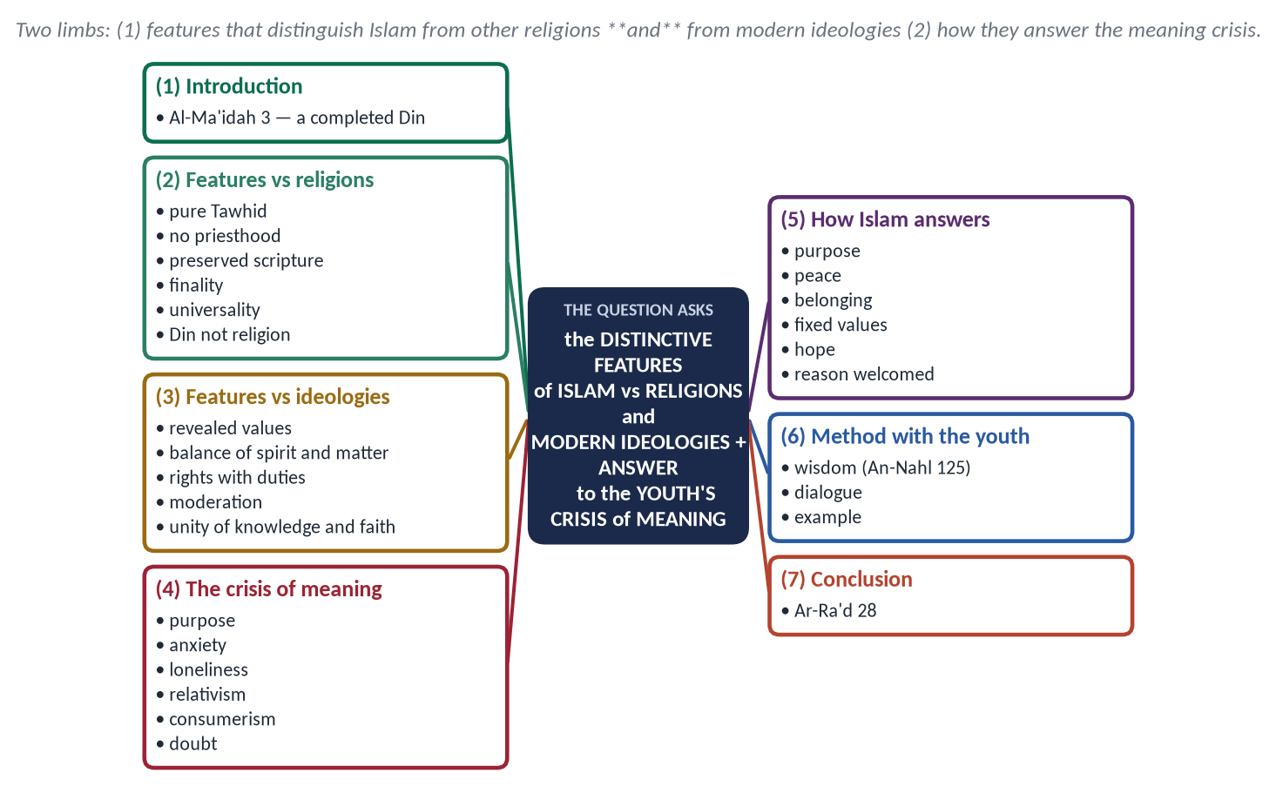
Figure 6 · The answer map: every branch is one numbered heading of the model answer below.

Decoding the question
- 'Distinctive' — features that only Islam has, or has in a unique balance. Common features (prayer, charity) do not count unless Islam's form is unique.
- 'Other religions and modern ideologies' — two comparisons: with religions (Judaism, Christianity, Hinduism, Buddhism) and with ideologies (secular liberalism, capitalism, communism, nationalism).
- 'Crisis of meaning' — the youth's questions: Why am I here? What is right? Why suffer? Where do I belong?

The model answer

(1) Introduction
✦ QURAN
﴿… ٱلۡيَوۡمَ أَكۡمَلۡتُ لَكُمۡ دِينَكُمۡ وَأَتۡمَمۡتُ عَلَيۡكُمۡ نِعۡمَتِي وَرَضِيتُ لَكُمُ ٱلۡإِسۡلَٰمَ دِينٗاۚ …﴾
“This day I have perfected for you your religion, completed My favour upon you and approved for you Islam as your religion.” (Al-Ma'idah, Quran)

Islam claims to be not a new religion but the original, completed Din of all the Prophets. Its features explain why it can speak to a generation that has lost its sense of meaning.

(2) Features that distinguish Islam from other religions

(i) Pure and uncompromising Tawhid
✦ QURAN
﴿قُلۡ هُوَ ٱللَّهُ أَحَدٌ ۝ ٱللَّهُ ٱلصَّمَدُ ۝ لَمۡ يَلِدۡ وَلَمۡ يُولَدۡ ۝ وَلَمۡ يَكُن لَّهُۥ كُفُوًا أَحَدُۢ﴾
“Say, "He is Allah, [who is] One. Allah, the Eternal Refuge. He neither begets nor is born. Nor is there to Him any equivalent.” (Al-Ikhlas, Quran)
➜ Pure Tawhid — no trinity, no incarnation, no equal.

No trinity, no incarnation, no idols, no intermediaries.

(ii) No priesthood — direct access to God
'When My servants ask you about Me — I am near' (Al-Baqarah 186). No confession to a priest, no caste of the holy.

(iii) A preserved scripture
'We sent down the Reminder, and We will guard it' (Al-Hijr 9). The Quran is recited today letter for letter as revealed, and the Sunnah is protected by the science of isnad.

(iv) Finality and universality
Muhammad ﷺ is the Seal of the Prophets (Al-Ahzab 40) and sent 'to all mankind' (Saba 28). Earlier religions were tribal or national.

(v) Belief in all the Prophets
A Muslim must believe in Musa and Isa (AS) (Al-Baqarah 285) — no other religion honours the founders of the others.

(vi) A complete Din, not a private religion
Islam guides worship and law, economy, family and state (Al-Baqarah 208).

(vii) Harmony with human nature and ease
Islam calls itself the Din of fitrah (Ar-Rum 30): it does not demand celibacy, monasticism or the denial of the body. 'Allah intends for you ease and does not intend hardship' (Al-Baqarah 185).

(viii) Reason as a partner of faith
No belief is required that contradicts reason; the Quran argues, gives signs and invites reflection (Aal-e-Imran 190–191).

(3) Features that distinguish Islam from modern ideologies
- Revealed, fixed values: ideologies change their morals with fashion and majority vote; Islam's values rest on revelation.
- Balance of spirit and matter: capitalism serves matter, some religions only spirit; Islam joins both (Al-Qasas 77).
- Rights with duties: liberalism speaks of rights; Islam of rights and responsibilities (the shepherd hadith).
- Moderation (wasatiyyah): 'We made you a middle nation' (Al-Baqarah 143) — between individualism and collectivism.
- Unity of faith and knowledge: no war between science and religion; 'read' was the first command.
- Human equality beyond nation and race: 'the most honoured of you is the most righteous' (Al-Hujurat 13) — against racism and narrow nationalism.
Question | Secular ideology | Many religions | Islam
Source of values | Human reason, majority | Tradition, clergy | Revelation + reason
Life's purpose | Pleasure, success | Salvation only | Worship in all of life (Adh-Dhariyat 56)
This world | Everything | Illusion or trial | A field for the Hereafter
Access to God | Irrelevant | Through priests | Direct

(4) The crisis of meaning among the youth
The young face anxiety and depression, loneliness in the midst of social media, doubt fed by online atheism, relativism ('everything is right for someone') and consumerism. The WHO estimates more than 700,000 suicides a year worldwide, most among the young.
In Pakistan the same crisis appears as despair and the wish to emigrate, addiction, online atheism in English-medium circles, and the pressure of exams and unemployment. Many young people know the rituals of Islam but have never been shown its reasons.

(5) How the distinctive features answer it
The youth's question | Islam's answer
Why am I here? | 'I did not create jinn and mankind except to worship Me' (Adh-Dhariyat 56) — life has a purpose; 'to test which of you is best in deed' (Al-Mulk 2)
Why is there no peace? | 'Verily, in the remembrance of Allah do hearts find rest' (Ar-Ra'd 28)
Where do I belong? | The Ummah — one body (Al-Bukhari and Muslim); the congregation, the mosque, the family
What is right? | Fixed values of revelation; the Prophet ﷺ as a living model (Al-Ahzab 21)
Why do I suffer? | Life is a test; 'with hardship comes ease' (Ash-Sharh 5–6); the Hereafter completes justice
Can I think freely? | Yes — the Quran repeatedly asks, 'Do you not reflect?'; no conflict between faith and science
Am I worth anything? | Honoured by Allah (Al-Isra 70); never too sinful to return (Az-Zumar 53)

✦ QURAN
﴿ٱلَّذِينَ ءَامَنُواْ وَتَطۡمَئِنُّ قُلُوبُهُم بِذِكۡرِ ٱللَّهِۗ أَلَا بِذِكۡرِ ٱللَّهِ تَطۡمَئِنُّ ٱلۡقُلُوبُ﴾
“Those who have believed and whose hearts are assured by the remembrance of Allah. Unquestionably, by the remembrance of Allah hearts are assured.” (Ar-Ra'd, Quran)
➜ Peace of heart — the answer to anxiety.

(6) The method with the youth
✦ QURAN
﴿ٱدۡعُ إِلَىٰ سَبِيلِ رَبِّكَ بِٱلۡحِكۡمَةِ وَٱلۡمَوۡعِظَةِ ٱلۡحَسَنَةِۖ …﴾
“Invite to the way of your Lord with wisdom and good instruction.” (An-Nahl, Quran)

Answer doubts with reason, not anger; give them belonging, not only rules; show the Prophet ﷺ as a person, not only a list of laws; and be the example — the young follow people before they follow arguments.

(7) Conclusion
Islam is distinct in its pure Tawhid, its preserved scripture, its finality and universality, and its balance between this world and the next. These are not only doctrines; they are answers — purpose, peace, belonging, values and hope — to the very questions that trouble today's young people.

Why this answer scores
- Two comparisons (religions and ideologies), each with its own heading and a table.
- The second limb is answered question by question, with a verse for each.
- A method section shows wisdom, not polemic.

Q. No. 5 · The Rights of Non-Muslim Citizens in an Islamic State, and the Minorities of Pakistan
THE QUESTION · SET 1 · Q5 · 20 marks · DIFFICULT
Discuss the rights of non-Muslim citizens in an Islamic state in the light of the Qur'an, Sunnah and the practice of the Rightly Guided Caliphs. Critically evaluate the condition of religious minorities in Pakistan against this standard.

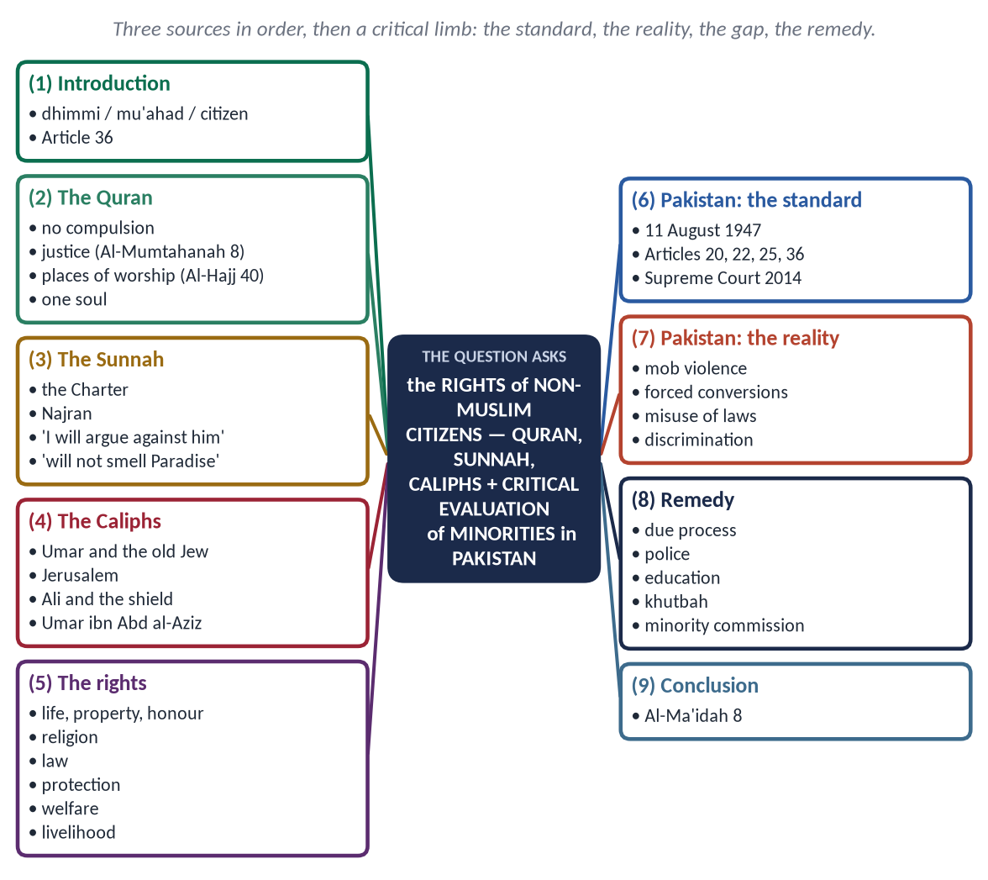
Figure 7 · The answer map: every branch is one numbered heading of the model answer below.

Decoding the question
- 'In the light of the Qur'an, Sunnah and the practice of the Rightly Guided Caliphs' — three sources, in that order.
- 'Critically evaluate' — measure Pakistan's practice against the standard: what is good, what is wrong, why, and what to do. Be factual and fair.

The model answer

(1) Introduction
The non-Muslim living in a Muslim state was called a dhimmi (one under the protection, dhimmah, of Allah and His Messenger) or mu'ahad (one under covenant). In a modern constitutional state they are equal citizens. Pakistan's Constitution promises them freedom and protection (Articles 20 and 36).

(2) The Quran
✦ QURAN
﴿لَآ إِكۡرَاهَ فِي ٱلدِّينِۖ قَد تَّبَيَّنَ ٱلرُّشۡدُ مِنَ ٱلۡغَيِّۚ …﴾
“There shall be no compulsion in religion; the right way has become clear from the wrong.” (Al-Baqarah, Quran)

✦ QURAN
﴿لَّا يَنۡهَىٰكُمُ ٱللَّهُ عَنِ ٱلَّذِينَ لَمۡ يُقَٰتِلُوكُمۡ فِي ٱلدِّينِ وَلَمۡ يُخۡرِجُوكُم مِّن دِيَٰرِكُمۡ أَن تَبَرُّوهُمۡ وَتُقۡسِطُوٓاْ إِلَيۡهِمۡۚ إِنَّ ٱللَّهَ يُحِبُّ ٱلۡمُقۡسِطِينَ﴾
“Allah does not forbid you from those who do not fight you because of religion and do not expel you from your homes - from being righteous toward them and acting justly toward them. Indeed, Allah loves those who act justly.” (Al-Mumtahanah, Quran)
➜ Birr and qist — kindness and justice to peaceful non-Muslims.

- Places of worship are protected: had Allah not checked one people by another, 'monasteries, churches, synagogues and mosques' would be destroyed (Al-Hajj 40).
- One human family: 'He created you from one soul' (An-Nisa 1).

(3) The Sunnah
✦ HADITH
أَلَا مَنْ ظَلَمَ مُعَاهَدًا، أَوِ انْتَقَصَهُ، أَوْ كَلَّفَهُ فَوْقَ طَاقَتِهِ، أَوْ أَخَذَ مِنْهُ شَيْئًا بِغَيْرِ طِيبِ نَفْسٍ، فَأَنَا حَجِيجُهُ يَوْمَ الْقِيَامَةِ
“Beware: whoever wrongs a non-Muslim under covenant, belittles him, burdens him beyond his ability or takes anything from him without his consent — I will argue against him on the Day of Resurrection.” (Abu Dawud)
➜ The Prophet ﷺ is the advocate of the minority.

✦ HADITH
مَنْ قَتَلَ مُعَاهَدًا لَمْ يَرِحْ رَائِحَةَ الْجَنَّةِ
“Whoever kills a non-Muslim living under a covenant will not smell the fragrance of Paradise.” (Al-Bukhari)

- The Charter of Madinah: the Jews of Madinah 'are a community (ummah) with the believers; to the Jews their religion and to the Muslims theirs'.
- The treaty of Najran: their churches, priests, property and worship guaranteed; their delegation prayed in the Prophet's ﷺ Mosque.
- He stood for the funeral of a Jew: 'Is it not a human soul?' (Al-Bukhari).

(4) The practice of the Rightly Guided Caliphs
- Abu Bakr (RA) ordered his armies not to harm monks in their cells.
- Umar (RA) granted the people of Jerusalem safety for 'their lives, property, churches and crosses', and refused to pray in the Church of the Holy Sepulchre lest Muslims later take it. Seeing an old Jew begging, he fixed a stipend for him from the Bayt al-Mal and exempted such people from jizyah. His last will: 'I commend to my successor the dhimmis — that their covenant be kept, that they be defended, and not be burdened beyond their ability' (Al-Bukhari).
- Ali (RA), as Caliph, lost the case of his own shield before Qadi Shurayh against a non-Muslim — the judge found Ali's evidence insufficient.
- Jizyah was a fee for protection, not a punishment: it was levied on able men of military age, in place of military service; women, children, the old, the poor and monks were exempt. When Abu Ubaydah (RA) withdrew from Hims before Yarmuk and could no longer protect its people, he returned their jizyah (Abu Yusuf, Kitab al-Kharaj). In a modern state, where all citizens serve and pay the same taxes, the institution has no place.
- Umar ibn Abd al-Aziz ordered his governors to redress every wrong done to the dhimmis and to support their poor from the Bayt al-Mal.

(5) The rights, in summary
Right | Basis
Life, property and honour | 'Will not smell Paradise'; Farewell Sermon
Freedom of religion and worship | Al-Baqarah 256; Al-Hajj 40; Najran
Equality before the law | Ali's shield; 'if Fatimah stole'
Protection and security | Umar's will; the state defends them
Social welfare | The stipend for the old Jew
Own personal law | Marriage, inheritance by their own laws
Livelihood and trade | Full freedom of work and property
Dignity | No insult to their faith (Al-An'am 108)

(6) Pakistan: the standard it set itself
✦ SCHOLARLY VIEW
Quaid-e-Azam Muhammad Ali Jinnah · Address to the Constituent Assembly, 11 August 1947
“You are free; you are free to go to your temples, you are free to go to your mosques or to any other place of worship in this State of Pakistan.”
➜ The founding promise.

The Constitution gives freedom of religion (Art. 20), safeguards in education (Art. 22), equality (Art. 25) and protection of minorities (Art. 36); the white in the national flag stands for them. In 2014 the Supreme Court directed a national council and a special police force to protect minorities' places of worship.

(7) Pakistan: the reality — a critical evaluation
- Positives: reserved seats in legislatures; minority leaders in the armed forces and judiciary; the Kartarpur Corridor (2019); strong statements by scholars after attacks; Paigham-e-Pakistan forbids violence against non-Muslims.
- Mob violence: the lynching of a Sri Lankan manager in Sialkot (2021); churches and homes burnt in Jaranwala (2023); lynchings in Sargodha and Swat (2024) — often on unproved accusations.
- Misuse of laws for personal disputes, and the lack of punishment for false accusers.
- Forced conversions and marriages of minor girls reported, especially in Sindh — against 'no compulsion'.
- Economic and social discrimination: menial jobs; hate material in some textbooks and speeches.

(8) Why the gap — and the remedy
The gap comes from ignorance of Islam's own teachings, weak policing and prosecution, political exploitation of religion, and slow courts.
- Due process: only courts decide guilt — 'if a sinner brings you news, verify it' (Al-Hujurat 6).
- Punish mob violence and false accusation swiftly.
- Teach the Sunnah of the mu'ahad in schools, khutbahs and madaris.
- A statutory National Commission for Minorities with real powers.
- Protect girls: marriage and conversion only with free, adult consent before a court.

(9) Conclusion
✦ QURAN
﴿… وَلَا يَجۡرِمَنَّكُمۡ شَنَـَٔانُ قَوۡمٍ عَلَىٰٓ أَلَّا تَعۡدِلُواْۚ ٱعۡدِلُواْ هُوَ أَقۡرَبُ لِلتَّقۡوَىٰۖ …﴾
“Do not let the hatred of a people lead you to injustice. Be just; that is nearer to righteousness.” (Al-Ma'idah, Quran)

Islam gave non-Muslims protection, dignity and justice thirteen centuries before modern minority-rights charters. Pakistan has written this standard into its Constitution; its task is to live it, so that the Prophet ﷺ is not the one who argues against us on the Day.

Why this answer scores
- Three sources in the order asked, each with evidence.
- The critical limb is balanced: positives, failures with dated facts, causes and a remedy.
- The Quaid's 11 August speech and Article 36 connect the Islamic standard to Pakistan's own promise.

Q. No. 6 · Riba and the Road to an Interest-Free Pakistan by 2028
THE QUESTION · SET 1 · Q6 · 20 marks · DIFFICULT
The Federal Shariat Court (2022) and the 26th Constitutional Amendment (2024) have fixed 1 January 2028 for the elimination of Riba from Pakistan. Explain the Islamic concept of Riba and critically analyze the challenges and the roadmap for an interest-free economy.

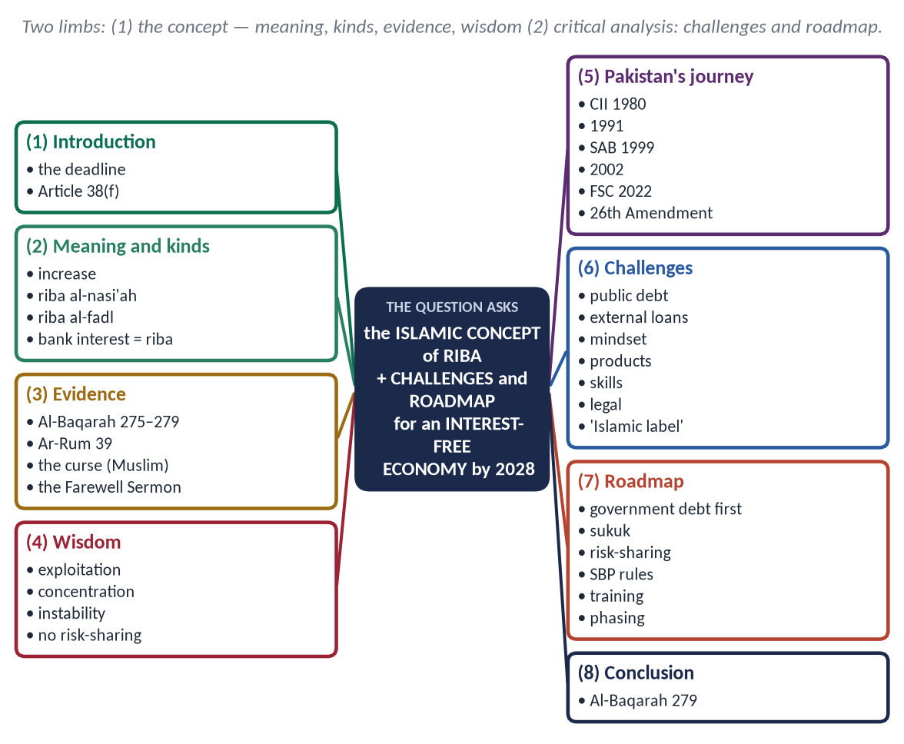
Figure 8 · The answer map: every branch is one numbered heading of the model answer below.

Decoding the question
- 'Explain the concept' — meaning, kinds, evidence and why Islam forbids it.
- 'Critically analyze' — not propaganda: state real obstacles and a practical sequence of reform, and assess whether 2028 is achievable.

The model answer

(1) Introduction
On 28 April 2022 the Federal Shariat Court declared interest-based laws un-Islamic and set a five-year deadline. The 26th Amendment (2024) wrote the target into the Constitution: riba is to be eliminated 'as early as possible and preferably by 1 January 2028' (Article 38(f)). The next paper will be written in the shadow of that date.

(2) The concept of riba
- Literal: increase, growth (raba).
- Technical: any predetermined increase over the principal of a loan, as a condition of the loan or of delay.
- Riba al-nasi'ah (riba of delay): the increase for time — the riba of the Jahiliyyah and of modern bank interest.
- Riba al-fadl (riba of excess): unequal exchange of the same commodity — 'gold for gold, silver for silver … like for like, hand to hand' (Muslim).
- Commercial and consumer interest are both riba: the FSC (2022) held that the prohibition is not limited to 'usury' or to high rates.

(3) The evidence
✦ QURAN
﴿ٱلَّذِينَ يَأۡكُلُونَ ٱلرِّبَوٰاْ لَا يَقُومُونَ إِلَّا كَمَا يَقُومُ ٱلَّذِي يَتَخَبَّطُهُ ٱلشَّيۡطَٰنُ مِنَ ٱلۡمَسِّۚ ذَٰلِكَ بِأَنَّهُمۡ قَالُوٓاْ إِنَّمَا ٱلۡبَيۡعُ مِثۡلُ ٱلرِّبَوٰاْۗ وَأَحَلَّ ٱللَّهُ ٱلۡبَيۡعَ وَحَرَّمَ ٱلرِّبَوٰاْۚ …﴾
“Those who consume riba cannot stand except as one stands who is being beaten by Satan into insanity. That is because they say, 'Trade is just like riba.' But Allah has permitted trade and forbidden riba.” (Al-Baqarah, Quran)

✦ QURAN
﴿… وَذَرُواْ مَا بَقِيَ مِنَ ٱلرِّبَوٰٓاْ إِن كُنتُم مُّؤۡمِنِينَ ۝ فَإِن لَّمۡ تَفۡعَلُواْ فَأۡذَنُواْ بِحَرۡبٖ مِّنَ ٱللَّهِ وَرَسُولِهِۦۖ وَإِن تُبۡتُمۡ فَلَكُمۡ رُءُوسُ أَمۡوَٰلِكُمۡ لَا تَظۡلِمُونَ وَلَا تُظۡلَمُونَ﴾
“… and give up what remains of riba, if you are believers. If you do not, then be informed of a war from Allah and His Messenger. But if you repent, you may have your principal — do no wrong and suffer no wrong.” (Al-Baqarah, Quran)
➜ Riba is a war with Allah and His Messenger; the lender keeps only his principal.

✦ HADITH
لَعَنَ رَسُولُ اللَّهِ ﷺ آكِلَ الرِّبَا، وَمُؤْكِلَهُ، وَكَاتِبَهُ، وَشَاهِدَيْهِ، وَقَالَ: هُمْ سَوَاءٌ
“The Messenger of Allah ﷺ cursed the one who consumes riba, the one who pays it, the one who writes it and its two witnesses, and said: they are all equal.” (Muslim)

In the Farewell Sermon he abolished the riba of his own uncle Abbas first (Muslim).

(4) The wisdom of the prohibition
- Injustice: the lender's gain is guaranteed; all the risk falls on the borrower — 'neither wronging nor being wronged'.
- Concentration of wealth: money grows by itself for those who have it (Al-Hashr 7).
- Instability: debt bubbles and crises — the global crisis of 2008 began with interest-based debt piled on debt.
- Debt slavery: households and states trapped in compound interest; Pakistan now spends a very large share of its federal revenue on interest payments.
- Islam's alternative: risk-sharing — profit is lawful when risk is shared (al-ghunm bil-ghurm: gain goes with the risk of loss).

(5) Pakistan's journey
Year | Step
1980–81 | Council of Islamic Ideology report on eliminating interest; profit-and-loss sharing accounts opened
1991 | FSC declared interest un-Islamic
1999 | Shariat Appellate Bench of the Supreme Court upheld it (23 December)
2002 | That judgment set aside and the case remanded to the FSC
2022 | FSC judgment (28 April): eliminate riba within five years
2024 | 26th Amendment: Article 38(f) — preferably by 1 January 2028

Islamic banking has grown to roughly a quarter of the banking system, and the government has issued sukuk (Islamic bonds).

(6) The challenges — a critical analysis
- Public debt: most domestic government borrowing and all IMF and commercial foreign loans carry interest; the state is the largest borrower.
- External dependence: Pakistan cannot unilaterally change the terms of foreign loans.
- Enough assets for sukuk: sukuk need real assets (roads, airports) as backing.
- The 'Islamic label' problem: critics argue that many Islamic-bank products (murabahah) imitate interest in form; real risk-sharing (mudarabah, musharakah) is small.
- Skills and law: shortage of Shariah scholars trained in finance; laws, courts and accounting built for interest.
- Mindset and trust: depositors fear loss; many see Islamic banking as the same thing with a new name.

(7) The roadmap
Stage | Measures
The state first | Convert government domestic debt to sukuk and other Shariah-compliant instruments; issue sukuk regularly
The central bank | A Shariah-compliant monetary policy tool in place of the interest-based policy rate; conversion targets for banks
Genuine risk-sharing | Push mudarabah and musharakah for SMEs, agriculture and housing; not only murabahah
Legal reform | Amend banking, contract and recovery laws; Shariah boards and audit
Skills | Train bankers, judges and accountants; Islamic finance in university courses
External finance | Negotiate Islamic structures with friendly states and the Islamic Development Bank
Social finance | Qard hasan, Zakat and Waqf funds for the poor so they do not fall to moneylenders

- Assessment: full elimination by 2028 is ambitious. Domestic banking can largely convert; foreign debt will take longer. The word 'preferably' in Article 38(f) shows that realism. What matters is steady, sincere progress, not a date alone.
- Objections answered:
- 'Interest is only compensation for inflation.' → Then index the principal honestly, or share profit and loss; a fixed return regardless of outcome remains riba.
- 'Islamic banking is interest with another name.' → The criticism is partly fair for some products; the remedy is more musharakah and mudarabah, not a return to interest.
- 'No economy can work without interest.' → Equity, trade and leasing already finance much of the world economy; interest-free finance is a matter of design and will.
✦ SCHOLARLY VIEW
M. Umer Chapra · *Towards a Just Monetary System*
An interest-free system based on equity and risk-sharing is more stable and just, because finance is tied to real production rather than to the growth of debt.
➜ The economic case, not only the religious.

(8) Conclusion
Riba is forbidden because it is injustice — to the borrower, to the poor and to the economy. Pakistan has now committed itself, in its Constitution, to leave it. The road is hard, but the Quran promises that the alternative is just: 'you may have your principal — neither wronging nor being wronged' (Al-Baqarah 279).

Why this answer scores
- The concept is exact: kinds, evidence and wisdom.
- It is critical, not a slogan: real obstacles, the 'Islamic label' debate, and a staged roadmap.
- Dates (1991, 1999, 2002, 2022, 2024) show command of Pakistan's riba story.

Q. No. 7 · Takfir, the Khawarij and Militancy — and the Answer of Paigham-e-Pakistan
THE QUESTION · SET 1 · Q7 · 20 marks · DIFFICULT
"Takfir and the rebellion of the Khawarij are the roots of militancy in the name of Islam." Analyze this statement in the light of Islamic history, and explain how 'Paigham-e-Pakistan' counters the narrative of the militants.

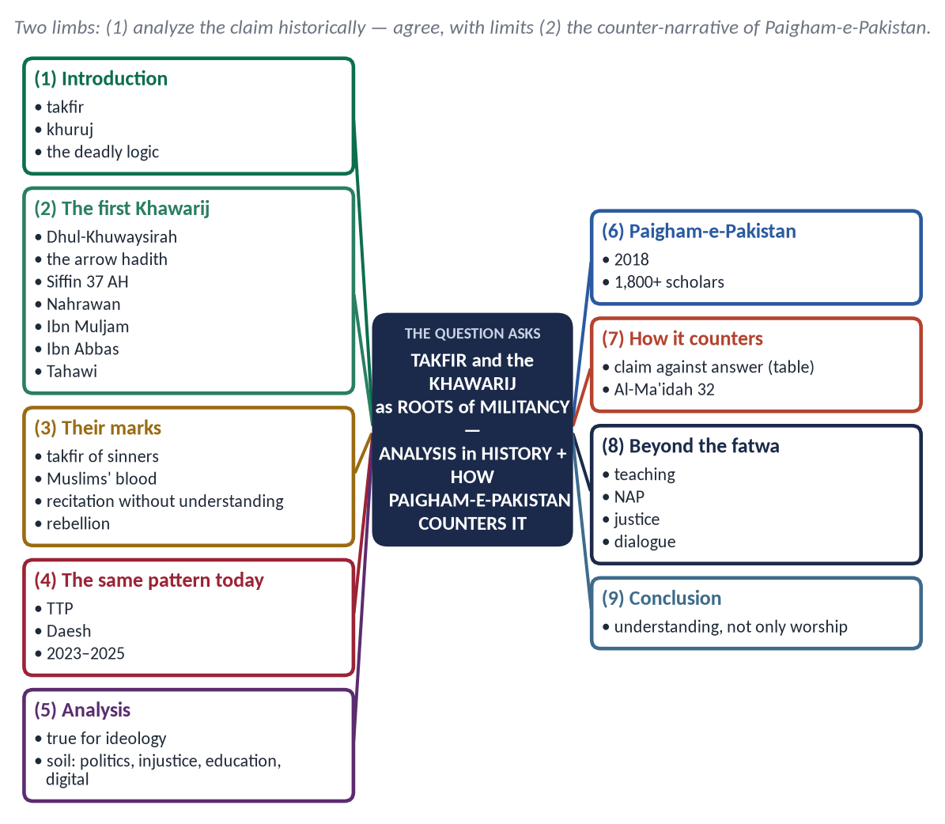
Figure 9 · The answer map: every branch is one numbered heading of the model answer below.

Decoding the question
- 'Analyze this statement' — test it: show where it is true (the ideological root) and where it is incomplete (political, social and foreign causes).
- 'In the light of Islamic history' — the first Khawarij and the Prophet's ﷺ prophecy.
- 'How Paigham-e-Pakistan counters' — name its points and show which militant claim each one answers.

The model answer

(1) Introduction
Takfir (تَكْفِير) is declaring a Muslim a disbeliever; khuruj (خُرُوج) is armed rebellion against the Muslim state. Together they make a deadly logic: 'You are not a Muslim; therefore your blood is lawful.' Every militant group — from the first Khawarij to Daesh and the TTP — has followed it.

(2) The first Khawarij in Islamic history
- The prophecy: when Dhul-Khuwaysirah accused the Prophet ﷺ of injustice in distributing booty, he said that from this man's kind would come a people:
✦ HADITH
يَقْرَءُونَ الْقُرْآنَ لَا يُجَاوِزُ حَنَاجِرَهُمْ، يَمْرُقُونَ مِنَ الدِّينِ كَمَا يَمْرُقُ السَّهْمُ مِنَ الرَّمِيَّةِ
“They will recite the Quran but it will not go beyond their throats; they will pass out of the religion as an arrow passes through its target.” (Al-Bukhari and Muslim)

✦ HADITH
يَقْتُلُونَ أَهْلَ الْإِسْلَامِ وَيَدَعُونَ أَهْلَ الْأَوْثَانِ
“They will kill the people of Islam and leave the idol-worshippers alone.” (Al-Bukhari and Muslim)
➜ The mark of the Khawarij — then and now.

- Siffin (37 AH): when Ali (RA) accepted arbitration, a group left his army crying 'la hukma illa lillah' — 'no judgement but Allah's'. Ali replied: 'A word of truth by which falsehood is intended.'
- They declared Ali, Mu'awiyah and all who accepted arbitration disbelievers, killed the Companion Abdullah ibn Khabbab and his pregnant wife, and were defeated at Nahrawan (38 AH).
- In 40 AH the Khariji Ibn Muljam martyred Ali (RA) at prayer.
- Ibn Abbas debated them with the Quran and about two thousand returned — the first de-radicalisation by dialogue.
- Later Khariji groups such as the Azariqah declared all other Muslims apostates and killed their women and children — the same logic in its most extreme form.
- The Ummah's scholarly answer was fixed in its creeds:
✦ SCHOLARLY VIEW
Imam Abu Ja'far al-Tahawi · *Al-'Aqidah al-Tahawiyyah* (Hanafi creed)
We do not declare any of the people of the Qiblah a disbeliever because of a sin, so long as he does not declare that sin lawful.
➜ The Sunni principle against takfir.

✦ HADITH
مَنْ حَمَلَ عَلَيْنَا السِّلَاحَ فَلَيْسَ مِنَّا
“Whoever raises arms against us is not of us.” (Al-Bukhari and Muslim)
➜ Armed rebellion against the Muslim community is outside the way of the Prophet ﷺ.

(3) The marks of the Khariji mind
Mark | Evidence / meaning
Takfir of Muslims for sins | 'If a man calls his brother "disbeliever", it returns to one of them' (Al-Bukhari)
Lawful blood of Muslims | 'Do not become disbelievers after me, striking one another's necks' (Al-Bukhari and Muslim)
Recitation without understanding | Verses torn from context; 'the Quran does not pass their throats'
Harshness and pride | Scorn for scholars and the Companions
Rebellion against the state | Private war instead of public authority
Youth and zeal | 'Young of age, foolish of mind' (Al-Bukhari)

(4) The same pattern today
The TTP declared Pakistan's state, army and elected system un-Islamic and attacked mosques, schools (the Army Public School, Peshawar, 2014) and markets; Daesh declared whole societies apostate. Terrorism rose sharply again in 2023–2025, with suicide attacks on police, soldiers and civilians. The ideology is the same: takfir → khuruj → killing.

(5) Analysis — is the statement complete?
- True at the ideological level: without takfir, the killing of Muslims cannot be justified; every militant manifesto begins by declaring its victims non-Muslims or apostates.
- But incomplete: ideology spreads where there is soil:
- political: occupation and foreign wars (Afghanistan, Iraq), and the use of militants as proxies;
- social: injustice, poverty, unemployment, ungoverned border areas;
- educational: literal reading without the sciences of tafsir, hadith and fiqh;
- digital: online recruitment and propaganda.
- Verdict: takfir and khuruj are the roots of the ideology; injustice and neglect are the soil. A cure must treat both.

(6) Paigham-e-Pakistan — what it is
Launched in January 2018, Paigham-e-Pakistan is a national narrative and a unanimous fatwa of more than 1,800 scholars of all schools, prepared with the International Islamic University, Islamabad. It is based on the Constitution and the Quran and Sunnah.

(7) How it counters the militant narrative
Militant claim | Paigham-e-Pakistan's answer
'Pakistan's state is un-Islamic' | Pakistan is an Islamic state under the Constitution (Art. 2, 2A, 227); declaring it or its people kafir is wrong
'We may wage jihad ourselves' | Only the state can declare jihad (qital); private armed jihad is fasad
'Suicide attacks are martyrdom' | Suicide attacks are haram; those who do them are rebels (bughat)
'Force Shariah with the gun' | Enforcing Shariah by force is rebellion; change must be peaceful and constitutional
'Kill those who differ' | No takfir of any school or person by individuals; sectarian hatred forbidden
'Minorities are enemies' | Non-Muslims' life, property and worship are protected

✦ QURAN
﴿… مَن قَتَلَ نَفۡسَۢا بِغَيۡرِ نَفۡسٍ أَوۡ فَسَادٖ فِي ٱلۡأَرۡضِ فَكَأَنَّمَا قَتَلَ ٱلنَّاسَ جَمِيعٗا …﴾
“Whoever kills a soul — unless for a soul or for corruption in the land — it is as if he had slain mankind entirely.” (Al-Ma'idah, Quran)

(8) Beyond the fatwa
A fatwa does not work alone. It needs: teaching it in madaris, schools and universities; khutbahs on it; the National Action Plan carried out; justice and development in the affected regions; counter-messaging on social media; and de-radicalisation that follows Ibn Abbas's method of dialogue.

(9) Conclusion
The Khawarij left the Ummah not for lack of worship but for lack of understanding: they made takfir their weapon and the blood of Muslims their harvest. Paigham-e-Pakistan answers them with the voice of the whole Ummah's scholarship. Its victory depends on whether we teach it, live it and remove the injustices on which the Khariji narrative feeds.

Why this answer scores
- The statement is analyzed, not simply accepted: roots (ideology) and soil (causes).
- History is exact: Siffin, Nahrawan, Ibn Muljam, Ibn Abbas's dialogue.
- Paigham-e-Pakistan is shown point against point — the examiner's 'how it counters'.

Q. No. 8 · Short Notes
THE QUESTION · SET 1 · Q8 · 20 marks (10 + 10)
Write notes on the following: (a) Sawm as a school of Taqwa: its spiritual and social wisdom (MEDIUM); (b) The letters of Hazrat Umar (RA) and Hazrat Ali (RA) to their governors as a charter of good governance (DIFFICULT).

(a) Sawm as a School of Taqwa
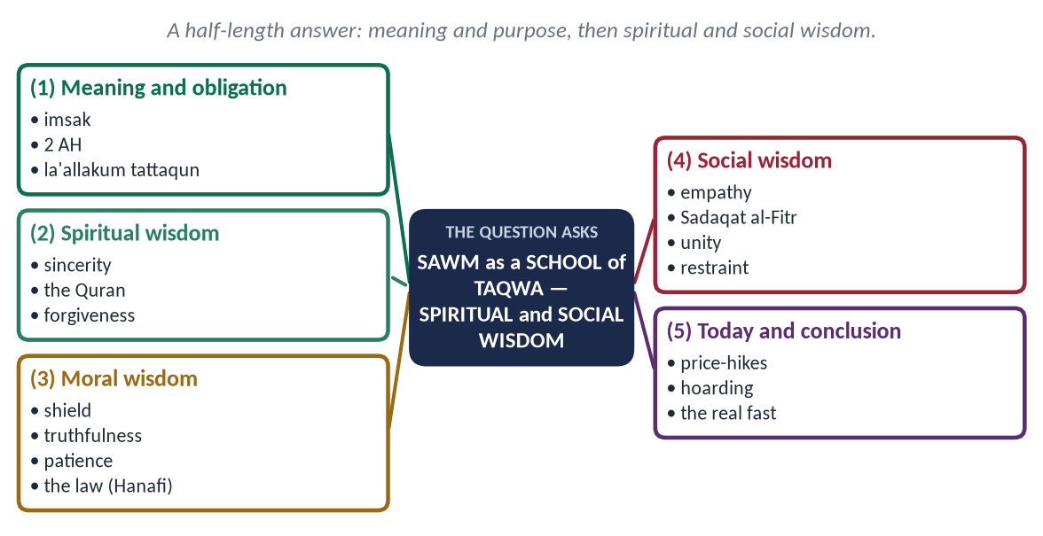
Figure 10 · The answer map: every branch is one numbered heading of the model answer below.

(1) Meaning and obligation
Sawm (صَوْم) means to hold back (imsak): abstaining from food, drink and marital relations from dawn to sunset with intention. It was made obligatory in 2 AH, in the month in which the Quran was revealed.
✦ QURAN
﴿يَـٰٓأَيُّهَا ٱلَّذِينَ ءَامَنُواْ كُتِبَ عَلَيۡكُمُ ٱلصِّيَامُ كَمَا كُتِبَ عَلَى ٱلَّذِينَ مِن قَبۡلِكُمۡ لَعَلَّكُمۡ تَتَّقُونَ﴾
“O you who have believed, decreed upon you is fasting as it was decreed upon those before you that you may become righteous.” (Al-Baqarah, Quran)
➜ The purpose of fasting in one word: taqwa.

The purpose is stated in one word: taqwa — the constant awareness of Allah that guards a person from wrong.

(2) Spiritual wisdom
- Sincerity: fasting is a secret worship — no one can see it but Allah:
✦ HADITH
كُلُّ عَمَلِ ابْنِ آدَمَ لَهُ إِلَّا الصِّيَامَ، فَإِنَّهُ لِي وَأَنَا أَجْزِي بِهِ
“Every deed of the son of Adam is for him except fasting; it is for Me, and I shall reward it.” (Al-Bukhari and Muslim)

- Closeness to the Quran: Ramadan is its month; Tarawih, the last ten nights, I'tikaf and Laylat al-Qadr, 'better than a thousand months'.
- Forgiveness: 'Whoever fasts Ramadan with faith and seeking reward will have his past sins forgiven' (Al-Bukhari and Muslim).

(3) Moral wisdom
- Self-control: 'Fasting is a shield' (Al-Bukhari and Muslim) — if the lawful is left for Allah, the unlawful is easier to leave.
- Truthfulness: 'Whoever does not give up false speech and acting upon it, Allah has no need of his giving up his food and drink' (Al-Bukhari).
- Patience and willpower: a month-long training that forms habits for the year.

(3a) The law of the fast (Hanafi)
- Exempted: the sick and the traveller (make up later), pregnant and nursing women if they fear harm, and the very old who pay fidyah — 'Allah intends for you ease' (Al-Baqarah 185).
- Breaks the fast: deliberate eating, drinking or marital relations; forgetful eating does not.
- Kaffarah: for deliberately breaking a Ramadan fast by eating or relations — sixty consecutive fasts, or feeding sixty poor people if unable.
- The law shows the balance of Islam: a firm duty with a merciful form.

(4) Social wisdom
- Empathy: the rich feel the hunger of the poor.
- Charity: Sadaqat al-Fitr — 'a purification for the fasting person and food for the poor' (Abu Dawud); most Zakat is paid in Ramadan.
- Unity: the whole Ummah fasts and breaks its fast together; iftar is shared.
- Health and discipline: a fixed rhythm of eating and sleeping.
- Economic discipline: less waste and consumption when practised as the Sunnah teaches — dates, water and moderation.
- Social peace: 'If someone abuses him, let him say: I am fasting' (Al-Bukhari and Muslim) — the fast trains a whole society in restraint.

(5) Today — and conclusion
Ramadan in Pakistan shows both faces: charity at its peak, but also price-hikes, anger and wasteful iftars. 'No one hoards except a sinner' (Muslim). The fast that produces taqwa produces honest traders, patient drivers and generous neighbours. That is Sawm as a school: a month of training for eleven months of life.

(b) The Letters of Hazrat Umar (RA) and Hazrat Ali (RA) to Their Governors
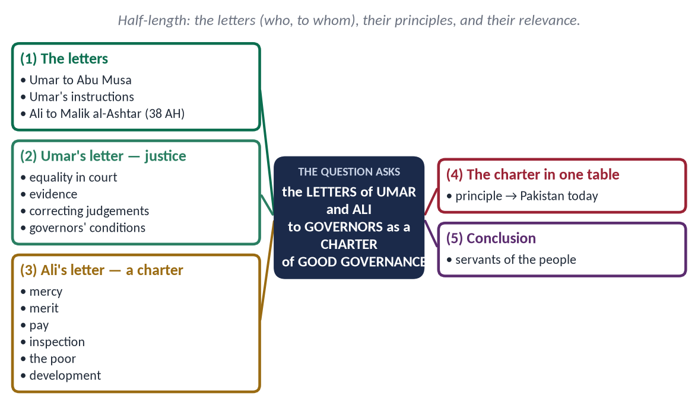
Figure 11 · The answer map: every branch is one numbered heading of the model answer below.

(1) The letters
The syllabus names these letters as a model of governance. They are among the earliest written charters of administration in history:
- Umar's letter to Abu Musa al-Ash'ari, judge of Basra — the charter of justice.
- Umar's standing instructions to his governors, and the conditions he imposed on them.
- Ali's letter to Malik al-Ashtar on appointing him governor of Egypt (38 AH), preserved in Nahj al-Balaghah — the fullest Islamic document on administration.

(2) Umar's letter — justice
✦ SCHOLARLY VIEW
Hazrat Umar ibn al-Khattab (RA) · Letter to Abu Musa al-Ash'ari
“Treat people equally in your presence, your gathering and your judgement, so that the noble do not hope for your partiality and the weak do not despair of your justice. The burden of proof is on the claimant and the oath on the one who denies.”
➜ Equality before the law and the rules of evidence.

He also told him that a judgement found to be wrong must be corrected, 'for returning to the truth is better than persisting in falsehood'.
- To all governors: 'I have not sent you as tyrants, but as leaders of guidance'; do not shut your doors against the people. Governors had to declare their assets, not ride fine horses, wear fine clothes or keep a doorkeeper; complaints were heard at Hajj every year.

(3) Ali's letter — a complete charter
✦ SCHOLARLY VIEW
Hazrat Ali ibn Abi Talib (RA) · Letter to Malik al-Ashtar
“Let your heart feel mercy, love and kindness for the people … for they are of two kinds: either your brother in religion or your equal in creation.”
➜ The citizen, Muslim or not, has a claim on the ruler's mercy.

- Merit: appoint officials after testing them, not out of favour or partiality.
- Pay: give officials enough so that they are not tempted, and so that there is proof against them if they betray.
- Inspection: send trustworthy people to watch the officials secretly.
- The poor: set aside time for the needy, 'for they are more in need of justice than others'.
- Economy: care for the development of the land more than for collecting revenue, 'for revenue comes only from development'.
- Consultation: do not consult the miser, the coward or the greedy.

(4) The charter in one table
Principle | Its meaning for Pakistan today
Equality before law | No VIP culture in courts and police stations
Open door | Accessible offices; online complaint systems that work
Merit and testing | Transparent recruitment; no political postings
Adequate pay + inspection | Pay reform with strict accountability
Care of the poor | Pro-poor budgets; social protection
Development before revenue | Growth-friendly taxation; broaden the base rather than squeeze the few

(5) Conclusion
Written thirteen centuries ago, the letters of Umar and Ali contain almost every principle of modern good governance — rule of law, merit, transparency, accountability and welfare. The Quaid told Pakistan's officers that they were servants of the people; these letters show exactly what that service means.

Why these notes score
- Each note is a complete mini-answer: meaning, evidence, headings, today, conclusion.
- Note (b) names the letters exactly (to whom, when, where preserved) — the syllabus line itself.

Prediction Set 2 — The Paper
Sit this paper under exam conditions: Part I in 30 minutes without notes, then Part II in 2 hours 30 minutes. The key and the model answers follow the paper.
FEDERAL PUBLIC SERVICE COMMISSION | Roll Number
COMPETITIVE EXAMINATION FOR RECRUITMENT TO POSTS IN BS-17
UNDER THE FEDERAL GOVERNMENT, 2027
ISLAMIC STUDIES
TIME ALLOWED: THREE HOURS | PART-I (MCQS) | MAXIMUM MARKS = 20
PART-I (MCQS): MAXIMUM 30 MINUTES | PART-II | MAXIMUM MARKS = 80
NOTE:
(i) Part-II is to be attempted on the separate Answer Book.
(ii) Attempt ONLY FOUR questions from PART-II. ALL questions carry EQUAL marks.
(iii) All the parts (if any) of each Question must be attempted at one place instead of at different places.
(iv) Write Q. No. in the Answer Book in accordance with Q. No. in the Q. Paper.
(v) No Page/Space be left blank between the answers. All the blank pages of Answer Book must be crossed.
(vi) Extra attempt of any question or any part of the question will not be considered.
PART – I (MCQS) (COMPULSORY)
Q. No. 1. (i) Select the best option/answer and fill in the appropriate box on the Answer Sheet. (20×1=20)
(ii) Answer Sheet will be taken back after 30 minutes.
(1) The guide hired by the Prophet (ﷺ) and Abu Bakr (RA) for the route of the Hijrah was:
(a) Amir ibn Fuhayrah | (b) Abdullah ibn Urayqit | (c) Abdullah ibn Abi Bakr | (d) None of these
(2) Hilf al-Fudul, the pact for the oppressed, was concluded in the house of:
(a) Abu Talib | (b) Abdullah ibn Jud'an | (c) Abd al-Muttalib | (d) None of these
(3) The Battle of Mu'tah (8 AH) was fought against:
(a) The Persians | (b) The Byzantines and their Arab allies | (c) The Quraysh | (d) None of these
(4) The incident of Ifk (the slander against Hazrat Aishah) took place on the return from the expedition against:
(a) Banu al-Mustaliq | (b) Tabuk | (c) Khaybar | (d) None of these
(5) The Prophet's (ﷺ) letter to Muqawqis, the ruler of Egypt, was carried by:
(a) Dihyah al-Kalbi | (b) Hatib ibn Abi Balta'ah | (c) Shuja' ibn Wahb | (d) None of these
(6) Which Surah is called 'Arus al-Qur'an' (the bride of the Qur'an)?
(a) Ya-Sin | (b) Ar-Rahman | (c) Al-Mulk | (d) None of these
(7) Al-Burhan fi Ulum al-Qur'an was written by:
(a) Jalal al-Din al-Suyuti | (b) Badr al-Din al-Zarkashi | (c) Ibn Kathir | (d) None of these
(8) Dhul-Qarnayn is mentioned in Surah:
(a) Al-Kahf | (b) Maryam | (c) Ta-Ha | (d) Al-Anbiya
(9) According to the Hanafi school, Tawaf al-Wada' (the farewell circuit) is:
(a) Fard | (b) Wajib | (c) Sunnah | (d) Mustahab
(10) According to the Hanafi school, the obligatory acts (fara'id) of ghusl are:
(a) Two | (b) Three | (c) Four | (d) Six
(11) Kashf al-Mahjub, the earliest treatise on Sufism in Persian, was written by:
(a) Khawaja Moinuddin Chishti | (b) Ali ibn Uthman al-Hujwiri | (c) Baba Farid Ganj Shakar | (d) None of these
(12) Shah Waliullah's translation of the Holy Qur'an, Fath al-Rahman, was in:
(a) Arabic | (b) Urdu | (c) Persian | (d) None of these
(13) Bayt al-Hikmah in Baghdad reached its height as a centre of translation under Caliph:
(a) Harun al-Rashid | (b) Al-Ma'mun | (c) Al-Mansur | (d) None of these
(14) The title 'Ghasil al-Mala'ikah' (washed by the angels) belongs to:
(a) Hamzah ibn Abd al-Muttalib | (b) Hanzalah ibn Abi Amir | (c) Mus'ab ibn Umayr | (d) None of these
(15) Hazrat Umar (RA) received the keys of Jerusalem from the Patriarch:
(a) Sophronius | (b) Heraclius | (c) Muqawqis | (d) None of these
(16) Al-Risalah, regarded as the first book on Usul al-Fiqh, was written by:
(a) Imam Abu Yusuf | (b) Imam Shafi'i | (c) Imam Malik | (d) None of these
(17) A sale in which the full price is paid in advance for goods to be delivered at a fixed future date is:
(a) Murabahah | (b) Ijarah | (c) Salam | (d) Istisna'
(18) Mishkat al-Masabih was compiled by:
(a) Imam al-Nawawi | (b) Khatib al-Tabrizi | (c) Imam al-Baghawi | (d) None of these
(19) The Prophet sent to the people of Nineveh was:
(a) Yunus | (b) Ilyas | (c) Yusha' | (d) None of these
(20) The national narrative against terrorism, 'Paigham-e-Pakistan', was launched in:
(a) 2014 | (b) 2016 | (c) 2018 | (d) None of these

PART – II
Q. No. 2. Can human reason, science and Artificial Intelligence replace Wahi (Divine Revelation) as the guide of human life? Argue in the light of the Qur'an and Sunnah. (20)
Q. No. 3. Analyze the diplomacy of the Holy Prophet (ﷺ) through his letters to the rulers and his dealings with delegations. What principles of foreign policy can Pakistan derive from them today? (20)
Q. No. 4. Islam grants women the rights of education, property, work and participation, yet Pakistan stands at the bottom of the Global Gender Gap Index. Examine the causes of this gap and suggest remedies in the light of Islamic teachings. (20)
Q. No. 5. Materialism and consumerism are the new idols of modern society. Explain the Islamic concept of Zuhd (detachment) and Qana'ah (contentment) and its role in reforming individual and collective life. (20)
Q. No. 6. The European Renaissance owes a debt to Baghdad, Cordoba and Sicily. Evaluate the impact of Islamic civilization on the West, and explain why this debt is seldom acknowledged. (20)
Q. No. 7. Is modern parliamentary democracy compatible with the Islamic concept of Shura? Examine in the light of the practice of the Rightly Guided Caliphs and the Constitution of Pakistan, 1973. (20)
Q. No. 8. Write notes on the following: (20)
(a) Zakat and the eradication of poverty: why has Zakat not eliminated poverty in Pakistan? (10)
(b) Online radicalisation and fake news: the Qur'anic principle of verification (Tabayyun) (10)
**************

Prediction Set 2 — Answer Key and Model Answers
Set 2 — The Twist Paper. The repeat engine with the twists the 2024–2026 examiner adds: revelation against AI, diplomacy for Pakistan's foreign policy, women's rights against the gender-gap data, Islam's gift to the West (the reverse of 2026), and Shura against the 1973 Constitution.

Set 2 · Part I — Answer Key
No. | Key | Answer | Level | Area | Why / the fact to remember
1 | (b) | Abdullah ibn Urayqit | D | Sirah | Abdullah ibn Urayqit, a non-Muslim trusted guide — a lesson in employing the competent. Amir ibn Fuhayrah grazed the sheep; Abdullah ibn Abi Bakr brought the news.
2 | (b) | Abdullah ibn Jud'an | D | Sirah | Abdullah ibn Jud'an in Makkah. The Prophet (ﷺ) later said he would answer such a call even in Islam.
3 | (b) | The Byzantines and their Arab allies | M | Sirah | The Byzantines and the Ghassanids. Zayd ibn Harithah, Ja'far and Abdullah ibn Rawahah fell in turn; Khalid ibn al-Walid saved the army and was called 'Sayf Allah'.
4 | (a) | Banu al-Mustaliq | D | Sirah | Banu al-Mustaliq (al-Muraysi'); her innocence was declared in An-Nur 11–20.
5 | (b) | Hatib ibn Abi Balta'ah | D | Sirah | Hatib ibn Abi Balta'ah. Muqawqis replied politely and sent gifts, including Mariyah al-Qibtiyyah.
6 | (b) | Ar-Rahman | D | Quran | Ar-Rahman, with its refrain 'Which of the favours of your Lord will you deny?' Ya-Sin is called 'the heart of the Qur'an'.
7 | (b) | Badr al-Din al-Zarkashi | D | Quran | Al-Zarkashi (d. 1392). Al-Suyuti wrote Al-Itqan (asked 2018 and 2022), building on it.
8 | (a) | Al-Kahf | M | Quran | Al-Kahf (83–98), with the People of the Cave and Musa's journey with Khidr.
9 | (b) | Wajib | D | Beliefs & worships | Wajib for pilgrims from outside the Miqat; Tawaf al-Ziyarah is the fard, Tawaf al-Qudum the sunnah.
10 | (b) | Three | D | Beliefs & worships | Three: rinsing the mouth, rinsing the nose, and washing the whole body. Wudu has four.
11 | (b) | Ali ibn Uthman al-Hujwiri | M | History & civilization | Data Ganj Bakhsh Ali Hujwiri of Lahore (he came in the time of Mas'ud Ghaznavi — asked 2025).
12 | (c) | Persian | D | History & civilization | Persian, the literary language of Muslim India; his sons Shah Rafi al-Din and Shah Abd al-Qadir produced Urdu translations.
13 | (b) | Al-Ma'mun | D | History & civilization | Al-Ma'mun (813–833), who funded the translation of Greek, Persian and Indian works; al-Khwarizmi worked there.
14 | (b) | Hanzalah ibn Abi Amir | D | Companions | Hanzalah, martyred at Uhud straight from his wedding night; the Prophet (ﷺ) said the angels were washing him.
15 | (a) | Sophronius | D | Companions | Sophronius (15/16 AH). Umar declined to pray inside the Church of the Holy Sepulchre so that it would not be turned into a mosque.
16 | (b) | Imam Shafi'i | D | Fiqh | Imam al-Shafi'i (d. 820) — the founder of Usul al-Fiqh as a science.
17 | (c) | Salam | D | Fiqh | Salam — permitted for farmers ('in a known measure, known weight, for a known term', Al-Bukhari). Istisna' is an order to manufacture.
18 | (b) | Khatib al-Tabrizi | D | Hadith | Khatib al-Tabrizi (1337) expanded al-Baghawi's Masabih al-Sunnah; al-Nawawi compiled Riyad al-Salihin.
19 | (a) | Yunus | M | Prophets | Yunus (AS) — the only nation that believed when it saw the punishment coming (Yunus 98).
20 | (c) | 2018 | D | Modern | January 2018, with a unanimous fatwa of more than 1,800 scholars of all schools against suicide attacks and armed rebellion.

Level: 16 difficult, 4 medium. Score yourself: 16 or more is excellent; 12–15 good; below 12, revise the One-Liner Bank.

Prediction Set 2 — Model Answers
Each answer follows the method of the Master Anatomy (Part Five): the answer map, the decoding of the question, headings taken from the question's words, evidence inside every heading, a figure, the contemporary and Pakistan angle, and a conclusion.

Q. No. 2 · Can Reason, Science and Artificial Intelligence Replace Wahi?
THE QUESTION · SET 2 · Q2 · 20 marks · DIFFICULT
Can human reason, science and Artificial Intelligence replace Wahi (Divine Revelation) as the guide of human life? Argue in the light of the Qur'an and Sunnah.

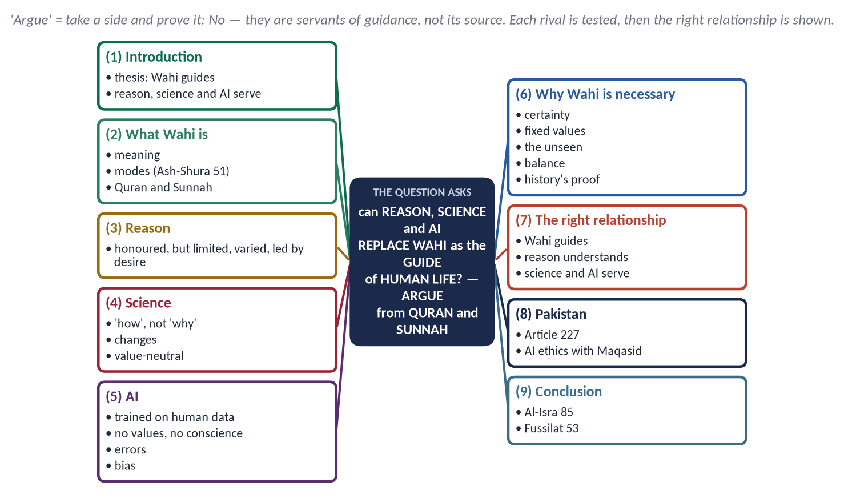
Figure 12 · The answer map: every branch is one numbered heading of the model answer below.

Decoding the question
- 'Argue' — take a clear position and defend it: No — reason, science and AI cannot replace Wahi, but Wahi welcomes them as servants.
- Three rivals: reason, science and AI. Test each separately; AI is the new, difficult part.
- 'In the light of the Qur'an and Sunnah' — every argument must rest on a verse or hadith.

The model answer

(1) Introduction
Every age thinks it has found a guide better than revelation. The eighteenth century trusted reason, the twentieth science; the twenty-first is tempted to trust Artificial Intelligence, which can write, reason and advise in seconds. The Quran's answer is the same in every age:
✦ QURAN
﴿… وَمَآ أُوتِيتُم مِّنَ ٱلۡعِلۡمِ إِلَّا قَلِيلٗا﴾
“And you have not been given of knowledge except a little.” (Al-Isra, Quran)

Thesis: reason, science and AI are gifts of Allah and tools of great power, but they cannot tell man why he lives, what is good and where he is going. Only Wahi can.

(2) What Wahi is
Wahi (وَحْي) literally means a quick, hidden communication; technically, Allah's message to His Prophets — by inspiration, from behind a veil, or through an angel (Ash-Shura 51). It is preserved in the Quran (recited revelation) and the Sunnah (unrecited revelation):
✦ QURAN
﴿وَمَا يَنطِقُ عَنِ ٱلۡهَوَىٰٓ ۝ إِنۡ هُوَ إِلَّا وَحۡيٞ يُوحَىٰ﴾
“Nor does he speak from [his own] inclination. It is not but a revelation revealed.” (An-Najm, Quran)
➜ The Prophet's ﷺ guidance is not from desire — it is revelation.

(3) Human reason — honoured but limited
Islam honours reason: the Quran asks again and again, 'Do you not reason?' But reason has four limits:
- It depends on data from the senses; it cannot reach the unseen — Allah, the soul, the Hereafter.
- It differs from person to person and age to age: the same reason that built the United States banned alcohol in 1920 and allowed it again in 1933.
- It is led by desire: 'Have you seen him who takes his desire as his god?' (Al-Jathiyah 23).
- It cannot fix final values: reason can say how to build a bomb, not whether to use it.
✦ SCHOLARLY VIEW
Imam al-Ghazali · *Al-Munqidh min al-Dalal*
After years of doubt, he found that neither the senses nor pure reason could give certainty; it came to him as a light that Allah cast into the heart.
➜ Even the sharpest mind needs guidance from above.

(4) Science — the 'how', not the 'why'
- Science describes how things work; it cannot say why we exist or what we ought to do.
- Its conclusions change with new evidence; guidance for life needs what does not change.
- It is value-neutral: the same physics gives electricity and Hiroshima.
- The Quran welcomes it: 'We will show them Our signs in the horizons and within themselves' (Fussilat 53) — science reads the signs, Wahi gives their meaning.

(5) Artificial Intelligence — the new claimant
AI appears to 'know everything'. But:
- It is made from human data. It only rearranges what humans have written — with all their errors, prejudices and desires. It is reason multiplied, not a new source above reason.
- It has no values of its own. Its 'ethics' are whatever its designers and companies set; they change with markets and laws.
- It makes confident errors ('hallucinations') and can be used for deep-fakes and propaganda.
- It has no conscience and no accountability. It will not stand before Allah; the human who uses it will: 'Every soul will be held in pledge for what it earned' (Al-Muddaththir 38).
- It cannot give purpose. Ask an AI the meaning of life and it will summarise human opinions — it cannot know.

(6) Why Wahi is necessary — the arguments
Argument | Proof
Certainty vs guess | 'Most of them follow nothing but assumption; assumption avails nothing against the truth' (Yunus 36)
No contradiction | 'Had it been from other than Allah, they would have found in it much contradiction' (An-Nisa 82)
Free of desire and interest | Revelation serves no class, company or nation (An-Najm 3–4)
Fixed moral values | Riba, alcohol, adultery forbidden for all times; reason keeps reversing itself
The unseen and the ultimate | Allah, the soul (Al-Isra 85), the Hereafter — beyond every laboratory and algorithm
Balance | Neither capitalism's greed nor communism's force; Al-Qasas 77
History's proof | Revelation turned Arabia into a just civilization in 23 years
The inimitable challenge | 'If mankind and jinn gathered to produce the like of this Quran, they could not' (Al-Isra 88)

✦ HADITH
تَرَكْتُ فِيكُمْ أَمْرَيْنِ لَنْ تَضِلُّوا مَا تَمَسَّكْتُمْ بِهِمَا: كِتَابَ اللَّهِ وَسُنَّةَ نَبِيِّهِ
“I have left among you two things; you will never go astray as long as you hold fast to them: the Book of Allah and the Sunnah of His Prophet.” (Al-Muwatta' (Malik))

(7) The right relationship — guide and servants
✦ HADITH
أَنْتُمْ أَعْلَمُ بِأَمْرِ دُنْيَاكُمْ
“You know better the affairs of your world.” (Muslim)
➜ In technical worldly matters, experience decides; in belief, worship and moral law, Wahi decides.

- Wahi sets the goals and the limits (what is right, what is forbidden).
- Reason understands Wahi and applies it through Ijtihad.
- Science and AI are tools to reach the goals: medicine, agriculture, translation of the Quran, access to hadith, climate models — all can serve.
- When they conflict with a clear text, the fault lies in our understanding or our data, not in the Creator's word: 'Does He not know, He who created?' (Al-Mulk 14).
✦ SCHOLARLY VIEW
Allama Muhammad Iqbal · *Reconstruction of Religious Thought in Islam*
The birth of Islam was the birth of inductive intellect — Islam turned man towards observation and experience; but intellect without the light of faith leaves him without direction.
➜ Reason and revelation as partners.

(8) Pakistan — applying the principle
- Article 227: no law shall be repugnant to the Quran and Sunnah — Wahi as the limit within which reason legislates.
- An AI policy guided by the Maqasid al-Shariah — protecting faith, life, intellect, family and property: privacy, no deep-fake defamation, no gambling algorithms, no replacement of human judgement in courts.
- Teaching students to verify AI output (Al-Hujurat 6).

(9) Conclusion
Reason is the eye, science the telescope and AI the most powerful lens ever made — but even the best lens needs light to see. That light is Wahi. Reason, science and AI can make life easier; only revelation can make it meaningful and just. 'We will show them Our signs in the horizons and within themselves until it becomes clear to them that it is the truth' (Fussilat 53).

Why this answer scores
- A clear thesis — the command word 'argue' is obeyed.
- Each rival is tested separately; the AI section gives reasons, not fear.
- The answer ends with the right relationship, showing that Islam welcomes knowledge.

Q. No. 3 · The Diplomacy of the Holy Prophet (ﷺ) and Pakistan's Foreign Policy
THE QUESTION · SET 2 · Q3 · 20 marks · DIFFICULT
Analyze the diplomacy of the Holy Prophet (ﷺ) through his letters to the rulers and his dealings with delegations. What principles of foreign policy can Pakistan derive from them today?

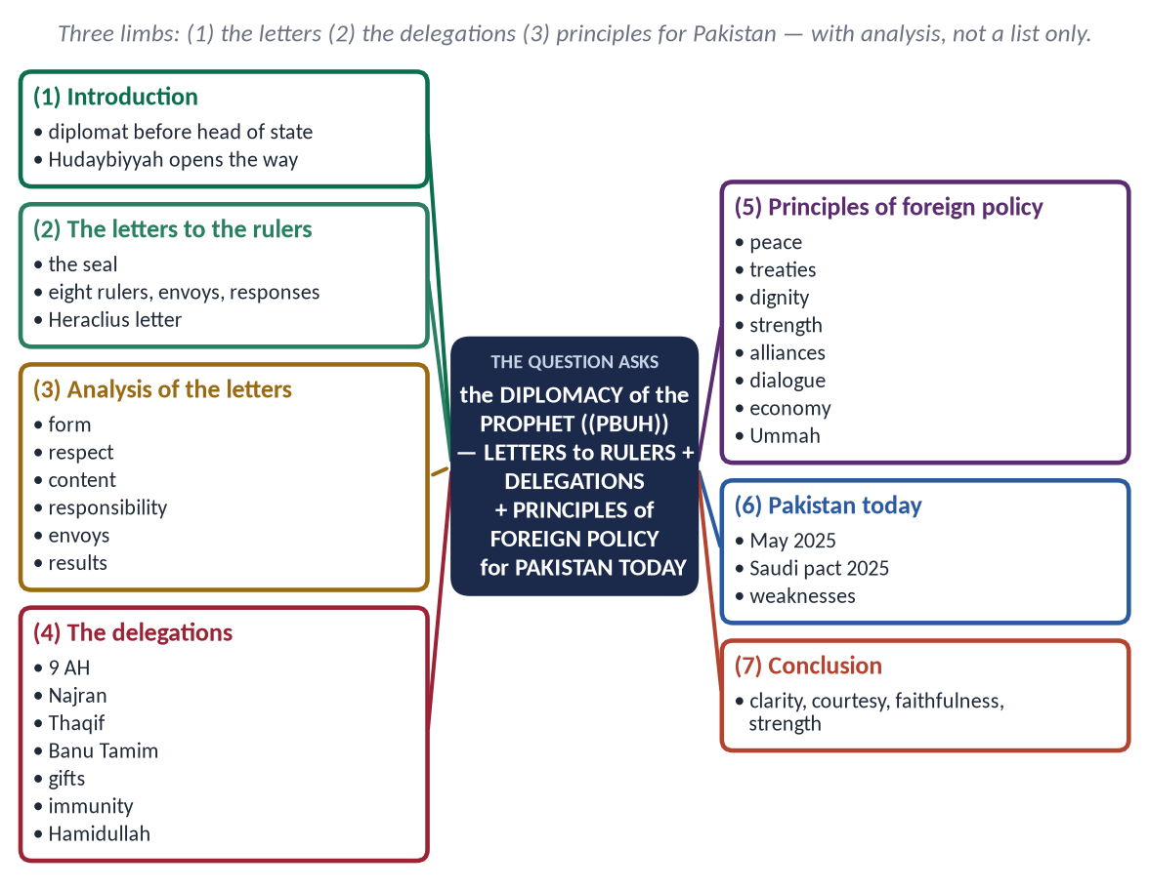
Figure 13 · The answer map: every branch is one numbered heading of the model answer below.

Decoding the question
- 'Analyze' — not only describe the letters: explain their form, content, tone and results, and what they reveal about his method.
- 'Letters to the rulers' and 'dealings with delegations' — two separate headings.
- 'Principles … Pakistan … today' — derive principles and apply them to Pakistan's present diplomacy, neutrally.

The model answer

(1) Introduction
The Prophet ﷺ was a diplomat before he was a head of state: he mediated the placing of the Black Stone, joined Hilf al-Fudul, secured asylum in Abyssinia, negotiated the Charter of Madinah and the Treaty of Hudaybiyyah. The peace of Hudaybiyyah (6 AH) opened the way for his boldest step — letters to the rulers of the world.
✦ QURAN
﴿وَمَآ أَرۡسَلۡنَٰكَ إِلَّا كَآفَّةٗ لِّلنَّاسِ بَشِيرٗا وَنَذِيرٗا وَلَٰكِنَّ أَكۡثَرَ ٱلنَّاسِ لَا يَعۡلَمُونَ﴾
“And We have not sent you except comprehensively to mankind as a bringer of good tidings and a warner. But most of the people do not know.” (Saba, Quran)
➜ His mission was to all mankind — hence letters to every power.

(2) The letters to the rulers (6–7 AH)
He had a silver seal made, inscribed 'Muhammad Rasul Allah', because kings did not accept unsealed letters (Al-Bukhari).
Ruler | Envoy | Response
Heraclius, Byzantine emperor | Dihyah al-Kalbi | Questioned Abu Sufyan; respected the letter; did not accept, fearing his nobles
Khusrau Parvez, Persia | Abdullah ibn Hudhafah al-Sahmi | Tore the letter; the Prophet ﷺ said his kingdom would be torn apart
Muqawqis, Egypt | Hatib ibn Abi Balta'ah | Polite reply and gifts (including Mariyah)
Negus (Najashi), Abyssinia | Amr ibn Umayyah al-Damri | Honoured it; had long protected the Muslims
Harith al-Ghassani, Syria | Shuja' ibn Wahb | Angry refusal
Mundhir ibn Sawa, Bahrain | Al-Ala' al-Hadrami | Accepted Islam
Jayfar and Abd, Oman | Amr ibn al-As | Accepted Islam
Hawdhah ibn Ali, Yamamah | Salit ibn Amr | Demanded a share of power; refused

✦ FROM THE SIRAH
بِسْمِ اللَّهِ الرَّحْمَنِ الرَّحِيمِ، مِنْ مُحَمَّدٍ عَبْدِ اللَّهِ وَرَسُولِهِ إِلَى هِرَقْلَ عَظِيمِ الرُّومِ، سَلَامٌ عَلَى مَنِ اتَّبَعَ الْهُدَى، أَمَّا بَعْدُ فَإِنِّي أَدْعُوكَ بِدِعَايَةِ الْإِسْلَامِ، أَسْلِمْ تَسْلَمْ، يُؤْتِكَ اللَّهُ أَجْرَكَ مَرَّتَيْنِ
“In the name of Allah, the Most Gracious, the Most Merciful. From Muhammad, the servant of Allah and His Messenger, to Heraclius, the great one of the Romans. Peace be upon whoever follows guidance. I invite you to Islam: accept Islam and you will be safe; Allah will give you your reward twice.” (Al-Bukhari)
➜ The model diplomatic letter.

(3) Analysis of the letters
- Form: brief, clear, sealed; opening with Bismillah; the sender named as 'servant of Allah and His Messenger' — humility and authority together.
- Respect: each ruler addressed by his title — 'the great one of the Romans', 'the great one of the Copts'. Firm in message, courteous in address.
- Content: an invitation, not a threat; the common word of Aal-e-Imran 64 quoted to Christian rulers.
- Responsibility: 'If you turn away, you bear the sin of your people' — the ruler answers for his subjects.
- The right envoy: Dihyah, known for dignity; Hatib, a man of wit; Amr ibn al-As, a skilled negotiator. The messenger is part of the message.
- Results: Bahrain and Oman entered Islam without war; Egypt and Abyssinia became friendly; Persia's arrogance and Byzantium's hesitation were exposed. Islam became an international message.

(4) The dealings with delegations
9 AH is called 'Am al-Wufud, the Year of Delegations: tribes and peoples came from all Arabia.
- Najran (Christians): received in the Mosque, allowed to pray there; theology discussed openly (Aal-e-Imran 59–61); when they declined the Mubahalah, a treaty protected their churches, priests and property.
- Thaqif (Ta'if): once his bitterest enemies at Ta'if; now received with a tent in the Mosque, patient negotiation and a gradual approach.
- Banu Tamim: a contest of poets and orators — answered by Thabit ibn Qays and Hassan ibn Thabit: cultural diplomacy.
- Hospitality and gifts: delegations were lodged, fed and honoured, and in his last days he told his Companions: 'Give gifts to the delegations as I used to give them' (Al-Bukhari).
- Immunity of envoys: to the envoys of the false prophet Musaylimah he said:
✦ HADITH
لَوْلَا أَنَّ الرُّسُلَ لَا تُقْتَلُ لَضَرَبْتُ أَعْنَاقَكُمَا
“Were it not that envoys are not killed, I would have struck your necks.” (Abu Dawud)
➜ Diplomatic immunity — thirteen centuries before the Vienna Convention (1961).

✦ SCHOLARLY VIEW
Dr. Muhammad Hamidullah · *The Muslim Conduct of State*
The Prophet's ﷺ treaties, letters and treatment of envoys laid the foundations of siyar — Islamic international law — long before Grotius.
➜ The scholarly verdict.

(5) Principles of foreign policy
Principle | Prophetic basis | Pakistan today
Peace as the first choice | 'If they incline to peace, incline to it' (Al-Anfal 61); Hudaybiyyah | Resolve disputes by dialogue, the UN and law; war only in self-defence
Treaties honoured | Abu Jandal returned under the treaty; 'fulfil the covenant' (Al-Isra 34) | Keep commitments; this is the source of credibility
Dignity and self-respect | Firm letters; no compromise on principle | Independent policy; no dependence that dictates choices
Strength that deters | 'Prepare against them what force you can' (Al-Anfal 60) | Credible defence as the guarantee of peace
Wise alliances | Khuza'ah allied at Hudaybiyyah; the Charter's allies | Balanced ties with China, the Gulf, the US and neighbours; the Pakistan–Saudi defence agreement (2025)
Dialogue and a common word | Aal-e-Imran 64; Najran | Interfaith and inter-civilizational dialogue; countering Islamophobia
Economic diplomacy | Trade routes secured; Khaybar sharecropping | Trade, investment and remittances as pillars of foreign policy
Unity of the Ummah | Brotherhood beyond tribes | An active role in the OIC; mediation among Muslim states
Soft power | Poets, orators, hospitality | Culture, education, media, the diaspora
Justice for the oppressed | An-Nisa 75 | Principled advocacy for Kashmir and Palestine through law and diplomacy

(6) Pakistan today — an analysis
After the India–Pakistan conflict of May 2025, Pakistan's case was carried through diplomacy — explaining its position to world capitals and accepting a ceasefire — the Prophetic pattern of strength with restraint. The Strategic Mutual Defence Agreement with Saudi Arabia (September 2025) reflects the principle of wise alliances. Yet weaknesses remain: economic dependence limits independence; relations with neighbours such as Afghanistan are troubled; and the diaspora and culture are under-used as soft power. The Prophetic model asks for economic self-reliance, credibility through kept promises, and patient dialogue — the Hudaybiyyah method.

(7) Conclusion
The Prophet ﷺ conquered more hearts with a letter and a treaty than with the sword. His diplomacy combined clarity of message, courtesy of manner, faithfulness to agreements and strength without arrogance. A Pakistan that follows these principles will be respected as a state that is firm, reliable and at peace.

Why this answer scores
- The letters are analyzed (form, tone, content, envoys, results), not only listed.
- The delegations have their own heading with named examples.
- The principles are shown in a three-column table — Prophetic basis → Pakistan today.

Q. No. 4 · Islam's Rights for Women and Pakistan's Gender Gap
THE QUESTION · SET 2 · Q4 · 20 marks · DIFFICULT
Islam grants women the rights of education, property, work and participation, yet Pakistan stands at the bottom of the Global Gender Gap Index. Examine the causes of this gap and suggest remedies in the light of Islamic teachings.

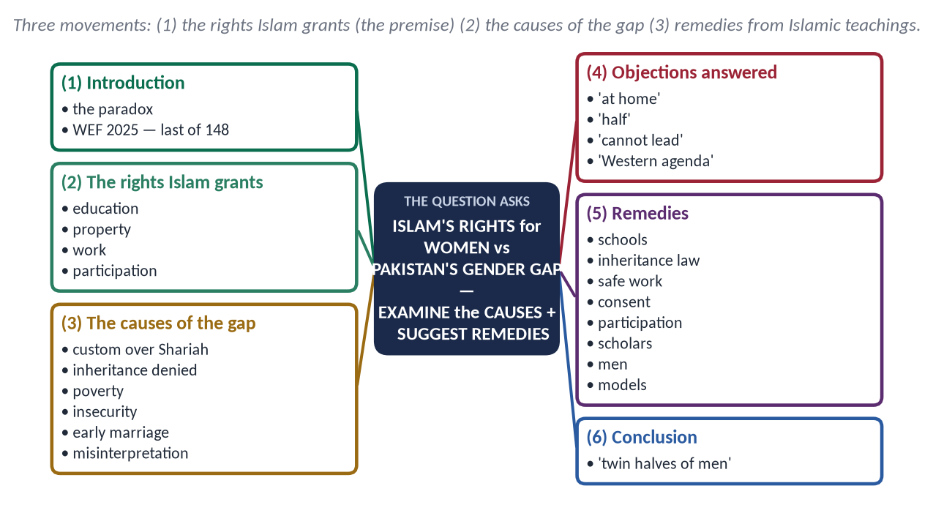
Figure 14 · The answer map: every branch is one numbered heading of the model answer below.

Decoding the question
- 'Examine the causes' — the central limb. Distinguish Islam from custom, and include economic, social and legal causes.
- 'Remedies in the light of Islamic teachings' — each remedy must rest on a verse, hadith or Companion's practice.
- Be fair and factual: the gap is not caused by Islam; it is caused by not living Islam.

The model answer

(1) Introduction
The Global Gender Gap Report 2025 of the World Economic Forum placed Pakistan last of 148 countries. Female literacy lags far behind male literacy, and only about a quarter of women are in the labour force. Yet the religion of Pakistan's people gave women these rights fourteen centuries ago. The paradox demands an honest examination.

(2) The rights Islam grants

(i) Education
✦ HADITH
طَلَبُ الْعِلْمِ فَرِيضَةٌ عَلَى كُلِّ مُسْلِمٍ
“Seeking knowledge is an obligation upon every Muslim.” (Ibn Majah)
➜ For men and women.

The Prophet ﷺ fixed a day for teaching women (Al-Bukhari); Aishah (RA) became one of the greatest jurists, teaching senior Companions; al-Shifa bint Abdullah taught Hafsah (RA) to write at the Prophet's request (Abu Dawud).

(ii) Property and inheritance
✦ QURAN
﴿… لِّلرِّجَالِ نَصِيبٞ مِّمَّا ٱكۡتَسَبُواْۖ وَلِلنِّسَآءِ نَصِيبٞ مِّمَّا ٱكۡتَسَبۡنَۚ …﴾
“For men is a share of what they have earned, and for women is a share of what they have earned.” (An-Nisa, Quran)

Mahr is hers (An-Nisa 4); her inheritance is fixed by Allah (An-Nisa 7, 11); no husband or father may take her property.

(iii) Work
Khadijah (RA) was a leading trader of Makkah; al-Shifa was appointed by Umar to supervise the market; women worked in farming, nursing (Rufaydah al-Aslamiyyah) and crafts. The only conditions are dignity and the protection of the family.

(iv) Participation
Women gave the bay'ah directly to the Prophet ﷺ (Al-Mumtahanah 12); Umm Salamah's advice resolved the crisis at Hudaybiyyah; the Quran makes men and women partners in public good:
✦ QURAN
﴿وَٱلۡمُؤۡمِنُونَ وَٱلۡمُؤۡمِنَٰتُ بَعۡضُهُمۡ أَوۡلِيَآءُ بَعۡضٖۚ يَأۡمُرُونَ بِٱلۡمَعۡرُوفِ وَيَنۡهَوۡنَ عَنِ ٱلۡمُنكَرِ …﴾
“The believing men and believing women are allies of one another; they enjoin what is right and forbid what is wrong.” (At-Tawbah, Quran)

(3) The causes of the gap
Cause | How it widens the gap
Custom above Shariah | Tribal and feudal customs (vani, swara, 'honour') treated as religion; the Quran's rights ignored
Denial of inheritance | Daughters pressured to 'give up' their share (haq bakhshwana) to keep land in the family
Poverty and preference for sons | Scarce money spent on boys' schooling and health
Distance and insecurity | No girls' school nearby; harassment on transport and at work
Early marriage | Education ends; health risks for young mothers
Low participation | Women confined to reserved seats; few in local government and decision-making
Misinterpretation | Weak narrations and cultural readings presented as Islam ('women should not study')
Weak enforcement | Good laws, slow courts, poor policing

✦ HADITH
إِنَّمَا النِّسَاءُ شَقَائِقُ الرِّجَالِ
“Women are the twin halves of men.” (Abu Dawud and Al-Tirmidhi)
➜ A society that neglects half of itself cannot rise.

Analysis: the evidence shows that where Islamic teachings are understood — education, inheritance, dignity — the gap narrows. The gap is widest where custom rules. The problem is not the Din but the distance from the Din.

(4) Objections answered
- 'Islam keeps women at home.' → Islam protects the family and dignity, not exclusion: women traded, taught, nursed the wounded and gave the bay'ah. Modesty (An-Nur 30–31) regulates conduct for both men and women; it is not a bar to learning or work.
- 'Islam gives women half.' → Only in some inheritance cases, and balanced by duties: the man pays mahr and maintenance, while her share is hers alone; in several cases she receives an equal or larger share.
- 'Women cannot lead or decide.' → The Quran praises the wise rule of the Queen of Sheba who consulted her council (An-Naml 32–35), and the Prophet ﷺ accepted Umm Salamah's counsel at Hudaybiyyah.
- 'This is a Western agenda.' → Education, property and consent are Islamic rights; defending them needs no foreign slogan.

(5) Remedies in the light of Islamic teachings
- Girls' education as a religious duty: build schools within reach, stipends for girls, female teachers — 'Whoever raises two daughters … will come with me on the Day like these two' (Muslim).
- Enforce inheritance: the Enforcement of Women's Property Rights Act 2020 and Section 498A PPC; mutation of land in the daughter's name at death — 'These are the limits of Allah' (An-Nisa 13).
- Safe work and transport: the Protection against Harassment of Women at the Workplace Act 2010; lower the gaze — men first (An-Nur 30).
- Economic empowerment: microfinance on Islamic lines, home-based enterprise, digital skills — following Khadijah's example.
- Marriage with consent and maturity: the Prophet ﷺ let Khansa bint Khidam annul a marriage made without her consent (Al-Bukhari).
- Participation: women in local councils, the judiciary and civil service — the Shura of Umm Salamah.
- Scholars and the pulpit: Friday sermons on women's rights; separate Islam from custom clearly.
- Health: maternal care and nutrition for girls — the right to life and health is the first right (Al-An'am 151).
- Role models: Fatima Jinnah; Begum Ra'ana Liaquat Ali Khan, founder of APWA (1949); Benazir Bhutto, the first woman elected to lead a Muslim-majority country (1988); scientists, doctors and pilots of today — shown in textbooks and media.
- Men's responsibility: 'The best of you are those best to their wives' (Al-Tirmidhi) — reform begins with fathers, brothers and husbands.
✦ SCHOLARLY VIEW
Quaid-e-Azam Muhammad Ali Jinnah · Speech at Aligarh, 1944
“No nation can rise to the height of glory unless your women are side by side with you.”
➜ The founder's vision.

(6) Conclusion
Pakistan's gender gap is a measure of the distance between its faith and its customs. The remedy is not to borrow a foreign model or to blame Islam, but to implement the rights Islam already gives — education, property, dignified work and a voice in public life. When the twin halves stand together, the nation stands.

Why this answer scores
- It examines causes in a table and draws a clear conclusion: custom, not Islam.
- Every remedy has an Islamic basis and a Pakistani law or policy.
- Balanced and respectful — no attack on any group.

Q. No. 5 · Zuhd and Qana'ah Against Materialism and Consumerism
THE QUESTION · SET 2 · Q5 · 20 marks · MEDIUM
Materialism and consumerism are the new idols of modern society. Explain the Islamic concept of Zuhd (detachment) and Qana'ah (contentment) and its role in reforming individual and collective life.

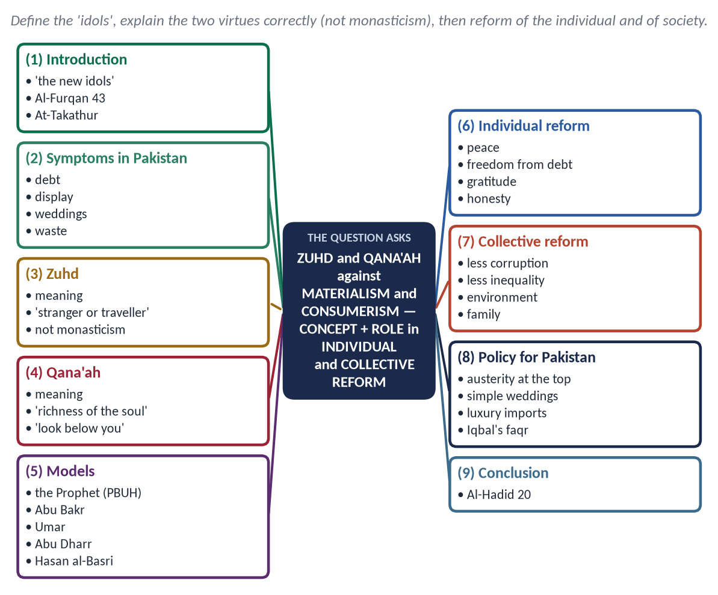
Figure 15 · The answer map: every branch is one numbered heading of the model answer below.

Decoding the question
- 'New idols' — the answer should show how materialism becomes a kind of shirk: making wealth the object of devotion.
- Explain both terms — and show that zuhd is not renouncing the world.
- Role in individual and collective life — two headings.

The model answer

(1) Introduction
Materialism is the belief that matter and wealth are the highest reality; consumerism is the culture that measures a person by what he buys and displays. Advertising, credit cards and social media have made them the idols of the age.
✦ QURAN
﴿أَلۡهَىٰكُمُ ٱلتَّكَاثُرُ ۝ حَتَّىٰ زُرۡتُمُ ٱلۡمَقَابِرَ﴾
“Competition in [worldly] increase diverts you. Until you visit the graveyards.” (At-Takathur, Quran)
➜ At-Takathur — the rivalry for more distracts until the grave.

✦ QURAN
﴿أَرَءَيۡتَ مَنِ ٱتَّخَذَ إِلَٰهَهُۥ هَوَىٰهُ أَفَأَنتَ تَكُونُ عَلَيۡهِ وَكِيلًا﴾
“Have you seen the one who takes as his god his own desire? Then would you be responsible for him.” (Al-Furqan, Quran)
➜ The one who takes his desire as his god — the modern idol.

(2) The symptoms in Pakistan
A growing culture of 'buy now, pay later' and consumer loans; Lavish weddings and dowries that push families into debt; display on social media; imported luxuries in a country that borrows to pay its bills; bribes to maintain a lifestyle; waste of food while many go hungry.

(3) Zuhd — detachment
- Meaning: zuhd (زُهْد) is to hold the world in the hand, not in the heart — to use it without being owned by it.
✦ HADITH
كُنْ فِي الدُّنْيَا كَأَنَّكَ غَرِيبٌ أَوْ عَابِرُ سَبِيلٍ
“Be in this world as though you were a stranger or a traveller passing through.” (Al-Bukhari)
➜ The traveller uses the world without being owned by it.

- Not monasticism: 'Who has forbidden the adornment of Allah which He produced for His servants?' (Al-A'raf 32); 'Do not forget your share of the world' (Al-Qasas 77). The Prophet ﷺ married, traded and ate good food; he forbade the Companions who wanted to abandon sleep, marriage or food.
- The Quranic definition: 'So that you do not despair over what has escaped you, nor exult over what He has given you' (Al-Hadid 23).
✦ SCHOLARLY VIEW
Imam al-Ghazali · *Ihya' Ulum al-Din*, the Book of Poverty and Zuhd
Zuhd is to turn the heart's desire away from something to what is better than it — from the passing to the lasting.
➜ Zuhd is a direction of the heart, not poverty.

(4) Qana'ah — contentment
- Meaning: qana'ah (قَنَاعَة) is being satisfied with what Allah has given after lawful effort.
✦ HADITH
لَيْسَ الْغِنَى عَنْ كَثْرَةِ الْعَرَضِ، وَلَكِنَّ الْغِنَى غِنَى النَّفْسِ
“Richness is not in having many goods; true richness is the richness of the soul.” (Al-Bukhari and Muslim)

✦ HADITH
قَدْ أَفْلَحَ مَنْ أَسْلَمَ، وَرُزِقَ كَفَافًا، وَقَنَّعَهُ اللَّهُ بِمَا آتَاهُ
“He has succeeded who accepts Islam, is given sufficient provision, and whom Allah makes content with what He has given him.” (Muslim)

- The method: 'Look at those below you, not at those above you' (Muslim) — the cure of comparison, which is the engine of consumerism.
- Not laziness: contentment follows effort — 'tie your camel, then trust'.

(5) The models
The Prophet ﷺ slept on a mat that marked his side; Umar wept, and he said: 'Are you not pleased that they have this world and we the Hereafter?' (Al-Bukhari). Abu Bakr gave all his wealth for Tabuk; Umar ruled an empire in a patched cloak; Abu Dharr warned against hoarding; Hasan al-Basri taught that the world is a bridge, not a home.

(6) Role in reforming individual life
- Peace of mind: freedom from the endless race — 'hearts find rest in the remembrance of Allah' (Ar-Ra'd 28).
- Freedom from debt and from the anxiety of display.
- Honesty: a contented person does not need bribes.
- Gratitude: 'If you are grateful, I will increase you' (Ibrahim 7).
- Generosity: what is not needed is given.
- Time for what matters: family, knowledge, worship.
- Health: moderation in food — 'The son of Adam fills no vessel worse than his stomach' (Al-Tirmidhi).

(7) Role in reforming collective life
Social problem of consumerism | How zuhd and qana'ah reform it
Corruption | Officials content with lawful income; Umar's governors forbidden luxury
Inequality and classism | Less display, less envy; wealth circulated (Al-Hashr 7)
Debt — household and national | Spending within means; fewer imported luxuries
Waste | 'The wasteful are brothers of the devils' (Al-Isra 27)
Environmental damage | Moderate use of resources; wudu with a little water even at a flowing river (Ibn Majah)
Family breakdown | Simple marriages — 'the most blessed marriage is the one with least burden' (Ahmad)

(8) Policy for Pakistan
- Austerity at the top: the Caliphs lived simply so that the people would; official luxury — convoys, protocol, imported cars — should end.
- Simple weddings: enforce the provincial one-dish limits on marriage functions; discourage dowry, as the Prophet ﷺ married his daughter Fatimah (RA) with the simplest gifts.
- Discourage luxury imports and encourage saving and investment over display.
- Consumer education in schools: needs versus wants; the ethics of advertising.
✦ SCHOLARLY VIEW
Allama Muhammad Iqbal · *Faqr* in his poetry
Iqbal's faqr is not beggary but the self-respect of one who needs nothing from anyone but Allah — the faqr of Ali and of the Companions who ruled the world yet owned little.
➜ Zuhd as strength, not weakness.

(9) Conclusion
✦ QURAN
﴿ٱعۡلَمُوٓاْ أَنَّمَا ٱلۡحَيَوٰةُ ٱلدُّنۡيَا لَعِبٞ وَلَهۡوٞ وَزِينَةٞ وَتَفَاخُرُۢ بَيۡنَكُمۡ وَتَكَاثُرٞ فِي ٱلۡأَمۡوَٰلِ وَٱلۡأَوۡلَٰدِۖ …﴾
“Know that the life of this world is but play and amusement, adornment, boasting to one another and rivalry in wealth and children.” (Al-Hadid, Quran)

Zuhd and qana'ah do not ask a Muslim to leave the world; they ask him to keep it in its place. A contented individual is free; a contented society is just. Against the idols of consumerism, they restore the one freedom that matters — freedom from everything except Allah.

Why this answer scores
- Both terms are defined precisely and zuhd is protected from the monastic misunderstanding.
- Individual and collective roles are separate, the second in a problem–solution table.
- Pakistan's symptoms make the answer contemporary.

Q. No. 6 · The Impact of Islamic Civilization on the West
THE QUESTION · SET 2 · Q6 · 20 marks · DIFFICULT
The European Renaissance owes a debt to Baghdad, Cordoba and Sicily. Evaluate the impact of Islamic civilization on the West, and explain why this debt is seldom acknowledged.

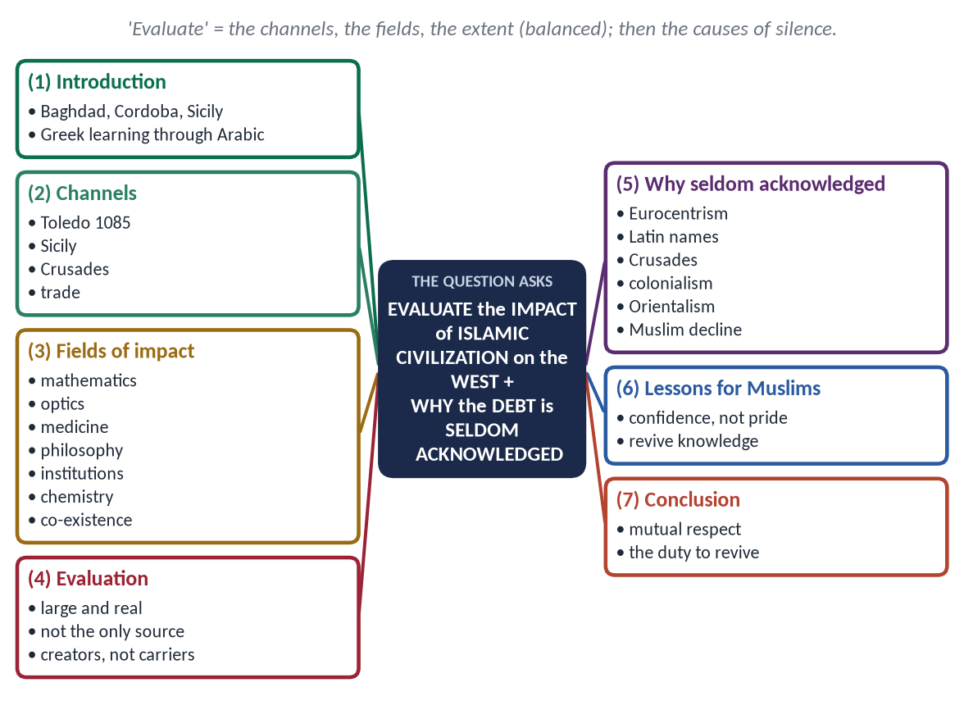
Figure 16 · The answer map: every branch is one numbered heading of the model answer below.

Decoding the question
- 'Evaluate' — show the channels and the fields, then judge the extent fairly: the debt is real and large, but Greek, Roman and Christian sources also mattered.
- 'Why … seldom acknowledged' — give causes, historical and intellectual.
- This is the reverse of 2026 Q4 (the West's impact on Muslims): the syllabus says 'impact on the West and vice versa'.

The model answer

(1) Introduction
When Europe was in its 'Dark Ages', Baghdad's Bayt al-Hikmah, Cordoba's 400,000-volume library and the courts of Sicily were the centres of the world's learning. The Renaissance is often called the 'rebirth' of Greek learning — but Greek learning reached Europe largely through Arabic, enriched by five centuries of Muslim research.
✦ QURAN
﴿ٱقۡرَأۡ بِٱسۡمِ رَبِّكَ ٱلَّذِي خَلَقَ ۝ خَلَقَ ٱلۡإِنسَٰنَ مِنۡ عَلَقٍ ۝ ٱقۡرَأۡ وَرَبُّكَ ٱلۡأَكۡرَمُ ۝ ٱلَّذِي عَلَّمَ بِٱلۡقَلَمِ ۝ عَلَّمَ ٱلۡإِنسَٰنَ مَا لَمۡ يَعۡلَمۡ﴾
“Recite in the name of your Lord who created. Created man from a clinging substance. Recite, and your Lord is the most Generous. Who taught by the pen. Taught man that which he knew not.” (Al-Alaq, Quran)
➜ The first revelation commanded reading and the pen — the seed of a scientific civilization.

(2) The channels of transmission
- Spain (al-Andalus): after the Christian capture of Toledo (1085), scholars such as Gerard of Cremona translated scores of Arabic works into Latin.
- Sicily: the Norman king Roger II kept Muslim scholars at court; al-Idrisi made his world map (1154) there.
- The Crusades and trade through Venice and Genoa brought goods, techniques and ideas.
- Ottoman contact in the later period.

(3) The fields of impact

(i) Mathematics and astronomy
- Al-Khwarizmi gave the words algebra (al-jabr) and algorithm (from his name); the Hindu-Arabic numerals and zero reached Europe through Arabic, spread by Fibonacci's *Liber Abaci* (1202).
- Muslim astronomers (al-Battani, al-Tusi) corrected Ptolemy; many star names — Aldebaran, Altair — are Arabic.

(ii) Optics and the experimental method
Ibn al-Haytham's *Kitab al-Manazir* was translated into Latin and shaped the optics of Roger Bacon and later Kepler; his insistence on experiment anticipated the scientific method.

(iii) Medicine
Ibn Sina's *al-Qanun fi al-Tibb* was a textbook in European universities for centuries; al-Razi distinguished smallpox from measles; al-Zahrawi's surgical encyclopaedia and instruments were used in Europe; the bimaristan (hospital) was a Muslim institution.

(iv) Philosophy
Ibn Rushd (Averroes) was known in Europe as 'the Commentator' on Aristotle; his defence of reason influenced Thomas Aquinas and gave rise to 'Latin Averroism' at Paris.

(v) Institutions, technology and culture
- Universities: al-Qarawiyyin in Fez (859), founded by Fatimah al-Fihri, and al-Azhar preceded Europe's universities.
- Paper came through the Muslim world from China to Spain and then Europe.
- Architecture: the pointed arch and ribbed vaults of Muslim Spain; agriculture: irrigation, and crops such as sugar cane, cotton and citrus.
- Words: algebra, alcohol, alchemy, admiral, cipher, sugar, cotton, coffee — the vocabulary records the debt.
✦ SCHOLARLY VIEW
Robert Briffault · *The Making of Humanity* (1919)
The debt of science to the Arabs does not consist only in startling discoveries; science owes a great deal more to Arab culture — it owes its existence.
➜ The strongest Western acknowledgement.

✦ SCHOLARLY VIEW
King Charles III (then Prince of Wales) · 'Islam and the West', Oxford Centre for Islamic Studies, 1993
Medieval Islam contributed much to European civilization, and that debt has been largely forgotten in the West.
➜ The theme of the question, stated by a Western head of state.

(vi) Chemistry, geography and navigation
- Jabir ibn Hayyan and later chemists developed distillation, crystallisation and laboratory apparatus; the alembic and the word chemistry (from al-kimiya) passed to Europe.
- Al-Idrisi's world map, the Muslim astrolabe and Arab navigational knowledge helped Europe's age of exploration.

(vii) A culture of co-existence
In Cordoba, Muslims, Christians and Jews lived and studied together; the Jewish philosopher Maimonides wrote his Guide for the Perplexed in Arabic. Europe met in al-Andalus a model of learned pluralism centuries before its own wars of religion ended.

(4) Evaluation — the extent of the debt
- Large and real: in mathematics, medicine, optics, philosophy and institutions, Europe built directly on Muslim work.
- Not the only source: Greek, Roman and Byzantine heritage, and Europe's own later creativity (printing, the scientific revolution) also matter.
- The fair verdict: Muslims were not only 'carriers' of Greek learning but creators who added the experimental method, algebra, clinical medicine and new institutions. Modern historians such as George Saliba have shown direct links, for example between Muslim astronomers and Copernicus.

(5) Why is the debt seldom acknowledged?
Cause | Explanation
Eurocentric history | The story 'Greece → Rome → Renaissance' leaves out the Muslim centuries
Latinised names | Avicenna, Averroes, Alhazen, Rhazes — readers did not know they were Muslims
Crusades and rivalry | A religious enemy could not easily be credited as a teacher
Colonialism | The colonised had to be shown as backward to justify colonial rule
Orientalism | Edward Said (Orientalism, 1978) showed how the West constructed a static, inferior 'East'
Muslim decline | Muslims themselves forgot their own heritage and stopped producing knowledge

(6) Lessons for Muslims
The debt is a source of confidence, not pride. The same civilization that taught Europe declined when it stopped thinking. The lesson is to revive the culture of knowledge — research as fard kifayah, universities of quality, translation and ijtihad — and to engage the West as partners in a shared human heritage.
✦ HADITH
الْكَلِمَةُ الْحِكْمَةُ ضَالَّةُ الْمُؤْمِنِ، فَحَيْثُ وَجَدَهَا فَهُوَ أَحَقُّ بِهَا
“A word of wisdom is the lost property of the believer; wherever he finds it, he has the best right to it.” (Al-Tirmidhi)
➜ Muslims once took wisdom from all and gave it to all — its chain is weak, but its meaning agrees with Az-Zumar 18.

(7) Conclusion
Baghdad, Cordoba and Sicily lit lamps that Europe carried into its Renaissance. The debt is seldom acknowledged because of old rivalries and new prejudices — and because Muslims themselves stopped adding to it. Recognising it builds mutual respect between civilizations; reviving it is the duty of Muslims today.

Why this answer scores
- Channels → fields → evaluation → causes of silence: the full command 'evaluate … explain why'.
- Names, books and dates show real knowledge; two Western acknowledgements strengthen the case.
- The evaluation is balanced, and the conclusion turns the lesson back on Muslims.

Q. No. 7 · Shura and Parliamentary Democracy: The Caliphs and the 1973 Constitution
THE QUESTION · SET 2 · Q7 · 20 marks · DIFFICULT
Is modern parliamentary democracy compatible with the Islamic concept of Shura? Examine in the light of the practice of the Rightly Guided Caliphs and the Constitution of Pakistan, 1973.

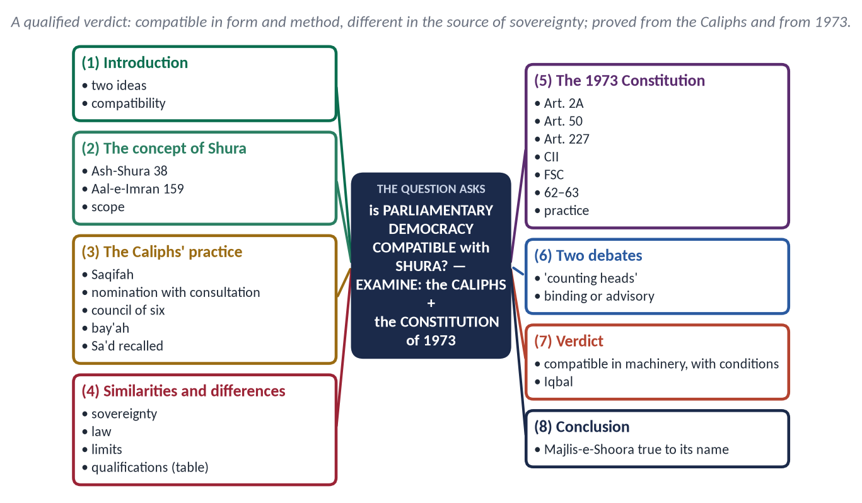
Figure 17 · The answer map: every branch is one numbered heading of the model answer below.

Decoding the question
- 'Is … compatible?' — a yes/no question that needs a qualified verdict with reasons.
- 'Examine' — test the claim against two bodies of evidence: the Caliphs' practice and the 1973 Constitution.
- Define both terms first, then compare in a table.

The model answer

(1) Introduction
Shura (شُورَىٰ) means mutual consultation. Parliamentary democracy is a system in which the people elect representatives, the government is drawn from and answerable to parliament, and law is made by majority. Muslims have long asked whether the two can live together. The answer lies in what the Caliphs did and in what Pakistan's Constitution says.

(2) The concept of Shura
✦ QURAN
﴿… وَأَمۡرُهُمۡ شُورَىٰ بَيۡنَهُمۡ …﴾
“And their affairs are (decided by) consultation among them.” (Ash-Shura, Quran)
➜ Shura is a character of the believing community.

✦ QURAN
﴿… وَشَاوِرۡهُمۡ فِي ٱلۡأَمۡرِۖ …﴾
“And consult them in the matter.” (Aal-e-Imran, Quran)
➜ Revealed after Uhud — even after the consultation had led to loss.

✦ HADITH
الْمُسْتَشَارُ مُؤْتَمَنٌ
“The one who is consulted is in a position of trust.” (Abu Dawud and Al-Tirmidhi)
➜ An adviser must give honest advice.

Scope: Shura operates within the Quran and Sunnah; on what is clearly settled by revelation there is no vote.

(3) The practice of the Rightly Guided Caliphs
- Abu Bakr (RA): chosen after debate at Saqifah Bani Sa'idah, then given the public bay'ah in the Mosque. His first address:
✦ FROM THE SIRAH
فَإِنِّي قَدْ وُلِّيتُ عَلَيْكُمْ وَلَسْتُ بِخَيْرِكُمْ، فَإِنْ أَحْسَنْتُ فَأَعِينُونِي، وَإِنْ أَسَأْتُ فَقَوِّمُونِي
“I have been given authority over you, though I am not the best of you. If I do well, help me; if I do wrong, set me right.” (Ibn Hisham)

- Umar (RA): nominated by Abu Bakr after consulting senior Companions, then accepted by public bay'ah. He ran a standing council of Muhajirin and Ansar and consulted even on the Hijri calendar and the land of Iraq: 'There is no Caliphate without consultation.'
- Uthman (RA): chosen by the council of six named by Umar; Abd al-Rahman ibn Awf consulted the people of Madinah, even women and travellers, for three days.
- Ali (RA): given the bay'ah by the people of Madinah in a time of crisis.
- Accountability of governors: when the people of Kufa complained against their governor Sa'd ibn Abi Waqqas, Umar sent inspectors to ask in every mosque, and recalled him (Al-Bukhari) — even a Companion of the first rank was answerable to the people.
- Lessons: no heredity; consent of the people; consultation in governance; accountability — a citizen could question Umar in public.

(4) Similarities and differences
Point | Shura (Islam) | Parliamentary democracy
Sovereignty | Allah; people exercise authority as a trust | The people
Source of law | Quran and Sunnah + ijtihad | The will of the majority
Limits | Cannot make lawful what Allah forbade | Any law with a majority
Choice of rulers | Consent and bay'ah | Elections
Qualifications | Knowledge, piety, competence, trust | Mostly legal and political
Accountability | To the people and to Allah | To parliament and voters
Rights | Given by Allah; cannot be voted away | Constitutional; can be amended
Parties | Not prescribed; allowed if not divisive | Central

Similarities: both reject hereditary and absolute rule; both require consent, representation, accountability and the rule of law. Differences: in Islam sovereignty belongs to Allah, and the majority cannot override revelation.

(5) The Constitution of Pakistan, 1973
- Article 2A (Objectives Resolution): sovereignty belongs to Allah; authority is a sacred trust exercised through the chosen representatives of the people — Shura in constitutional language.
- Article 50: Parliament is named the Majlis-e-Shoora.
- Article 227: no law shall be repugnant to the Quran and Sunnah.
- The Council of Islamic Ideology (Arts 228–230) advises Parliament; the Federal Shariat Court (Art. 203-D) can strike down un-Islamic laws.
- Articles 62–63: qualifications of honesty and good character for members.
- Critical note: in practice the CII's reports are rarely debated, and dynastic parties, money in elections and weak internal democracy fall short of the Caliphs' standard.

(6) Two debates answered
- 'Democracy counts heads; it does not weigh them.' Iqbal's famous criticism (in Zarb-e-Kalim) warns against rule by numbers without quality. The Islamic answer is not to abolish elections but to add qualifications (Arts 62–63 applied fairly), expert councils (the classical ahl al-hall wa al-'aqd) and limits set by revelation.
- Is Shura binding or advisory? Classical jurists mostly treated it as advisory to the ruler; many modern scholars hold that decisions on public affairs should follow the majority of the representatives. The Caliphs usually followed the majority on open questions (Uhud before them; Iraq's land under Umar), but held firm where a clear text or principle was at stake — as Abu Bakr did in collecting Zakat from those who refused it. A parliament that is bound by the Constitution reflects this balance.

(7) Verdict
Parliamentary democracy is compatible with Shura in its machinery — elections, representation, debate, majority decisions on open questions, and accountability — provided that sovereignty is Allah's and the legislature works within the Quran and Sunnah. Pakistan's Constitution is an attempt at exactly this synthesis.
✦ SCHOLARLY VIEW
Allama Muhammad Iqbal · *Reconstruction of Religious Thought in Islam* (Lecture VI)
The transfer of the power of ijtihad from individual representatives of schools to a Muslim legislative assembly is the only possible form ijma' can take in modern times.
➜ Parliament as the modern forum of Shura and collective ijtihad.

(8) Conclusion
Shura is not a Western import but a Quranic command. The Caliphs showed that rulers must be chosen by consent, must consult, and can be corrected. Modern democracy offers the tools; Islam gives the limits and the soul. When Pakistan's Majlis-e-Shoora lives up to its name, the two meet.

Why this answer scores
- A qualified verdict — the honest answer to 'is it compatible?'
- Both bodies of evidence named in the question — the Caliphs and 1973 — have their own headings.
- A comparison table and Iqbal's view give depth.

Q. No. 8 · Short Notes
THE QUESTION · SET 2 · Q8 · 20 marks (10 + 10)
Write notes on the following: (a) Zakat and the eradication of poverty: why has Zakat not eliminated poverty in Pakistan? (MEDIUM); (b) Online radicalisation and fake news: the Qur'anic principle of verification (Tabayyun) (DIFFICULT).

(a) Zakat and Poverty in Pakistan
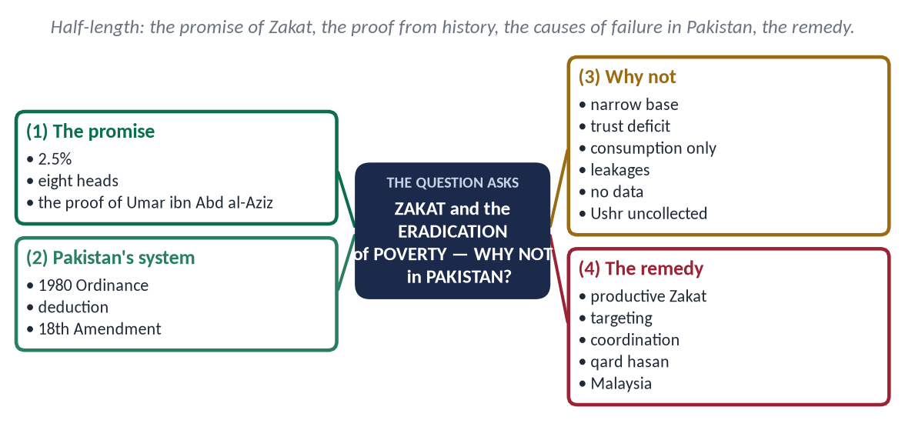
Figure 18 · The answer map: every branch is one numbered heading of the model answer below.

(1) The promise
Zakat is a yearly transfer of 2.5% of idle wealth above the nisab to the eight heads of At-Tawbah 60. The Prophet ﷺ described its purpose:
✦ HADITH
تُؤْخَذُ مِنْ أَغْنِيَائِهِمْ فَتُرَدُّ عَلَى فُقَرَائِهِمْ
“It is taken from their rich and returned to their poor.” (Al-Bukhari and Muslim)
➜ A built-in welfare system in every community.

History proves it works: in the caliphate of Umar ibn Abd al-Aziz, collectors in some provinces could find no one to accept Zakat.

(2) Pakistan's system
The Zakat and Ushr Ordinance 1980 set up Zakat councils and compulsory deduction from bank accounts on the first of Ramadan; after the 18th Amendment (2010) Zakat became a provincial subject. Yet about two-fifths of Pakistanis live below the poverty line.

(3) Why Zakat has not eliminated poverty
- A narrow base: only bank deposits and a few assets are deducted; many withdraw funds before Ramadan or file exemptions.
- Trust deficit: most Pakistanis give Zakat privately; the state collects only a small part.
- Consumption, not rehabilitation: small cash grants that feed a family for a month but do not lift it out of poverty.
- Leakages and politics: weak targeting, political influence in local committees.
- No data link: Zakat bodies, BISP and Bayt-ul-Mal work separately.
- Zakat alone is not the whole system: riba, hoarding, weak inheritance and injustice keep creating poverty faster than Zakat removes it.
- Ushr and agricultural wealth — the largest potential source — are hardly collected by the state; business stock, gold and property are left to private conscience.
- No welfare vision: under Umar (RA) Zakat was one part of a system of stipends, a registry (diwan) and public works; today it works alone.

(4) The remedy
- Productive Zakat: tools, livestock, a shop — 'the upper hand is better than the lower hand' (Al-Bukhari and Muslim); Umar: 'When you give, make them free of need.'
- Digital targeting through the national socio-economic registry; audited, published accounts.
- Coordination of Zakat, BISP, Bayt-ul-Mal, waqf and trusted charities.
- Qard hasan microfinance for the working poor; skills training.
- Assess modern wealth properly: shares, savings certificates, business stock, rental income and gold are all zakatable; honest self-assessment would multiply collections.
- Zakat is not a tax: it is worship with fixed rates and fixed recipients; it must never be spent on general government expenses.
- Remove the causes: riba (Al-Baqarah 276: 'Allah destroys riba and increases charity'), hoarding and denial of inheritance.
- Model to learn from: Malaysia's state Zakat centres use professional management, online payment and published accounts, and Muslims pay willingly; trust follows transparency.
Zakat can end poverty — when it is honest, organised and productive, and part of a just economy.

(b) Online Radicalisation and the Principle of Tabayyun
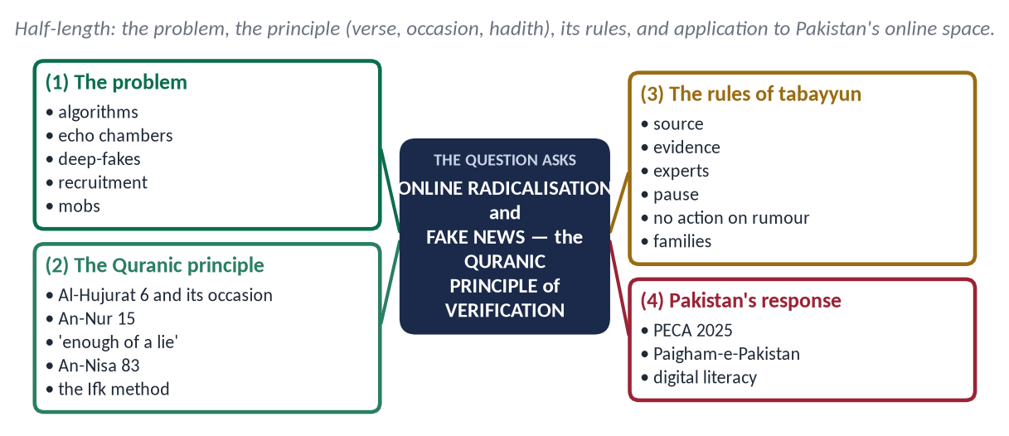
Figure 19 · The answer map: every branch is one numbered heading of the model answer below.

(1) The problem
Social media rewards anger and speed. Algorithms push users into echo chambers; militant groups recruit through encrypted apps; deep-fakes put false words in real mouths; rumours of blasphemy have triggered mob violence (Sialkot 2021, Jaranwala 2023). Radicalisation now begins on a phone.

(2) The Quranic principle
✦ QURAN
﴿يَـٰٓأَيُّهَا ٱلَّذِينَ ءَامَنُوٓاْ إِن جَآءَكُمۡ فَاسِقُۢ بِنَبَإٖ فَتَبَيَّنُوٓاْ أَن تُصِيبُواْ قَوۡمَۢا بِجَهَٰلَةٖ فَتُصۡبِحُواْ عَلَىٰ مَا فَعَلۡتُمۡ نَٰدِمِينَ﴾
“O you who have believed, if there comes to you a disobedient one with information, investigate, lest you harm a people out of ignorance and become, over what you have done, regretful.” (Al-Hujurat, Quran)
➜ Tabayyun — verify the news of the unreliable before acting, lest you harm a people in ignorance.

- Occasion: a report that the tribe of Banu al-Mustaliq had refused Zakat and turned hostile nearly led to an expedition; verification showed it was false.
- The lesson of the Ifk: 'When you received it with your tongues and said with your mouths what you had no knowledge of, thinking it insignificant — while it was, with Allah, tremendous' (An-Nur 15).
✦ HADITH
كَفَى بِالْمَرْءِ كَذِبًا أَنْ يُحَدِّثَ بِكُلِّ مَا سَمِعَ
“It is enough of a lie for a man to repeat everything he hears.” (Muslim)
➜ Forwarding without checking is itself a lie.

- Refer to the qualified: 'If they had referred it to the Messenger and to those in authority among them, those who can draw correct conclusions would have known it' (An-Nisa 83).
- The Prophetic method in the Ifk: when the slander spread, the Prophet ﷺ did not act on rumour; he waited, consulted Ali and Usamah, asked Barirah who knew Aishah best, and addressed the people only after the truth was clear.

(3) The rules of tabayyun for the digital age
- Check the source: who said it, and can they be trusted?
- Check the evidence: original video, date, context; beware of edited clips and AI fakes.
- Ask the experts: scholars on religion, the state on security.
- Pause before sharing: the 'share' button is a testimony you will answer for.
- Never act on a rumour — least of all with violence; only courts decide guilt.

(3a) How online radicalisation works — and how families can respond
Recruiters look for the lonely, angry or idealistic young person, offer belonging and a cause, then isolate him from parents and scholars. Warning signs: sudden secrecy, contempt for family and scholars, takfir of others, glorification of violence. The answer is presence — parents who talk, teachers who listen, scholars online who answer questions with knowledge and gentleness.

(4) Pakistan's response
The state has amended the Prevention of Electronic Crimes Act (2025) against fake news, and Paigham-e-Pakistan condemns incitement. Laws must be balanced with freedom of expression; the lasting cure is digital literacy in schools, responsible khutbahs and platforms that remove hate. Tabayyun — one verse revealed fourteen centuries ago — is the best media ethics the digital world has.

Why these notes score
- Each note has a complete mini-structure with evidence.
- Note (a) answers the 'why not' limb directly; note (b) gives the occasion of the verse and applies it to real Pakistani events.

Prediction Set 3 — The Paper
Sit this paper under exam conditions: Part I in 30 minutes without notes, then Part II in 2 hours 30 minutes. The key and the model answers follow the paper.
FEDERAL PUBLIC SERVICE COMMISSION | Roll Number
COMPETITIVE EXAMINATION FOR RECRUITMENT TO POSTS IN BS-17
UNDER THE FEDERAL GOVERNMENT, 2027
ISLAMIC STUDIES
TIME ALLOWED: THREE HOURS | PART-I (MCQS) | MAXIMUM MARKS = 20
PART-I (MCQS): MAXIMUM 30 MINUTES | PART-II | MAXIMUM MARKS = 80
NOTE:
(i) Part-II is to be attempted on the separate Answer Book.
(ii) Attempt ONLY FOUR questions from PART-II. ALL questions carry EQUAL marks.
(iii) All the parts (if any) of each Question must be attempted at one place instead of at different places.
(iv) Write Q. No. in the Answer Book in accordance with Q. No. in the Q. Paper.
(v) No Page/Space be left blank between the answers. All the blank pages of Answer Book must be crossed.
(vi) Extra attempt of any question or any part of the question will not be considered.
PART – I (MCQS) (COMPULSORY)
Q. No. 1. (i) Select the best option/answer and fill in the appropriate box on the Answer Sheet. (20×1=20)
(ii) Answer Sheet will be taken back after 30 minutes.
(1) The Adhan was instituted in 1 AH after the dream of:
(a) Bilal ibn Rabah | (b) Abdullah ibn Zayd | (c) Abdullah ibn Mas'ud | (d) None of these
(2) The last marriage of the Holy Prophet (ﷺ), in 7 AH, was with:
(a) Hazrat Safiyyah | (b) Hazrat Maymunah bint al-Harith | (c) Hazrat Umm Habibah | (d) None of these
(3) The Prophet's (ﷺ) mother, Hazrat Aminah, died at Abwa when he was:
(a) Four years old | (b) Six years old | (c) Eight years old | (d) None of these
(4) The trench of Madinah was dug on the advice of Salman al-Farsi (RA) in:
(a) 3 AH | (b) 4 AH | (c) 5 AH | (d) None of these
(5) In the Year of Delegations, the Christian delegation invited to Mubahalah (Aal-e-Imran 61) came from:
(a) Najran | (b) Himyar | (c) Aylah | (d) None of these
(6) According to the Hanafi school, the number of prostrations of recitation (Sajdat al-Tilawah) in the Qur'an is:
(a) 11 | (b) 14 | (c) 15 | (d) None of these
(7) Tadabbur-i-Qur'an, a tafsir built on the coherence (nazm) of the Qur'an, was written by:
(a) Abul A'la Mawdudi | (b) Amin Ahsan Islahi | (c) Mufti Muhammad Shafi | (d) None of these
(8) Hazrat Maryam (AS) is distinguished in the Qur'an because she is:
(a) The only woman mentioned by name | (b) The mother of Musa (AS) | (c) The first believer | (d) None of these
(9) According to the Hanafi school, Sadaqat al-Fitr becomes wajib:
(a) At the sighting of the Shawwal moon | (b) At dawn on the day of Eid al-Fitr | (c) After the Eid prayer | (d) None of these
(10) Munkar and Nakir are the angels who:
(a) Record the deeds | (b) Question the dead in the grave | (c) Guard Paradise | (d) None of these
(11) The Battle of Balakot (1831) was fought by Syed Ahmad Barelvi and:
(a) Shah Abdul Aziz | (b) Shah Ismail Shaheed | (c) Haji Shariatullah | (d) None of these
(12) The Faraizi Movement in Bengal was founded by:
(a) Titu Mir | (b) Haji Shariatullah | (c) Syed Ahmad Barelvi | (d) None of these
(13) The Suhrawardi order was established in Multan by:
(a) Baba Farid Ganj Shakar | (b) Shaykh Bahauddin Zakariya | (c) Shah Rukn-e-Alam | (d) None of these
(14) The title 'Sahib Sirr Rasul Allah' (keeper of the Prophet's (ﷺ) secret) belongs to:
(a) Hudhayfah ibn al-Yaman | (b) Abu Dharr al-Ghifari | (c) Salman al-Farsi | (d) None of these
(15) The garrison cities of Kufa and Basra were founded in the caliphate of:
(a) Hazrat Abu Bakr | (b) Hazrat Umar | (c) Hazrat Uthman | (d) None of these
(16) The Ottoman civil code based on Hanafi fiqh, compiled in 1869–1876, is:
(a) Fatawa-e-Alamgiri | (b) Al-Hidayah | (c) Majallat al-Ahkam al-Adliyyah | (d) None of these
(17) The four pillars (arkan) of Qiyas are al-asl, al-far', al-hukm and:
(a) Al-ijma' | (b) Al-'illah | (c) Al-'urf | (d) None of these
(18) Imam Muslim ibn al-Hajjaj, compiler of Sahih Muslim, belonged to:
(a) Bukhara | (b) Nishapur | (c) Tirmidh | (d) None of these
(19) According to the Qur'an, Suhuf (scriptures) were given to Ibrahim and:
(a) Nuh | (b) Musa | (c) Isa | (d) None of these
(20) The Federal Shariat Court's judgment declaring interest un-Islamic and fixing a deadline for a riba-free economy was delivered on:
(a) 23 December 1999 | (b) 28 April 2022 | (c) 1 January 2028 | (d) None of these

PART – II
Q. No. 2. Belief in the Finality of Prophethood (Khatm-e-Nubuwwat) guarantees the completeness of the Din and the unity of the Ummah. Discuss in the light of the Qur'an, Sunnah and Ijma, and explain how guidance continues after the end of Prophethood. (20)
Q. No. 3. "The rules of war laid down by the Holy Prophet (ﷺ) anticipated modern International Humanitarian Law by thirteen centuries." Compare them with the Geneva Conventions, and evaluate their violation in contemporary conflicts. (20)
Q. No. 4. Discuss the rights of the child in Islam in comparison with the UN Convention on the Rights of the Child (1989). How far does Pakistan protect these rights against child labour, lack of education and early marriage? (20)
Q. No. 5. "The nations before you were destroyed because they punished the weak and spared the powerful." In the light of this Hadith, discuss the rule of law as a characteristic of Islamic civilization, and assess the state of the rule of law in Pakistan. (20)
Q. No. 6. The Muslim Ummah comprises 57 states and a quarter of mankind, yet it could not stop the tragedy of Gaza. Analyze the causes of the weakness of the Ummah and suggest a Qur'anic roadmap for its unity. (20)
Q. No. 7. Explain the need and principles of collective Ijtihad in the age of Artificial Intelligence, biotechnology and digital finance. Evaluate the role of the Council of Islamic Ideology and the Federal Shariat Court in this regard. (20)
Q. No. 8. Write notes on the following: (20)
(a) Belief in the Hereafter as the foundation of accountability (10)
(b) Mob violence in the name of religion: an Islamic critique (10)
**************

Prediction Set 3 — Answer Key and Model Answers
Set 3 — The Crisis and Blind-Spot Paper. The paper a 'targeted' examiner would set, as in 2025: every question applies Islam to a live crisis — war and Gaza, children, the rule of law, the Ummah's weakness, AI-age Ijtihad and mob violence — with finality and the Hereafter as the doctrinal anchors.

Set 3 · Part I — Answer Key
No. | Key | Answer | Level | Area | Why / the fact to remember
1 | (b) | Abdullah ibn Zayd | D | Sirah | Abdullah ibn Zayd al-Ansari saw it in a dream (Umar saw the same); the Prophet (ﷺ) approved it and Bilal called it (Abu Dawud).
2 | (b) | Hazrat Maymunah bint al-Harith | D | Sirah | Maymunah (RA), at the time of Umrat al-Qada' (7 AH); she was the last woman he married.
3 | (b) | Six years old | M | Sirah | Six. His grandfather Abd al-Muttalib died when he was eight; he then lived with Abu Talib.
4 | (c) | 5 AH | M | Sirah | 5 AH — the Battle of the Trench (Ahzab), asked in 2017, 2023 and 2025.
5 | (a) | Najran | D | Sirah | Najran. They declined the Mubahalah, made a treaty and were allowed to pray in the Prophet's Mosque.
6 | (b) | 14 | D | Quran | Fourteen (Hanafi: one in Al-Hajj, and the one in Sad included). The Shafi'is also count fourteen (two in Al-Hajj, not Sad); the Hanbalis fifteen.
7 | (b) | Amin Ahsan Islahi | D | Quran | Amin Ahsan Islahi, developing the theory of nazm of Hamid al-Din Farahi. Mawdudi wrote Tafhim al-Qur'an; Mufti Shafi Ma'arif al-Qur'an.
8 | (a) | The only woman mentioned by name | M | Quran | The only woman named in the Qur'an; a whole surah bears her name.
9 | (b) | At dawn on the day of Eid al-Fitr | D | Beliefs & worships | At dawn (subh sadiq) on the day of Eid (Hanafi); it is best paid before the Eid prayer, and may be paid earlier.
10 | (b) | Question the dead in the grave | M | Beliefs & worships | They question the dead in the grave (Al-Tirmidhi). Kiraman Katibin record deeds; Ridwan guards Paradise.
11 | (b) | Shah Ismail Shaheed | D | History & civilization | Shah Ismail Shaheed, grandson of Shah Waliullah; both were martyred against the Sikhs at Balakot.
12 | (b) | Haji Shariatullah | D | History & civilization | Haji Shariatullah (early 19th century), for the observance of the fara'id; his son Dudu Miyan led it against the landlords.
13 | (b) | Shaykh Bahauddin Zakariya | D | History & civilization | Bahauddin Zakariya (d. 1262); Shah Rukn-e-Alam was his grandson. Baba Farid (Pakpattan) was Chishti; Sirhindi Naqshbandi (asked 2025).
14 | (a) | Hudhayfah ibn al-Yaman | D | Companions | Hudhayfah ibn al-Yaman, to whom the Prophet (ﷺ) confided the names of the hypocrites.
15 | (b) | Hazrat Umar | D | Companions | Hazrat Umar (RA), as part of his administration of the new provinces (Fustat too, by Amr ibn al-As).
16 | (c) | Majallat al-Ahkam al-Adliyyah | D | Fiqh | The Majallah — the first codification of Islamic civil law. Fatawa-e-Alamgiri was compiled under Aurangzeb; Al-Hidayah is by al-Marghinani.
17 | (b) | Al-'illah | D | Fiqh | Al-'illah — the effective cause shared by the original and the new case (wine → intoxication → drugs).
18 | (b) | Nishapur | D | Hadith | Nishapur (Khurasan). Al-Bukhari came from Bukhara and al-Tirmidhi from Tirmidh.
19 | (b) | Musa | D | Prophets | Musa — 'the scriptures of Ibrahim and Musa' (Al-A'la 19; An-Najm 36–37).
20 | (b) | 28 April 2022 | D | Modern | 28 April 2022. 23 December 1999 was the Shariat Appellate Bench's earlier judgment; 1 January 2028 is the deadline.

Level: 16 difficult, 4 medium. Score yourself: 16 or more is excellent; 12–15 good; below 12, revise the One-Liner Bank.

Prediction Set 3 — Model Answers
Each answer follows the method of the Master Anatomy (Part Five): the answer map, the decoding of the question, headings taken from the question's words, evidence inside every heading, a figure, the contemporary and Pakistan angle, and a conclusion.

Q. No. 2 · Khatm-e-Nubuwwat: Completeness of the Din, Unity of the Ummah and the Continuity of Guidance
THE QUESTION · SET 3 · Q2 · 20 marks · MEDIUM
Belief in the Finality of Prophethood (Khatm-e-Nubuwwat) guarantees the completeness of the Din and the unity of the Ummah. Discuss in the light of the Qur'an, Sunnah and Ijma, and explain how guidance continues after the end of Prophethood.

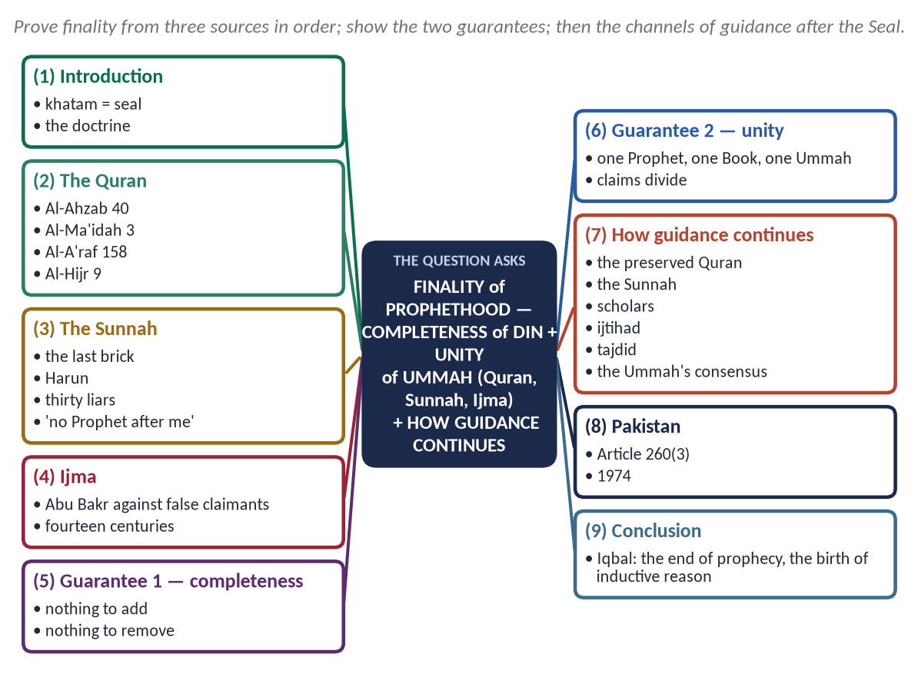
Figure 20 · The answer map: every branch is one numbered heading of the model answer below.

Decoding the question
- Three sources in order — Quran, Sunnah, Ijma — each needs a heading.
- Two guarantees in the statement: completeness of the Din and unity of the Ummah. Show how finality guarantees each.
- 'How guidance continues' — the twist. Without it the answer loses a fifth of its marks.

The model answer

(1) Introduction
Khatm-e-Nubuwwat (خَتْمِ نُبُوَّت) is the belief that the Prophet Muhammad ﷺ is the last Prophet and Messenger; no prophet of any kind will come after him. Khatam means a seal — that which closes and authenticates. It is a belief on which the whole Ummah has agreed for fourteen centuries.

(2) The Quran
✦ QURAN
﴿مَّا كَانَ مُحَمَّدٌ أَبَآ أَحَدٖ مِّن رِّجَالِكُمۡ وَلَٰكِن رَّسُولَ ٱللَّهِ وَخَاتَمَ ٱلنَّبِيِّـۧنَۗ وَكَانَ ٱللَّهُ بِكُلِّ شَيۡءٍ عَلِيمٗا﴾
“Muhammad is not the father of [any] one of your men, but [he is] the Messenger of Allah and last of the prophets. And ever is Allah, of all things, Knowing.” (Al-Ahzab, Quran)
➜ The explicit text: Khatam al-Nabiyyin — the seal of the Prophets.

- The Din perfected: 'This day I have perfected for you your religion' (Al-Ma'idah 3) — a perfect thing needs no addition.
- Universal mission: 'Say: O mankind, I am the Messenger of Allah to you all' (Al-A'raf 158) — no nation remains to receive another prophet.
- Revelation 'before you', never 'after you': 'Those who believe in what was revealed to you and what was revealed before you' (Al-Baqarah 4).
- The message guarded: 'We sent down the Reminder and We will guard it' (Al-Hijr 9) — earlier prophets came partly because earlier books were lost or altered; the Quran will not be.

(3) The Sunnah
✦ HADITH
فَأَنَا اللَّبِنَةُ، وَأَنَا خَاتِمُ النَّبِيِّينَ
“I am that (last) brick, and I am the seal of the Prophets.” (Al-Bukhari)
➜ The house of prophethood is complete.

✦ HADITH
أَمَا تَرْضَى أَنْ تَكُونَ مِنِّي بِمَنْزِلَةِ هَارُونَ مِنْ مُوسَى، إِلَّا أَنَّهُ لَا نَبِيَّ بَعْدِي
“Are you not pleased to be to me as Harun was to Musa — except that there is no Prophet after me?” (Al-Bukhari and Muslim)
➜ Even the closest companion, Hazrat Ali (RA), could not be a Prophet.

✦ HADITH
وَإِنَّهُ سَيَكُونُ فِي أُمَّتِي كَذَّابُونَ ثَلَاثُونَ، كُلُّهُمْ يَزْعُمُ أَنَّهُ نَبِيٌّ، وَأَنَا خَاتَمُ النَّبِيِّينَ لَا نَبِيَّ بَعْدِي
“There will be in my Ummah thirty liars, each claiming to be a Prophet; and I am the seal of the Prophets — there is no Prophet after me.” (Abu Dawud and Al-Tirmidhi)
➜ Every later claim was condemned in advance.

- 'Messengership and prophethood have ended; there is no messenger and no prophet after me' (Al-Tirmidhi).
- 'If there were to be a prophet after me, it would have been Umar' (Al-Tirmidhi) — the conditional shows it will not happen.

(4) Ijma — the consensus of the Ummah
- The first consensus after the Prophet ﷺ was on this belief: Abu Bakr (RA) and all the Companions fought the claimants Musaylimah (killed at Yamamah, 11–12 AH), Aswad al-Ansi and Tulayhah.
- Every school — Hanafi, Maliki, Shafi'i, Hanbali and others — has held that denying finality takes a person out of Islam.
✦ SCHOLARLY VIEW
Qadi Iyad · *Al-Shifa*
The Ummah has agreed that he is the Seal of the Prophets, that there is no prophet after him, and that whoever claims prophethood after him, or believes such a claim, is outside Islam.
➜ The consensus stated by a classical authority.

(5) How finality guarantees the completeness of the Din
- Nothing to add: the Din was completed at the Farewell Hajj; a new prophet would imply that it was incomplete.
- Nothing to remove: no one can abrogate a verse or a Sunnah; the Shariah is protected from 'revisions' by claimants.
- A fixed reference: every age measures itself against the same Quran and Sunnah; this gives certainty and stability to law and belief.

(6) How finality guarantees the unity of the Ummah
- One Prophet, one Book, one Qiblah, one Ummah: 'This is your Ummah, one Ummah, and I am your Lord' (Al-Anbiya 92).
- Every new claim of prophethood creates a new community that separates from the rest — history shows how such claims divided people. Finality closes the door to religious fragmentation.
- It keeps all Muslims equal: no new prophet, no new chosen group; only taqwa distinguishes (Al-Hujurat 13).

(7) How guidance continues after the end of prophethood
Channel | How it guides
The preserved Quran | Recited, memorised by millions, unchanged — guidance for all times (Al-Hijr 9)
The Sunnah | Preserved by the science of isnad; 'I have left two things: the Book of Allah and my Sunnah' (Al-Muwatta')
The scholars | 'The scholars are the heirs of the Prophets' (Abu Dawud and Al-Tirmidhi) — they inherit knowledge, not prophethood
Ijtihad | New questions answered from the sources — 'two rewards if right, one if wrong' (Al-Bukhari and Muslim)
Tajdid (renewal) | 'Allah will send to this Ummah at the head of every hundred years one who will renew its Din' (Abu Dawud)
The consensus of the Ummah | 'My Ummah will not agree upon misguidance' (Ibn Majah)
True dreams and inspiration | 'Nothing remains of prophethood except good tidings — the true dream' (Al-Bukhari) — for the individual, never binding on others

✦ SCHOLARLY VIEW
Allama Muhammad Iqbal · *Reconstruction of Religious Thought in Islam* (Lecture V)
Prophecy reaches its perfection in discovering the need of its own abolition; with the end of prophecy, man is left to use reason and experience under the permanent guidance of revelation.
➜ Finality marks the maturity of mankind.

(8) Pakistan
The Second Amendment (1974) and Article 260(3)(a) define a Muslim as one who believes in the absolute and unqualified finality of the Prophethood of Muhammad ﷺ. The belief is protected by the Constitution; the citizens who do not share it keep the rights of citizens under Articles 20 and 36 — the Islamic way is firmness of belief with justice to all.

(9) Conclusion
Finality is not a closing of guidance but its completion. Because the last Prophet brought a complete and preserved Din, the Ummah needs no new prophet — it needs knowledge, ijtihad and renewal. That is why the seal of prophethood is also the seal of the Ummah's unity.

Why this answer scores
- Quran → Sunnah → Ijma in the order asked, each with exact texts.
- Both guarantees have their own headings, with reasons.
- The 'how guidance continues' limb is answered in a table — the twist is not missed.

Q. No. 3 · The Prophetic Laws of War and Modern International Humanitarian Law
THE QUESTION · SET 3 · Q3 · 20 marks · DIFFICULT
"The rules of war laid down by the Holy Prophet (ﷺ) anticipated modern International Humanitarian Law by thirteen centuries." Compare them with the Geneva Conventions, and evaluate their violation in contemporary conflicts.

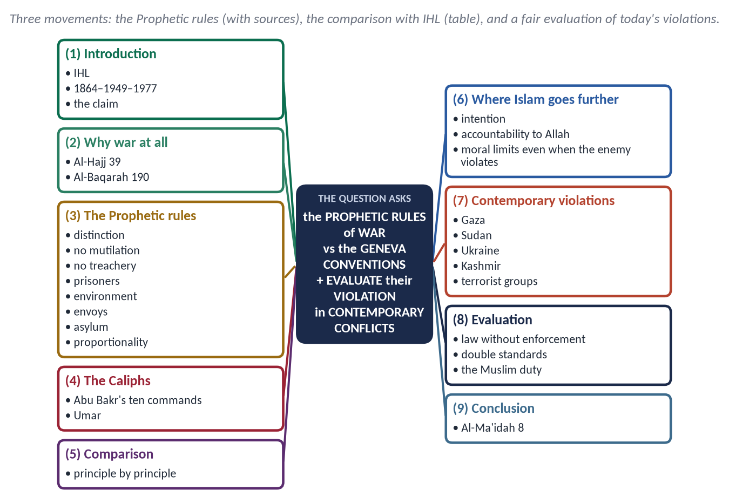
Figure 21 · The answer map: every branch is one numbered heading of the model answer below.

Decoding the question
- The quotation is the thesis: prove that the Prophetic rules contain the principles of IHL.
- 'Compare … with the Geneva Conventions' — a principle-by-principle table, with differences.
- 'Evaluate their violation in contemporary conflicts' — name conflicts factually, including violations by Muslim and non-state actors, and judge why the law fails.

The model answer

(1) Introduction
International Humanitarian Law (IHL) is the law that limits the effects of war. Its modern form began with the first Geneva Convention (1864), took shape in the four Geneva Conventions of 1949 and their Additional Protocols (1977). Yet in the seventh century the Prophet ﷺ gave his commanders standing orders that contain almost every principle of this law.

(2) Why war at all — and its limits
✦ QURAN
﴿أُذِنَ لِلَّذِينَ يُقَٰتَلُونَ بِأَنَّهُمۡ ظُلِمُواْۚ وَإِنَّ ٱللَّهَ عَلَىٰ نَصۡرِهِمۡ لَقَدِيرٌ﴾
“Permission [to fight] has been given to those who are being fought, because they were wronged. And indeed, Allah is competent to give them victory.” (Al-Hajj, Quran)
➜ Permission to fight was given only after persecution — war is defence, not aggression.

✦ QURAN
﴿وَقَٰتِلُواْ فِي سَبِيلِ ٱللَّهِ ٱلَّذِينَ يُقَٰتِلُونَكُمۡ وَلَا تَعۡتَدُوٓاْۚ إِنَّ ٱللَّهَ لَا يُحِبُّ ٱلۡمُعۡتَدِينَ﴾
“Fight in the way of Allah those who fight you but do not transgress. Indeed. Allah does not like transgressors.” (Al-Baqarah, Quran)
➜ Fight those who fight you, but do not transgress — the whole of IHL in one verse.

(3) The Prophetic rules of war
✦ HADITH
اغْزُوا بِاسْمِ اللَّهِ ... وَلَا تَغُلُّوا، وَلَا تَغْدِرُوا، وَلَا تَمْثُلُوا، وَلَا تَقْتُلُوا وَلِيدًا
“Fight in the name of Allah … do not steal from the spoils, do not betray, do not mutilate, and do not kill a child.” (Muslim)
➜ His standing orders to every commander (the hadith of Buraydah).

✦ HADITH
فَنَهَى رَسُولُ اللَّهِ ﷺ عَنْ قَتْلِ النِّسَاءِ وَالصِّبْيَانِ
“He forbade the killing of women and children.” (Al-Bukhari and Muslim)
➜ Condemns terrorism and the bombing of civilians alike.

- Distinction: fight only combatants; women, children, the old, monks and farmers are protected.
- Humane treatment of prisoners: the prisoners of Badr were fed bread while their captors ate dates; many were freed for ransom or for teaching ten children to read; 'they give food … to the captive' (Al-Insan 8). Thumamah ibn Uthal was freed and became a Muslim.
- No mutilation, no torture, no burning: 'None punishes with fire except the Lord of fire' (Abu Dawud).
- No treachery (perfidy): treaties kept even when costly — Abu Jandal returned at Hudaybiyyah.
- Protection of envoys: 'envoys are not killed' (Abu Dawud).
- Asylum: 'If one of the polytheists seeks your protection, grant it … then convey him to his place of safety' (At-Tawbah 6).
- Proportionality: 'If you punish, punish with the like of what you were made to suffer; but if you are patient, that is better' (An-Nahl 126).
- Minimum force: in about 27 campaigns, the total dead on both sides were only about 1,018.

(4) The Caliphs codified it
✦ FROM THE SIRAH
لَا تَقْتُلَنَّ امْرَأَةً وَلَا صَبِيًّا وَلَا كَبِيرًا هَرِمًا، وَلَا تَقْطَعَنَّ شَجَرًا مُثْمِرًا، وَلَا تُخَرِّبَنَّ عَامِرًا
“Do not kill a woman, a child or an old man; do not cut down a fruit-bearing tree; do not destroy a populated place.” (Muwatta Imam Malik)
➜ Hazrat Abu Bakr's instructions to his army — civilians, property and the environment protected.

(5) Comparison with the Geneva Conventions
Principle | Prophetic law | Geneva Conventions / Protocols
Distinction | Women, children, old, monks protected (Al-Bukhari; Muwatta) | Civilians protected (GC IV; AP I, Art. 48)
Prisoners of war | Fed, clothed, freed by ransom or teaching (Badr) | Humane treatment (GC III)
Wounded and dead | No mutilation; the dead buried | Care of wounded; respect for the dead (GC I)
No perfidy | 'Do not betray' | Perfidy prohibited (AP I, Art. 37)
Proportionality | An-Nahl 126; Al-Baqarah 190 | Proportionality in attack (AP I, Art. 51)
Property and environment | No cutting fruit trees; no destroying towns | Protection of civilian objects; the natural environment (AP I, Arts 52, 55)
Places of worship | Monks and their cells left alone | Cultural and religious property protected (Hague 1954)
Envoys | 'Envoys are not killed' | Diplomatic immunity (Vienna 1961)

(6) Where the Prophetic law goes further
- Intention: war only for justice and defence, never for plunder or glory.
- Accountability to Allah: a soldier who breaks the rules sins, even if no court catches him — conscience as enforcement.
- No reciprocity for crimes: if the enemy mutilates, Muslims still may not; 'do not let the hatred of a people lead you to injustice' (Al-Ma'idah 8).
- Peace preferred: 'If they incline to peace, incline to it' (Al-Anfal 61).
✦ SCHOLARLY VIEW
Dr. Muhammad Hamidullah · *The Muslim Conduct of State*
Islam gave the world the first written code of international and war law as a branch of law binding on the state, not a matter of the ruler's pleasure.
➜ The scholarly basis of the claim.

(7) Contemporary violations — the facts
- Gaza (2023–2025): the Hamas attack of 7 October 2023 killed civilians and took hostages; Israel's military campaign that followed killed tens of thousands of Palestinians, a large share of them women and children, and destroyed homes, hospitals and schools. In January 2024 the International Court of Justice ordered provisional measures in the case brought by South Africa.
- Sudan: the war since 2023 has brought mass killings of civilians, famine and displacement.
- Ukraine: attacks on cities and energy infrastructure.
- Kashmir and South Asia: civilian deaths across the Line of Control; in May 2025 strikes on towns during the India–Pakistan conflict; the suspension of the Indus Waters Treaty raised the danger of water as a weapon — while Islam treats water as a common right ('Muslims are partners in three: water, pasture and fire', Abu Dawud).
- Terrorist groups who claim Islam — Daesh, the TTP — kill civilians, execute prisoners and use suicide bombing, violating every rule the Prophet ﷺ laid down.

(8) Evaluation — why the law fails
- Enforcement without power: IHL has no army; the veto in the Security Council protects violators and their allies.
- Double standards: some violations are punished, others excused, depending on who commits them.
- Dehumanisation: propaganda turns civilians into 'targets'; technology (drones, AI targeting) makes killing distant and easy.
- Muslims' own failure: Muslim states have been divided and weak in using the law; militant groups have disgraced the Prophetic code.
- The lesson: law needs conscience and power. The Prophetic model joined both — rules that soldiers obeyed out of taqwa, and a state strong enough to enforce them.

(9) Conclusion
✦ QURAN
﴿… وَلَا يَجۡرِمَنَّكُمۡ شَنَـَٔانُ قَوۡمٍ عَلَىٰٓ أَلَّا تَعۡدِلُواْۚ ٱعۡدِلُواْ هُوَ أَقۡرَبُ لِلتَّقۡوَىٰۖ …﴾
“Do not let the hatred of a people lead you to injustice. Be just; that is nearer to righteousness.” (Al-Ma'idah, Quran)

The Prophet's ﷺ laws of war anticipated the Geneva Conventions in distinction, prisoners, perfidy, proportionality and the environment — and exceeded them in conscience. The tragedy of our age is not the absence of law but the absence of will. Muslims must lead in demanding one standard for all, and first live that standard themselves.

Why this answer scores
- The thesis is proved with hadith, the Muwatta' and the Caliph's orders.
- A principle-by-principle comparison with exact IHL articles.
- The evaluation is factual and balanced — violations by states and by militant groups, and the causes of failure.

Q. No. 4 · The Rights of the Child: Islam, the UN Convention and Pakistan
THE QUESTION · SET 3 · Q4 · 20 marks · DIFFICULT
Discuss the rights of the child in Islam in comparison with the UN Convention on the Rights of the Child (1989). How far does Pakistan protect these rights against child labour, lack of education and early marriage?

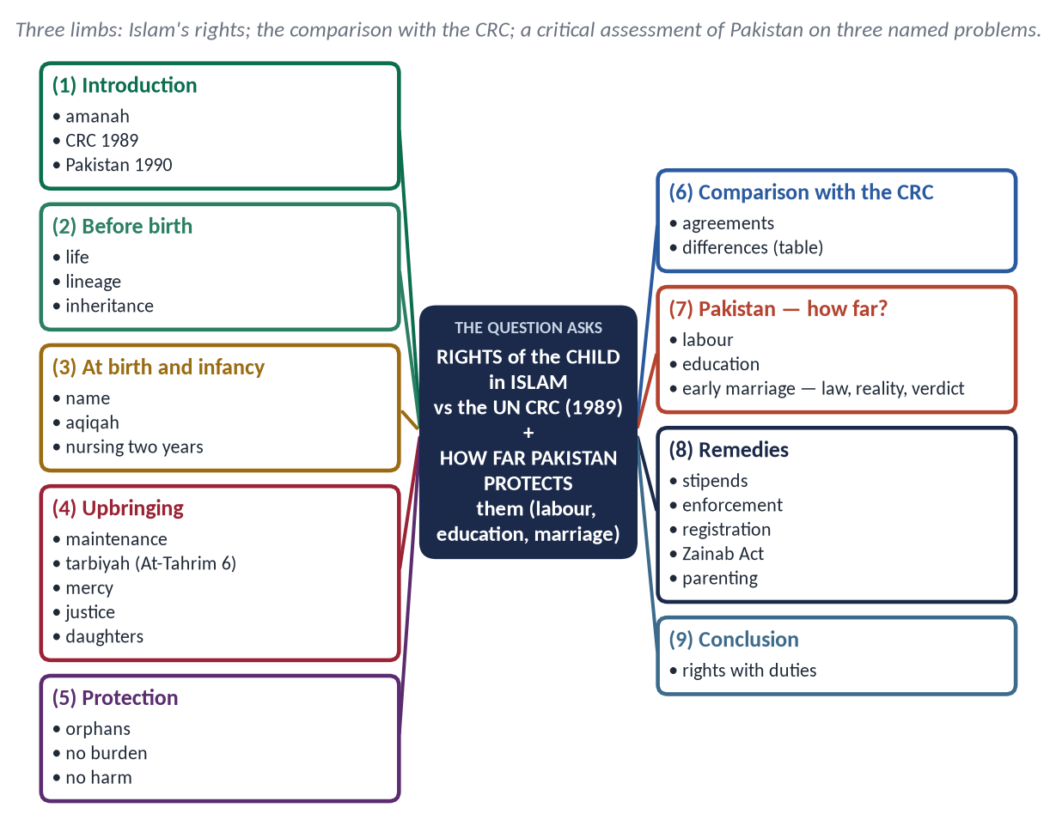
Figure 22 · The answer map: every branch is one numbered heading of the model answer below.

Decoding the question
- 'Discuss … in comparison' — Islam's rights first, then a comparison with the CRC (agreements and differences).
- 'How far' — a measured verdict on Pakistan, limited to three named problems: child labour, education, early marriage.
- Early marriage is a debated issue: present the Islamic principles and the positions fairly.

The model answer

(1) Introduction
In Islam a child is an amanah (trust) from Allah and a gift: 'He gives to whom He wills females, and to whom He wills males' (Ash-Shura 49). The UN Convention on the Rights of the Child (CRC), adopted in 1989, is the most widely ratified human-rights treaty; Pakistan ratified it in 1990. Both speak of the child's life, development and protection — but from different foundations.

(2) Rights before birth
- Life: 'Do not kill your children for fear of poverty' (Al-Isra 31); the unborn are protected — the Prophet ﷺ postponed the punishment of a pregnant woman until she had given birth and weaned the child (Muslim).
- A righteous mother and a lawful marriage — the child's right to a known lineage: 'Call them by their fathers' (Al-Ahzab 5).
- Inheritance is reserved for the unborn child.

(3) Rights at birth and in infancy
- A good name, the aqiqah and the call to prayer in the ear.
- Nursing for two full years (Al-Baqarah 233), with the father bearing the cost even after divorce.

(4) Rights in upbringing
- Maintenance: food, clothing, shelter and health — the father's duty.
- Education and tarbiyah:
✦ QURAN
﴿يَـٰٓأَيُّهَا ٱلَّذِينَ ءَامَنُواْ قُوٓاْ أَنفُسَكُمۡ وَأَهۡلِيكُمۡ نَارٗا …﴾
“O you who have believed, protect yourselves and your families from a Fire.” (At-Tahrim, Quran)
➜ Upbringing in faith and character is a duty.

- Mercy and play:
✦ HADITH
لَيْسَ مِنَّا مَنْ لَمْ يَرْحَمْ صَغِيرَنَا وَيُوَقِّرْ كَبِيرَنَا
“He is not one of us who does not show mercy to our young and respect to our elders.” (Al-Tirmidhi)

He kissed his grandson Hasan; when a man said he had ten children and had never kissed one, he said: 'Whoever does not show mercy will not be shown mercy' (Al-Bukhari and Muslim). He lengthened a prostration so as not to disturb a grandson who had climbed on his back (Al-Nasa'i), and shortened the prayer on hearing a child cry (Al-Bukhari).
- Justice among children:
✦ HADITH
اتَّقُوا اللَّهَ وَاعْدِلُوا بَيْنَ أَوْلَادِكُمْ
“Fear Allah and be just between your children.” (Al-Bukhari and Muslim)

- Daughters honoured: 'Whoever raises two girls until they come of age will come on the Day of Resurrection with me like this' — joining his fingers (Muslim).

(5) Rights of protection
- Orphans: 'Those who consume the property of orphans unjustly only consume fire in their bellies' (An-Nisa 10); 'I and the one who cares for an orphan will be like these two in Paradise' (Al-Bukhari).
- No burden beyond capacity: 'Allah does not burden a soul beyond its capacity' (Al-Baqarah 286) — the basis for forbidding harmful child labour.
- Protection from harm: 'There is to be no harm and no returning of harm' (Ibn Majah).

(6) Comparison with the CRC
Aspect | Islam | CRC (1989)
Basis | Rights given by Allah; parents' duty to Allah | A treaty between states
Life and survival | From conception; the unborn protected | Art. 6 — right to life; unborn left to states
Identity | Name, known lineage (Al-Ahzab 5) | Arts 7–8 — name, nationality, identity
Education | A religious duty (tarbiyah + knowledge) | Art. 28 — free primary education
Protection from exploitation | No burden beyond capacity; orphans' property | Art. 32 — economic exploitation; Art. 19 — abuse
Family | The family is the child's first right and school | Family recognised; the state stands in when it fails
Participation | Consultation with the young (Ibn Abbas, Usamah) | Art. 12 — the child's views heard
Duties | Rights with duties of respect and obedience in good | Rights; duties hardly mentioned
Age of majority | Puberty and maturity (rushd, An-Nisa 6) | Under 18 (Art. 1)

Agreements: life, identity, education, protection, the best interests of the child. Differences: the source (divine vs treaty), the unborn, the place of the family, the role of duties, and the definition of childhood.

(7) How far does Pakistan protect these rights?

(i) Child labour
- Article 11(3) forbids employing children under 14 in factories, mines or hazardous work; the Employment of Children Act 1991 and provincial laws add detail.
- Reality: millions of children work — in brick kilns, workshops, fields and homes. Cases of abuse of child domestic workers in 2023 shocked the nation. Enforcement is weak, and poverty pushes families.

(ii) Lack of education
- Article 25-A (2010): free and compulsory education for ages 5–16.
- Reality: about 26 million children are out of school, the majority of them girls; quality is low and dropout high.

(iii) Early marriage
- Law: the Child Marriage Restraint Act 1929 (16 for girls, 18 for boys); Sindh (2013) set 18 for both; the Islamabad Capital Territory (2025) also set 18 for both.
- The debate: the Council of Islamic Ideology objected to the 2025 law, holding that a fixed age cannot invalidate a marriage after puberty. Its supporters argue that the state may regulate marriage age to prevent harm (la darar), as many Muslim countries do.
- The Islamic principles agreed by all: marriage requires maturity (rushd) and the ability to bear its duties — 'until they reach the age of marriage, then if you perceive in them sound judgement…' (An-Nisa 6); the girl's consent is essential (Khansa bint Khidam, Al-Bukhari); and harm must be prevented. Forced child marriages, vani and swara are against Islam on every view.
- Verdict: Pakistan protects these rights on paper better than in practice. The gap lies in poverty, weak enforcement, custom and low awareness.

(8) Remedies
Stipends for poor families to keep children in school; strict enforcement against hazardous and domestic child labour; birth and marriage registration (NADRA) at every union council; the Zainab Alert, Response and Recovery Act 2020 implemented fully; khutbahs on children's rights; parenting education — 'each of you is a shepherd' (Al-Bukhari and Muslim).

(9) Conclusion
Islam protected the child from before birth to maturity, and joined rights with the duties of parents, society and state. The CRC shares most of these aims. Pakistan has signed the Convention and written many rights into its Constitution; the task now is to make the child in the brick kiln, the house and the village feel them.

Why this answer scores
- Islam's rights are arranged by the stages of life — clear and complete.
- The comparison table shows both agreement and difference.
- The Pakistan limb covers exactly the three named problems, with laws, reality and a verdict; the marriage debate is handled fairly.

Q. No. 5 · The Rule of Law in Islamic Civilization and in Pakistan
THE QUESTION · SET 3 · Q5 · 20 marks · DIFFICULT
"The nations before you were destroyed because they punished the weak and spared the powerful." In the light of this Hadith, discuss the rule of law as a characteristic of Islamic civilization, and assess the state of the rule of law in Pakistan.

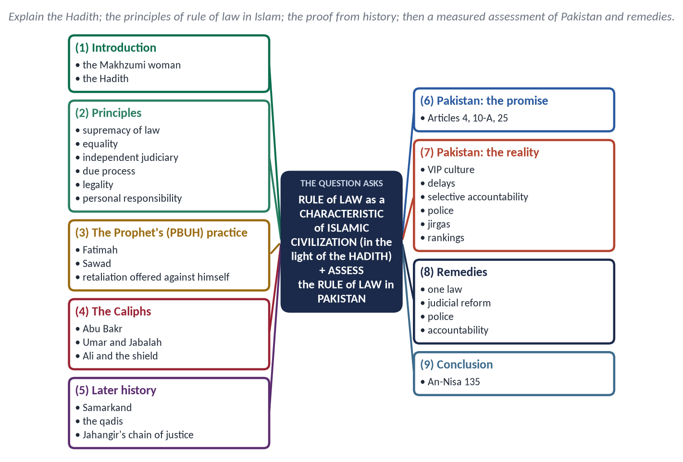
Figure 23 · The answer map: every branch is one numbered heading of the model answer below.

Decoding the question
- 'In the light of this Hadith' — begin with the Hadith and its occasion; use its principle (equality before the law) as the spine.
- 'A characteristic of Islamic civilization' — show that rule of law was a feature of the civilization, not only a rule in books.
- 'Assess' — a measured judgement on Pakistan: strengths, weaknesses, causes and remedies.

The model answer

(1) Introduction — the Hadith and its occasion
A woman of the noble clan of Banu Makhzum stole, and the Quraysh asked Usamah ibn Zayd to intercede. The Prophet ﷺ was angered and addressed the people:
✦ HADITH
إِنَّمَا أَهْلَكَ الَّذِينَ قَبْلَكُمْ أَنَّهُمْ كَانُوا إِذَا سَرَقَ فِيهِمُ الشَّرِيفُ تَرَكُوهُ، وَإِذَا سَرَقَ فِيهِمُ الضَّعِيفُ أَقَامُوا عَلَيْهِ الْحَدَّ
“Those before you were destroyed because when a noble person stole they let him go, and when a weak person stole they punished him.” (Al-Bukhari and Muslim)

✦ HADITH
وَايْمُ اللَّهِ لَوْ أَنَّ فَاطِمَةَ بِنْتَ مُحَمَّدٍ سَرَقَتْ لَقَطَعْتُ يَدَهَا
“By Allah, if Fatimah daughter of Muhammad stole, I would cut her hand.” (Al-Bukhari and Muslim)

Rule of law means that the law is supreme and applies equally to all — ruler and ruled, rich and poor. The Hadith makes it a matter of the survival of nations.

(2) The principles of rule of law in Islam
✦ QURAN
﴿يَـٰٓأَيُّهَا ٱلَّذِينَ ءَامَنُواْ كُونُواْ قَوَّـٰمِينَ بِٱلۡقِسۡطِ شُهَدَآءَ لِلَّهِ وَلَوۡ عَلَىٰٓ أَنفُسِكُمۡ أَوِ ٱلۡوَٰلِدَيۡنِ وَٱلۡأَقۡرَبِينَۚ …﴾
“O you who have believed, be persistently standing firm in justice, witnesses for Allah, even if it be against yourselves or parents and relatives.” (An-Nisa, Quran)

- Supremacy of the law: the Shariah binds the ruler; 'Obey me as long as I obey Allah' (Abu Bakr).
- Equality before the law: no immunity for rank, family or office.
- Independent judiciary: the qadi judges even the Caliph.
- Due process: 'The burden of proof is on the claimant and the oath on the one who denies' (Al-Bayhaqi); both sides heard.
- Legality: 'We never punish until We have sent a messenger' (Al-Isra 15) — no punishment without prior law.
- Personal responsibility: 'No bearer of burdens bears the burden of another' (Al-An'am 164).
- Presumption of innocence: the jurists' maxim — punishments are averted by doubt.

(3) The Prophet's ﷺ practice
- The Makhzumi woman — no intercession for the powerful.
- At Badr he pressed the stomach of Sawad ibn Ghaziyyah with an arrow while straightening the ranks; when Sawad asked for retaliation, the Prophet ﷺ uncovered his own stomach — and Sawad kissed it.
- In the Farewell Sermon he abolished first the riba and blood-claims of his own family.

(4) The Rightly Guided Caliphs
- Abu Bakr: 'The weak among you is strong with me until I take his right for him; the strong among you is weak with me until I take the right from him.'
- Umar: when the Ghassanid prince Jabalah ibn al-Ayham slapped a poor Bedouin during Tawaf, Umar ruled that the Bedouin could retaliate; the prince fled rather than accept equality. When the son of Amr ibn al-As, governor of Egypt, struck an Egyptian, Umar made the Egyptian take retaliation and said: 'Since when have you enslaved people when their mothers bore them free?'
- Ali: as Caliph he lost the case of his own shield before Qadi Shurayh, because his evidence did not meet the standard.

(5) Rule of law in later Islamic civilization
- The qadi system: qadis were appointed for life by merit; Imam Abu Yusuf became the first chief justice (qadi al-qudat) under the Abbasids; mazalim courts heard complaints against officials.
- Samarkand: when Muslim troops had entered the city without due warning, Umar ibn Abd al-Aziz sent a qadi who ruled that the army must withdraw; the people, astonished at such justice, chose to stay under Muslim rule (al-Baladhuri).
- The subcontinent: the Mughal emperor Jahangir hung a 'chain of justice' so that any subject could call for the emperor's hearing.
✦ SCHOLARLY VIEW
Ibn Khaldun · *Al-Muqaddimah*
Injustice ruins civilization: when rulers seize property and deny rights, people lose the incentive to work, and prosperity and the state decline together.
➜ Rule of law as the economic foundation of civilization.

(6) Pakistan: the promise
The Constitution gives every citizen the protection of law (Art. 4), a fair trial and due process (Art. 10-A) and equality before the law (Art. 25). The Objectives Resolution promises an independent judiciary.

(7) Pakistan: the reality — an assessment
Problem | The Hadith's warning
VIP culture | Protocols, privileged treatment and influence in police stations — 'they spared the noble'
Delayed justice | More than two million cases pending in the courts; delay denies justice to the weak
Selective accountability | Cases opened and closed with changes of government — the law as a weapon
A politicised police | Postings by influence; the poor fear the police station
Parallel 'justice' | Jirgas and panchayats that order vani, swara and honour punishments
Mob justice | Crowds punishing on rumour, bypassing courts
Low rankings | Pakistan near the bottom of the World Justice Project Rule of Law Index and about 135th of 180 in Transparency International's Corruption Perceptions Index (2024)

Strengths also exist: an active superior judiciary, a free press, a growing awareness of rights, and reforms such as model courts and e-filing. The verdict: Pakistan has the law of a just state but the practice of the nations the Hadith warned about.

(8) Remedies
- One law for all: end VIP immunities and protocol; equal treatment in police stations and courts.
- Judicial reform: more judges, time limits for trials, alternative dispute resolution, digitised records.
- Police reform: merit-based postings, independent complaints bodies, training in rights.
- Non-selective accountability by independent institutions.
- End parallel courts and punish mob violence.
- Education: civic and Islamic teaching on equality before law.

(9) Conclusion
The Prophet ﷺ made the rule of law a matter of survival: nations perish when law bends to power. Islamic civilization flourished while qadis could judge caliphs, and declined when rulers placed themselves above the law. Pakistan's survival and prosperity depend on the same test — whether its law treats the powerful and the weak alike.

Why this answer scores
- The Hadith and its occasion open and frame the answer, as the question requires.
- Rule of law is shown as a characteristic of the civilization — Prophet, Caliphs, later history.
- The Pakistan limb is a real assessment: strengths, problems (table), causes and remedies.

Q. No. 6 · The Weakness of the Ummah and a Quranic Roadmap for Unity
THE QUESTION · SET 3 · Q6 · 20 marks · DIFFICULT
The Muslim Ummah comprises 57 states and a quarter of mankind, yet it could not stop the tragedy of Gaza. Analyze the causes of the weakness of the Ummah and suggest a Qur'anic roadmap for its unity.

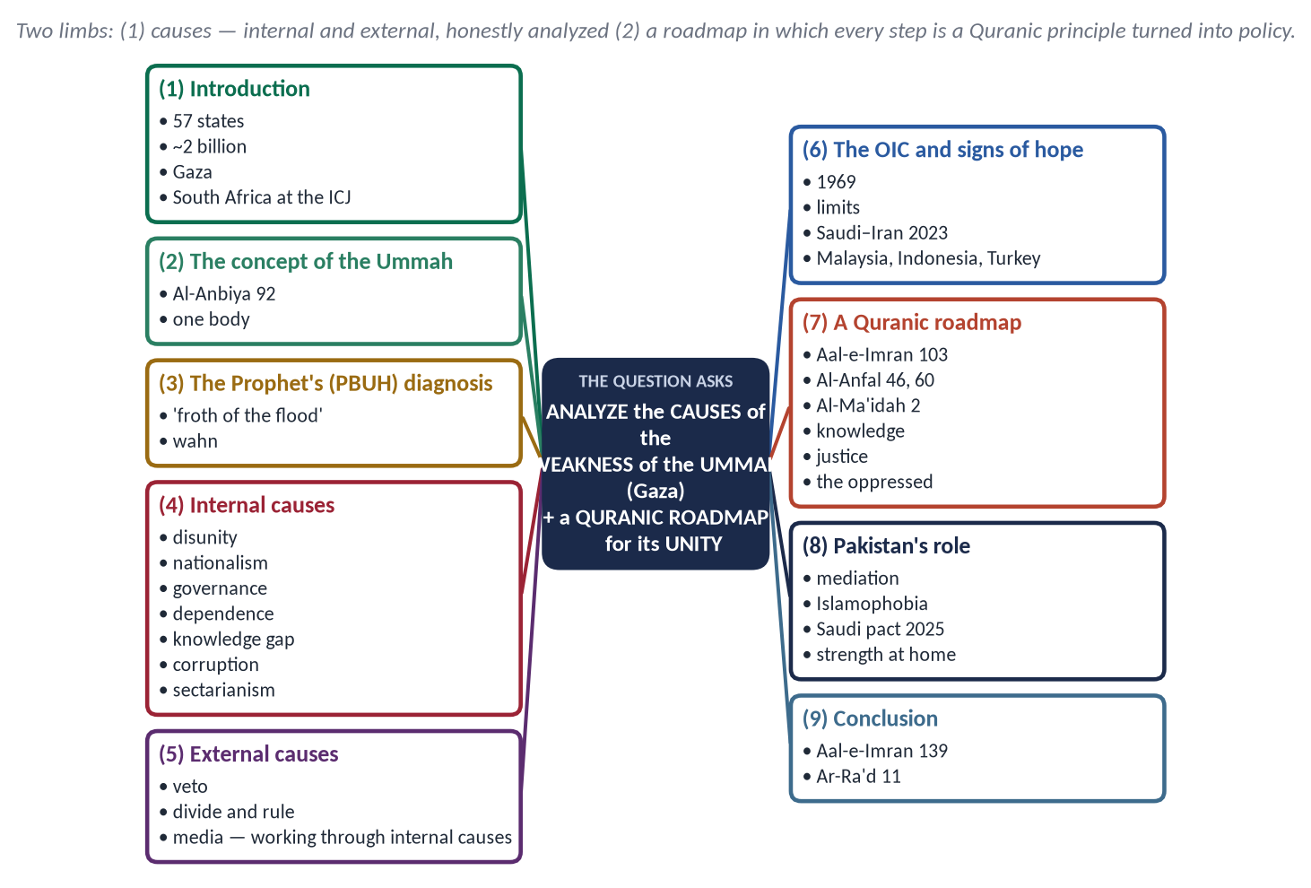
Figure 24 · The answer map: every branch is one numbered heading of the model answer below.

Decoding the question
- 'Analyze the causes' — classify them (internal and external), explain each, and show which matters most.
- 'Qur'anic roadmap' — every step must rest on a verse, and be turned into practical policy.
- Gaza is the example, not the whole answer. State the facts calmly.

The model answer

(1) Introduction
The Organisation of Islamic Cooperation has 57 member states; Muslims number about two billion, a quarter of humanity, with vast oil, gas, land and young populations. Yet during the war in Gaza (2023–2025), in which tens of thousands of Palestinians were killed and most of the territory was destroyed, the Muslim states could offer statements, aid convoys that often could not enter, and diplomacy that the great powers ignored. It was a non-Muslim state, South Africa, that took the case to the International Court of Justice. The question is not the Ummah's size, but its weakness.

(2) The concept of the Ummah
✦ QURAN
﴿إِنَّ هَٰذِهِۦٓ أُمَّتُكُمۡ أُمَّةٗ وَٰحِدَةٗ وَأَنَا۠ رَبُّكُمۡ فَٱعۡبُدُونِ﴾
“Indeed this, your religion, is one religion, and I am your Lord, so worship Me.” (Al-Anbiya, Quran)
➜ One Ummah, one Lord — the basis of unity.

✦ HADITH
مَثَلُ الْمُؤْمِنِينَ فِي تَوَادِّهِمْ وَتَرَاحُمِهِمْ وَتَعَاطُفِهِمْ مَثَلُ الْجَسَدِ، إِذَا اشْتَكَى مِنْهُ عُضْوٌ تَدَاعَى لَهُ سَائِرُ الْجَسَدِ بِالسَّهَرِ وَالْحُمَّى
“The believers are like one body: when one limb suffers, the whole body responds with sleeplessness and fever.” (Muslim)
➜ The argument for solidarity with Palestine, Kashmir and every suffering Muslim people.

(3) The Prophet's ﷺ diagnosis
✦ HADITH
يُوشِكُ الْأُمَمُ أَنْ تَدَاعَى عَلَيْكُمْ كَمَا تَدَاعَى الْأَكَلَةُ إِلَى قَصْعَتِهَا ... بَلْ أَنْتُمْ يَوْمَئِذٍ كَثِيرٌ، وَلَكِنَّكُمْ غُثَاءٌ كَغُثَاءِ السَّيْلِ
“The nations will soon call one another against you as diners call one another to a dish … No, you will be many on that day, but you will be froth, like the froth of a flood.” (Abu Dawud)
➜ He named the cause wahn — 'love of the world and hatred of death'.

(4) The internal causes
Cause | Analysis
Disunity and rivalry | Muslim states compete and even fight one another (Yemen, Sudan, Libya); 'Do not dispute, lest you lose courage and your strength depart' (Al-Anfal 46)
Narrow nationalism | National interest placed above the Ummah; the Ummah reduced to a slogan
Governance deficit | Many rulers lack popular legitimacy and fear their own people more than foreign powers
Economic and military dependence | Weapons, loans and markets controlled by others; no independent power to act
The knowledge gap | Low spending on research; few world-class universities — the neglect of a fard kifayah
Corruption and elite capture | Wealth spent on luxury rather than strength and welfare
Sectarian division | Sunni–Shia and other rivalries exploited by outsiders
Wahn | Love of comfort and fear of sacrifice — the Prophet's ﷺ own diagnosis

(5) The external causes
- Great-power politics: the veto in the UN Security Council has repeatedly blocked action.
- Divide and rule: colonial borders and later alliances kept Muslim states apart.
- Media narratives that portray Muslim suffering as 'security' and Muslim resistance as terrorism.
- Analysis: the external causes are real, but they work through the internal ones. A united, strong and just Ummah could not be ignored.

(6) The OIC — promise and limits
Founded in 1969 after the arson attack on Masjid al-Aqsa, the OIC has summits, a Fiqh Academy, the Islamic Development Bank and a voice at the UN — its resolution made 15 March the International Day to Combat Islamophobia (2022). But it has no enforcement mechanism, no common market and no joint defence; its decisions depend on members who disagree.

Signs of hope
- The Saudi–Iran agreement (March 2023) to restore relations showed that rivalry can be managed by diplomacy.
- Malaysia, Indonesia and Turkey show that Muslim societies can build strong economies and industries.
- The OIC's success on Islamophobia at the UN shows what united diplomacy can achieve.
- Millions of ordinary Muslims gave generously for Gaza, Sudan and the Rohingya — the body still feels the pain; what is missing is organised power.

(7) A Quranic roadmap for unity
✦ QURAN
﴿وَٱعۡتَصِمُواْ بِحَبۡلِ ٱللَّهِ جَمِيعٗا وَلَا تَفَرَّقُواْۚ …﴾
“And hold firmly to the rope of Allah all together and do not become divided.” (Aal-e-Imran, Quran)

Quranic principle | Verse | Policy
Unity on the rope of Allah | Aal-e-Imran 103 | A common charter of values; end wars between Muslim states; mediation councils
No disputes | Al-Anfal 46 | OIC dispute-resolution mechanism; stop sectarian propaganda
Preparation of strength | Al-Anfal 60 | Joint defence cooperation and defence industry; collective security agreements
Cooperation in good | Al-Ma'idah 2 | An Islamic common market, trade in local currencies, the IsDB strengthened
Knowledge | Az-Zumar 9; Al-Alaq 1–5 | Joint universities and research funds; science and AI as fard kifayah
Justice at home | An-Nisa 58 | Accountable, legitimate governments — strength begins with the people's trust
Help the oppressed | An-Nisa 75 | Humanitarian corridors, legal action at the ICJ and ICC, coordinated diplomacy
Change within | Ar-Ra'd 11 | Moral reform — honesty, discipline, sacrifice — to cure wahn

(8) Pakistan's role
Pakistan — a nuclear power with a large army and a founding role in the OIC — has a special duty: to mediate between Muslim states (as it has attempted between Saudi Arabia and Iran), to lead on Islamophobia at the UN, to strengthen defence ties such as the Strategic Mutual Defence Agreement with Saudi Arabia (2025), and above all to become economically strong and well governed, because a weak state cannot help others.

(9) Conclusion
✦ QURAN
﴿وَلَا تَهِنُواْ وَلَا تَحۡزَنُواْ وَأَنتُمُ ٱلۡأَعۡلَوۡنَ إِن كُنتُم مُّؤۡمِنِينَ﴾
“So do not weaken and do not grieve, and you will be superior if you are [true] believers.” (Aal-e-Imran, Quran)
➜ Do not weaken and do not grieve — superiority comes with true faith.

Gaza exposed not the smallness of the Ummah but its froth: many, but scattered and weak. The Quranic roadmap asks Muslims to hold the rope of Allah together, end their disputes, build strength and knowledge, and establish justice at home. When the body is healthy, it will feel the pain of every limb — and be able to act.

Why this answer scores
- Causes are analyzed — classified, explained and weighed ('external causes work through internal ones').
- The prophetic diagnosis (wahn) gives depth.
- The roadmap is a three-column table: verse → principle → policy.

Q. No. 7 · Collective Ijtihad in the Age of AI, Biotechnology and Digital Finance
THE QUESTION · SET 3 · Q7 · 20 marks · DIFFICULT
Explain the need and principles of collective Ijtihad in the age of Artificial Intelligence, biotechnology and digital finance. Evaluate the role of the Council of Islamic Ideology and the Federal Shariat Court in this regard.

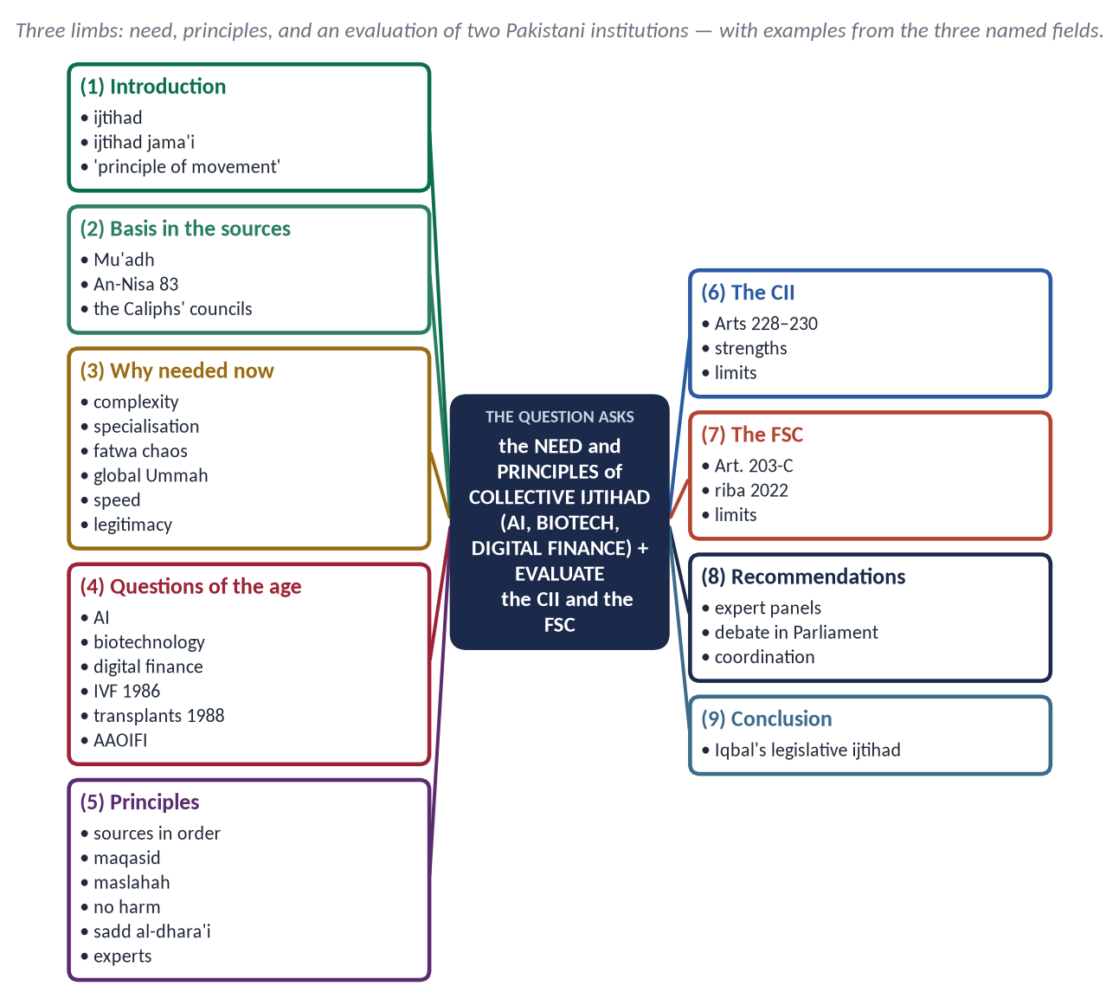
Figure 25 · The answer map: every branch is one numbered heading of the model answer below.

Decoding the question
- Collective ijtihad (ijtihad jama'i) = scholars and experts reasoning together — define it and show why individual ijtihad is not enough today.
- The three fields — AI, biotechnology, digital finance — must appear with real questions.
- 'Evaluate' the CII and FSC: functions, achievements, limitations, and reforms.

The model answer

(1) Introduction
Ijtihad (اِجْتِهَاد) is the utmost effort of a qualified jurist to derive a ruling from the sources. Collective ijtihad is ijtihad by a body — jurists together with specialists — reaching an agreed opinion. Iqbal called ijtihad 'the principle of movement in Islam'; in an age of machines that learn and cells that can be edited, that movement must be collective.

(2) The basis in the sources
✦ HADITH
كَيْفَ تَقْضِي إِذَا عَرَضَ لَكَ قَضَاءٌ؟ قَالَ: أَقْضِي بِكِتَابِ اللَّهِ ... فَبِسُنَّةِ رَسُولِ اللَّهِ ... أَجْتَهِدُ رَأْيِي وَلَا آلُو
“'How will you judge?' — 'By the Book of Allah … then the Sunnah … then I will use my own judgement and spare no effort.'” (Abu Dawud and Al-Tirmidhi)
➜ The Prophet ﷺ approved Mu'adh's method.

✦ QURAN
﴿… وَلَوۡ رَدُّوهُ إِلَى ٱلرَّسُولِ وَإِلَىٰٓ أُوْلِي ٱلۡأَمۡرِ مِنۡهُمۡ لَعَلِمَهُ ٱلَّذِينَ يَسۡتَنۢبِطُونَهُۥ مِنۡهُمۡۗ …﴾
“Had they referred it to the Messenger and to those of authority among them, then the ones who can draw correct conclusions would have known it.” (An-Nisa, Quran)
➜ Refer new matters to the qualified, together.

- The Caliphs' practice: Abu Bakr and Umar gathered the senior Companions to decide new questions — the land of Iraq, the punishment for drinking, the calendar. This was collective ijtihad.

(3) Why collective ijtihad is needed now
- Complexity: a ruling on gene therapy or algorithmic trading needs medicine, technology and economics, not only fiqh.
- Specialisation: no single person masters both the Shariah and modern science.
- The chaos of individual fatwas: contradictory online fatwas confuse people and damage trust.
- A global Ummah: questions arise everywhere at once; answers need wide acceptance.
- The speed of change: AI and finance change monthly.
- Legitimacy: a collective opinion is closer to ijma' and more likely to be accepted ('the hand of Allah is with the community', Al-Tirmidhi).

(4) The questions of the age
Field | Questions needing collective ijtihad
Artificial Intelligence | AI 'fatwa' chatbots; deep-fakes and defamation; data privacy; bias and injustice in algorithms; AI in courts and warfare; ownership of AI-created work
Biotechnology | IVF and surrogacy; gene editing; organ transplants and brain death; cloning; end-of-life care
Digital finance | Cryptocurrencies; digital banking and wallets; Islamic fintech; sukuk tokenisation; Zakat on digital assets

- Examples of collective ijtihad already given: the OIC International Islamic Fiqh Academy permitted IVF within marriage (1986) while forbidding third-party involvement, and permitted organ transplantation under conditions (1988); AAOIFI (Bahrain, 1991) sets Shariah standards for Islamic banks used across the world.

(5) The principles of collective ijtihad
- The sources in order: Quran → Sunnah → Ijma → Qiyas; no ijtihad against a clear text.
- Maqasid al-Shariah: protect faith, life, intellect, lineage and property — e.g. AI rules must protect intellect and honour; gene editing must not corrupt lineage.
- Maslahah and la darar: public interest and the prevention of harm ('no harm and no returning of harm', Ibn Majah).
- Sadd al-dhara'i': block the means to evil (e.g. deep-fake tools for defamation).
- Taysir (ease) and 'urf (custom) where they do not contradict the sources.
- Experts as partners: doctors, engineers and economists explain the facts (tahqiq al-manat); scholars give the ruling.
- Consultation and transparency: published reasoning, open to review.
✦ HADITH
إِذَا حَكَمَ الْحَاكِمُ فَاجْتَهَدَ ثُمَّ أَصَابَ فَلَهُ أَجْرَانِ، وَإِذَا حَكَمَ فَاجْتَهَدَ ثُمَّ أَخْطَأَ فَلَهُ أَجْرٌ
“When a judge rules, having striven, and is right, he has two rewards; and if he strives and errs, he has one reward.” (Al-Bukhari and Muslim)
➜ Ijtihad is rewarded even when it errs — so it must not be feared.

(6) The Council of Islamic Ideology — an evaluation
- Role: a constitutional body (Articles 228–230) that advises Parliament and the government whether laws are in accordance with Islam, and recommends how to bring existing laws into conformity.
- Strengths: members from different schools and some specialists — a natural forum for collective ijtihad; reports on riba, Zakat, family law and many other subjects.
- Limits: its advice is not binding; its reports are rarely debated in Parliament; its membership has too few experts in science, technology and finance; some opinions have drawn public debate (for example on DNA evidence in 2013, and on the child-marriage law in 2025).

(7) The Federal Shariat Court — an evaluation
- Role: established in 1980 (Article 203-C); it can declare a law repugnant to the Quran and Sunnah; its bench includes judges and up to three ulema.
- Strengths: binding judgments — above all the riba judgment of 28 April 2022; it has reviewed many laws.
- Limits: it cannot examine the Constitution, Muslim personal law or court procedure (Article 203-B); appeals to the Shariat Appellate Bench have often waited for years; it judges laws after they are made, rather than guiding new questions.

(8) Recommendations
- Permanent expert panels in the CII — AI, medicine, finance — working with the Higher Education Commission and universities.
- A rule that CII reports be debated in Parliament within a fixed time.
- Coordination with the OIC Fiqh Academy and AAOIFI to avoid isolated rulings.
- Faster disposal of Shariat appeals.
- Public, reasoned publications in Urdu and English.
✦ SCHOLARLY VIEW
Allama Muhammad Iqbal · *Reconstruction of Religious Thought in Islam* (Lecture VI)
The transfer of the power of ijtihad to a Muslim legislative assembly, advised by scholars, is the form ijma' can take in modern times.
➜ Collective ijtihad through the institutions of the state.

(9) Conclusion
New questions will not wait for a single genius. The Quran asks that they be referred to 'those who can draw correct conclusions' — today, scholars and specialists together. Pakistan already has the institutions; making the CII a real centre of collective ijtihad and the FSC a faster, wider court would turn Iqbal's vision into practice.

Why this answer scores
- Need, principles and evaluation — the three limbs are separate and complete.
- The three fields have real questions and real rulings (IVF 1986, transplants 1988, AAOIFI).
- The CII and FSC are evaluated fairly — role, strengths, limits, reform.

Q. No. 8 · Short Notes
THE QUESTION · SET 3 · Q8 · 20 marks (10 + 10)
Write notes on the following: (a) Belief in the Hereafter as the foundation of accountability (MEDIUM); (b) Mob violence in the name of religion: an Islamic critique (DIFFICULT).

(a) Belief in the Hereafter as the Foundation of Accountability
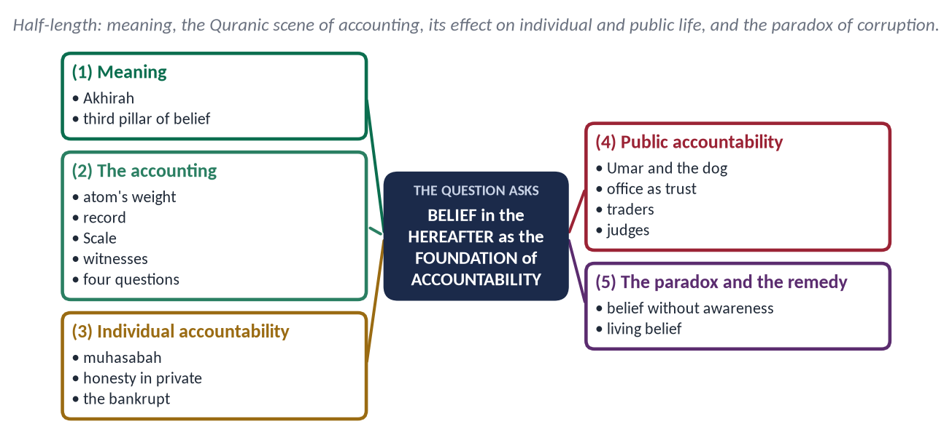
Figure 26 · The answer map: every branch is one numbered heading of the model answer below.

(1) Meaning
Akhirah (آخِرَة) is the life after death: resurrection, judgement and eternal reward or punishment. It is the third pillar of belief after Tawhid and Risalat.

(2) The accounting
✦ QURAN
﴿فَمَن يَعۡمَلۡ مِثۡقَالَ ذَرَّةٍ خَيۡرٗا يَرَهُۥ ۝ وَمَن يَعۡمَلۡ مِثۡقَالَ ذَرَّةٖ شَرّٗا يَرَهُۥ﴾
“So whoever does an atom's weight of good will see it. And whoever does an atom's weight of evil will see it.” (Az-Zalzalah, Quran)
➜ Even an atom's weight of good or evil will be seen.

- The record: 'Read your record; sufficient is yourself against you this Day as accountant' (Al-Isra 14).
- The Scale: 'We shall set up the just scales for the Day of Resurrection, so no soul will be wronged at all' (Al-Anbiya 47).
- The witnesses: hands and feet will speak (Ya-Sin 65).
✦ HADITH
لَا تَزُولُ قَدَمَا عَبْدٍ يَوْمَ الْقِيَامَةِ حَتَّى يُسْأَلَ ... وَعَنْ مَالِهِ مِنْ أَيْنَ اكْتَسَبَهُ وَفِيمَ أَنْفَقَهُ
“The feet of a servant will not move on the Day of Resurrection until he is asked … about his wealth, where he earned it and how he spent it.” (Al-Tirmidhi)
➜ Also about his life, youth and knowledge.

(3) Accountability in individual life
- Self-accounting (muhasabah): 'Take account of yourselves before you are taken to account' (Umar).
- Honesty in private: the believer who knows Allah sees him does not cheat when no one is watching.
- Social wrongs are not forgiven by prayer alone: the bankrupt of the Hereafter is the one who came with prayer and fasting but had abused, cheated and struck people (Muslim).

(4) Accountability in public life
- Umar (RA): 'If a dog dies of hunger on the banks of the Euphrates, Umar will be asked about it.'
- Abu Dharr asked for office; the Prophet ﷺ said: 'It is a trust, and on the Day of Resurrection it is disgrace and regret — except for one who takes it by right' (Muslim).
- Traders: 'Woe to those who give less in measure' (Al-Mutaffifin 1–6) — the scale of the market reminds of the Scale of the Day.
- Judges and rulers: 'Of three judges, one is in Paradise and two in the Fire' — the one who knew the truth and judged by it is saved (Abu Dawud); the fear of the Hereafter made Abu Hanifah refuse the office of chief judge.

(5) The paradox — and the remedy
Why is there corruption in a society that believes in the Day of Judgement? Because belief has become theoretical: remembered at funerals, forgotten at work; weakened by the false hope that rituals cancel injustice. The remedy is living belief — teaching the Hereafter as accountability for rights of people, remembering death ('remember often the destroyer of pleasures', Al-Tirmidhi), and institutions that make worldly accountability match the Hereafter's justice.
Conclusion: The Hereafter is the inner auditor of Islam. Where it is alive, laws are obeyed without police; where it dies, no police can make them obeyed.

(b) Mob Violence in the Name of Religion — an Islamic Critique
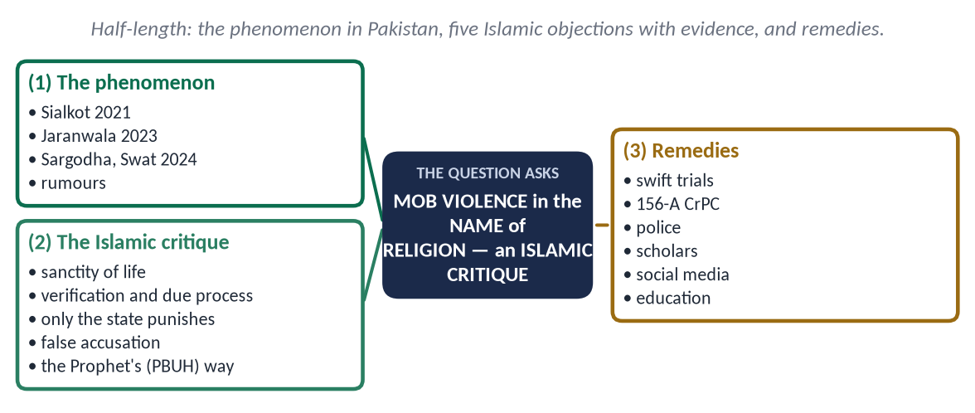
Figure 27 · The answer map: every branch is one numbered heading of the model answer below.

(1) The phenomenon
In Sialkot (December 2021) a mob lynched a Sri Lankan factory manager on an accusation of blasphemy — while his colleague Malik Adnan tried to shield him and was honoured by the state for courage. In Jaranwala (August 2023) churches and Christian homes were burnt; in Sargodha and Swat (2024) men were lynched on rumours. In almost every case the accusation was unproven, and the violence was sparked by rumour and social media.

(2) The Islamic critique

(i) The sanctity of life
✦ QURAN
﴿… مَن قَتَلَ نَفۡسَۢا بِغَيۡرِ نَفۡسٍ أَوۡ فَسَادٖ فِي ٱلۡأَرۡضِ فَكَأَنَّمَا قَتَلَ ٱلنَّاسَ جَمِيعٗا …﴾
“Whoever kills a soul — unless for a soul or for corruption in the land — it is as if he had slain mankind entirely.” (Al-Ma'idah, Quran)

'Whoever kills a believer intentionally, his recompense is Hell' (An-Nisa 93) — and the non-Muslim citizen is under the Prophet's ﷺ protection ('will not smell the fragrance of Paradise', Al-Bukhari).

(ii) Verification and due process
'If a sinful person brings you news, verify it' (Al-Hujurat 6). An accusation needs evidence; 'the burden of proof is on the claimant'. A mob has no evidence, no hearing and no judge.

(iii) Only the state may punish
By the consensus of the jurists, the prescribed punishments are carried out only by the lawful authority after trial. An individual or a crowd that punishes commits a crime, whatever the accusation.

(iv) False accusation is itself a grave sin
The Quran prescribes punishment for those who accuse without four witnesses in cases of honour (An-Nur 4); accusing someone falsely of a crime against religion is as grave.

(v) The way of the Prophet ﷺ
He bore insults patiently at Ta'if and answered the men who greeted him with 'death be upon you' only with 'and upon you', telling Aishah: 'Gently — Allah loves gentleness in every matter' (Al-Bukhari and Muslim). Mob violence in his name dishonours him.
✦ HADITH
الْمُسْلِمُ مَنْ سَلِمَ الْمُسْلِمُونَ مِنْ لِسَانِهِ وَيَدِهِ
“The Muslim is the one from whose tongue and hand the Muslims are safe.” (Al-Bukhari and Muslim)

(3) Remedies
- Swift trial and punishment of those who lead or incite mobs, and of false accusers.
- Procedural safeguards: investigation of religious accusations by senior police officers (Section 156-A, CrPC), strictly applied.
- Police training and quick response to protect the accused and their community.
- Scholars' leadership: Paigham-e-Pakistan declares that no individual may take the law into his hands; khutbahs must say it every time.
- Social media: remove incitement quickly; teach tabayyun.
- Education: teach in schools and madaris that only courts decide guilt, and that protecting an accused person from a mob — as Malik Adnan did — is an act of faith.
- Legal reform debate: jurists and the CII should examine how to prevent the misuse of religious laws for personal enmity, while keeping the honour of the Prophet ﷺ fully protected.
Conclusion: Mob violence is not zeal for Islam but rebellion against its law — against the sanctity of life, due process and the authority of the state. Those who love the Prophet ﷺ defend his honour by following his justice.

Why these notes score
- Note (a) links the doctrine to public accountability and faces the paradox honestly.
- Note (b) is a real critique: five Islamic objections, each with evidence, and dated Pakistani events.

